What’s your name and surname? ________________

What is your UČO? ________________

**1. Complete the sentences:**

Today is ________________ Where are you from? _______________________  
__________ you English? ____________________ She’s your teacher. _________ name is Lucy.

Please turn _____ your mobile phone. Where do you work? _______________

I ____________________ (not/smoke) My mother _________________ (study) English.

_________ your son play the piano?

**2. Name the body parts 3. Complete the numbers of words**

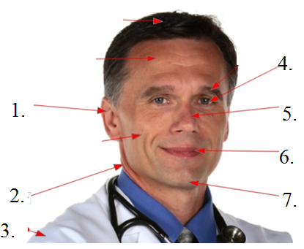 1) vessels 2) removes 3) supports 4)develops 5) blood

6) illnesses 7) woman’s 8) bones

Cardiovascular system carries ___ to various parts of the body. Urinary system ____ urea and other waste materials. A cardiologist specializes in ____ of the heart and blood ___. The womb is the part of a ___body where a baby grows and ____. Muscles are attached to ___ by tendons.

! dny v týdnu musíte znát, píšou se s velkým písmenem tedy: Friday

řešení testu najdete v materiálech z hodin a v učebnici či pracovním sešitu New English File Elementary