**Explain these words in English:**

ligament tear sprain dislocation herniated disc impair

inflammation cartilage crutches curvature brace joint

**Discuss these questions with your partner:**

1. What happens if skeletal system does not manage to withstand the pressures and stresses of daily activities?

2. What human activities often jeopardize the bones? And what toll do they take on the musculoskeletal system?

3. What are the negative effects of dislocation? (consider ligaments, nerves and bones)

4. What problems can people have with their vertebral column due to injury and what due to hereditary factors?

5. What disorders in musculoskeletal system are caused due to wear and tear of the body?

6. What disease/disorder which impairs the function of skeletal system do you consider the most serious and why?

**Fractures**

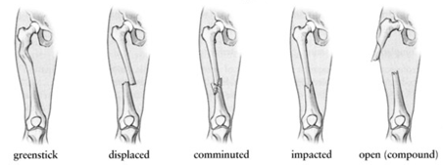

1.a, 2. c, 3. d, 4. b, 5. e

**2. Treatment of fractures: Word Formation.**

1. broken, 2. Union, 3. anatomical, 4. reduction/reducing, 5. excessive, 6. fixation, 7. malunion

3. 1. bleed, 2. scar, 3. bruise, 4. pain, 5. scratched, scab, 6. injuries, grazed, 7. wound, 8. swollen, 9. blister, 10. sprained, 11. scalded, 12. sting

**Disorders of the skeletal system: Describe the diseases with the help of the verbs which follow the respective disease.**

Arthritis: mean, involve, persist, be widespread, cripple

Osteoarthritis: occur, to be characterized by, to be seen in, include, wear away, rub, cause, to be affected by, use, reduce

Osteoporosis: mean, occur, dissolve, maintain, decrease, become, break, sneeze, cause, prevent, adhere to (keep to), avoid, smoke, drink, exercise

Scoliosis: view, appear, cause, interfere with, lead to, depend on, wear, correct, slow down, require, progress, straighten, fuse together

Spina bifida: include, cause, open, fail, wrap completely, leave unprotected, treat, close, prevent, operate, be dependent on

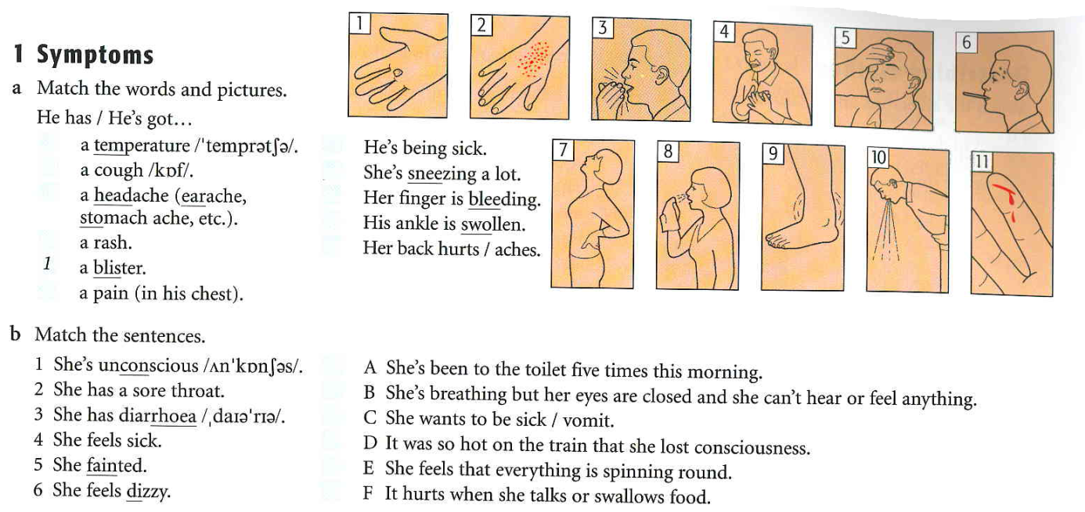

Listening transcription:

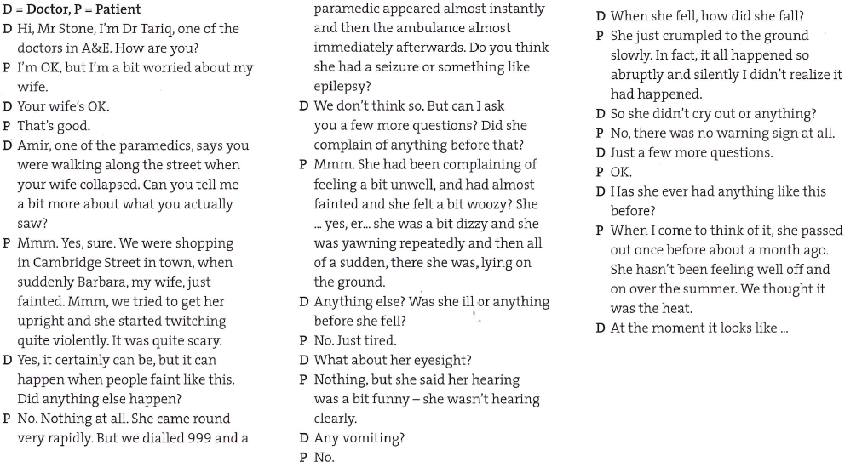

Faint = lose consciousness, pass out x pass away = die

to twitch

came around/round

seizure = fit

yawn

vomit

1) see listening transcript

2) 1. were walking, passed; 2. has not had, experienced, 3. had been admitted/was admitted, became; 4. has not suffered, has been feeling; 5. was yawning, had not done, fainted; 6. had fallen/fell, started, tried; 7. was lying, was not shaking; 8. happened, fell; 9. bit, messed, had been feeling

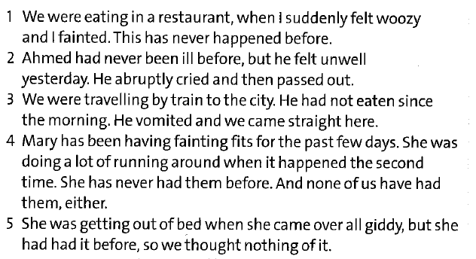

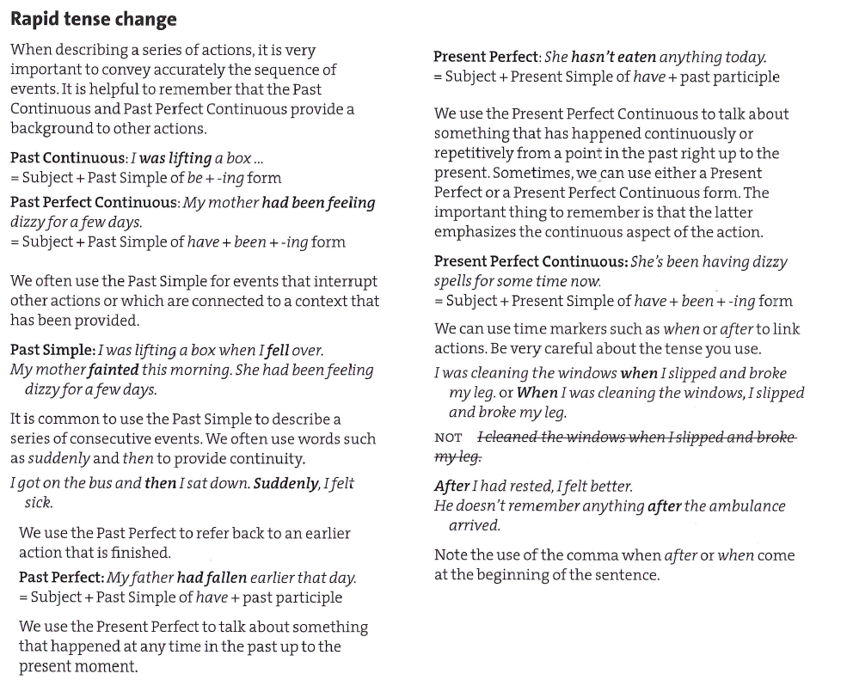

See further grammar explanation and exercises in Additional past tenses