**1. Fractures**

A fracture is a break in a bone. There are some types of fracture, match them with the definition and picture.

1. open (compound)
2. comminuted
3. displaced
4. greenstick
5. impacted
6. There is a break in the skin.
7. The bone is bent. It occurs mainly in children.
8. The bone is broken into several pieces.
9. The broken pieces are separated.
10. The broken pieces are pushed together.

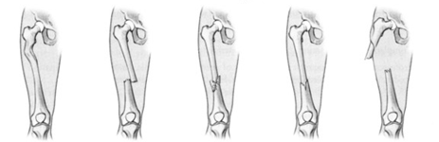

**2. Treatment of fractures: Word Formation.** Complete the correct form of the word.

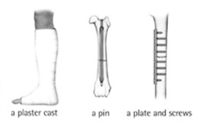Example: Most people find the idea of fame attractive 0 /attract/.

When the fragments of a _______ 1 /break/ bone heal and join together, they unite. ______ 2 /unite/ may be promoted, or helped, by reducing the fracture − replacing the fragments in their _____ 3 /anatomy/ position if they are displaced. After ______ 4 /reduce/, _________5 /excess/ movement of the bone is prevented by ______6 /fix/ − either external, for example a splint or plaster of Paris cast, or internal, for example a pin or plate and screws. A displaced fracture which is not reduced may result in ______7 /unite/− incomplete or incorrect union.

**3. Injuries**

blister, bleed, wound, scalded, swollen, sprained, sting,

grazed, scar, scab, pain, bruise, injuries, scratch

1. People with haemophilia ______ easily.
2. The operation only left a small ______.
3. The ______ turned blue then yellow and is slowly disappearing.
4. Are you in ______? Yes, it hurts a lot.
5. Look where the cat ______ me. It’s bleeding a bit but a ______ has already started to form.
6. His ______ are fairly minor. He only ______ his both knees when he fell down.
7. This ______ is a result of being stabbed with a knife on purpose.
8. My ankle is very ______, I have probably torn some ligaments.
9. I was wearing the new shoes the whole day and now I have a horrible ______ on my foot.
10. I’ve ______ my wrist, it is hurting terribly.
11. He ______ his hand when he accidentally spilled some boiling water from the kettle.
12. Be careful or that wasp will ______ you.

**4. Listening:** You will hear a dialogue between a doctor and a man. Answer the following questions:

1. Where are they?

2. What happened to his wife?

3. Did she have any health problem before?

