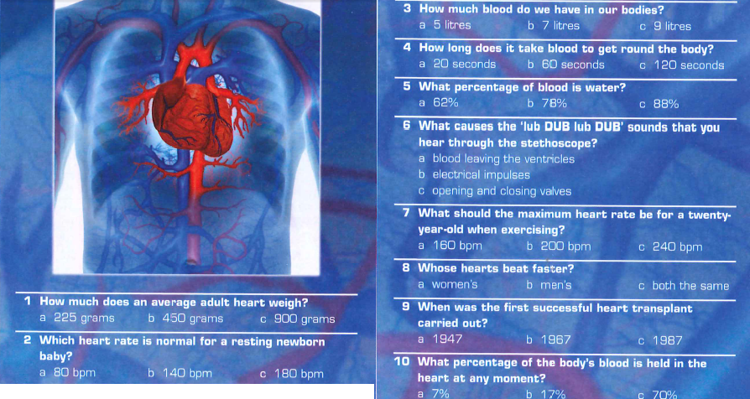

1-a, 2-b, 3-a, 4-a, 5-b, 6-c, 7-b, 8-a, 9-b, 10-a

The **____most_____** (1) important muscle in the body is the heart. Without the heart and its cardiovascular (circulatory) system, human life **___would______** (2) not be possible. The heart is roughly the **____size_____** (3) of a fist. It contracts **____at_____** (4) an average rate of 72 times per minute or nearly 38,000,000 times **___a______** (5) year. These rhythmic contractions are **_____called____** (6) the pulse rate and can **____be_____** (7) felt in the radial artery of the wrist.

The human heart consists of four **___chambers______** (8), two atria (or auricles) and two **____ventricles_____** (9). Each is made **____up_____** (10) of several layers of cardiac muscle arranged in circles and spirals. During the contraction phase, called the systole, oxygenated blood **_____is____** (11) pumped out of the left part of the heart into the aorta and from there through the arteries to all organs of the body. Carbon **___dioxide______** (12), a waste product of this process, is collected in the blood.

The rest of the system consists of **_____arterioles____** (13) (small arteries), venules (small __veins_____ (14), and capillaries, the smallest of blood **____vessels_____** (15). In total, **_____there____** (16) are more than 70,000 miles of them in the human body.

The blood is made up of two parts - plasma and blood **_____cells____** (17). The plasma is a clear, yellowish liquid **____which_____** (18) transports the 25 trillion erythrocytes and the many fewer leukocytes. The leukocytes are important **___in______** (19) fighting disease. **___Platelets/thrombocytes______** (20) in the blood permit clotting to take place at the site of a wound, thus preventing excessive bleeding.

***1. Match the words with their synonyms or definitions***

1-i, 2-m, 3-l, 4-c, 5-a, 6-d, 7-b, 8-e, 9-j, 10g, 11-h, 12-f, 13-k

***2. Listen and answer the questions:***

The contraction of the heart muscle is caused by ____Action potentials/electrical signals_____.

The abbreviation for electrocardiogram is __ECG_____ or ____EKG_____.

What are the individual phases of electrocardiogram and what happens during them? see the video

***Patient care***

correct order 4, 5, 2, 7, 1, 3, 6

1d, 2c, 3g, 4e, 5a, 6f, 7b

***3. and 4. Listening – see the transcript***

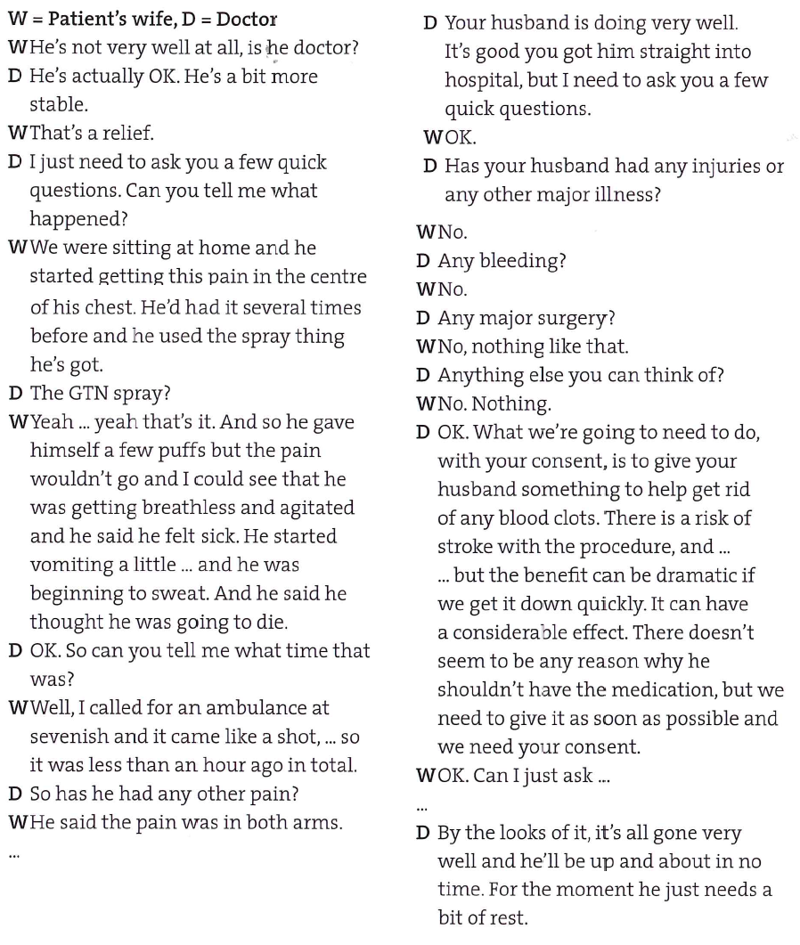

**The future**

There are several ways of talking about future:

|  |  |
| --- | --- |
| 1. SIMPLE FUTURE  will + verb (will go) | A. something that has been planned or arranged |
| 2. PRESENT SIMPLE  verb (go, goes) | B. an action which leads up to a given point in the future but is not necessarily finished at that point |
| 3. PRESENT CONTINUOUS  be + verb+ing (is going) | C. talking about future after **if**, **before**, **after**, **as soon as**, **when** and future timetabled events |
| 4. FUTURE CONTINUOUS  will + be + verb+ing (will be going) | D. an action that will have finished at a given point in the future |
| 5. FUTURE PERFECT  will + have + verb in PP  (will have gone) | E. the future in general and in main clause of a first conditional sentence |
| 6. FUTURE PERFECT CONTINUOUS  will + have + been + verb+ing  (will have been going) | F. action that will be happening at a given point in the future |
| 7. Going to | G. for talking about personal plan or intention, for making prediction, especially when this has already started to happen; for decision about the future |

Can you make an example for each of these possibilities?

1. WILL=SIMPLE FUTURE - the future in general and in main clause of a first conditional sentence

*The presentation will finish at about 4 o’clock.*

*If it finishes earlier, there will be more time for questions.*

2. PRESENT SIMPLE - talking about future after **if**, **before**, **after**, **as soon as**, **when**

- future timetabled events

*When he gets here, could you let me know?*

*Dr Carlin’s train leaves London at 1:30 and gets into Oxford at 2:10.*

3. PRESENT CONTINUOUS - something that has been planned or arranged

*We are sending out invitations over the next couple of weeks.*

4. FUTURE CONTINUOUS - an action that will be happening at a given point in the future

*This time next week, you will be flying back to the USA.*

5. FUTURE PERFECT - an action that will have finished at a given point in the future

*By the end of the year you will have learned enough English to be able to work in a hospital.*

6. FUTURE PERFECT CONTINUOUS - an action which leads up to a given point in the future but is not necessarily finished at that point

*This is a long presentation. By five o’clock, Dr Schwartz will have been talking for an hour and half.*

7. Going to + infinitive – for talking about personal plan or intention, for making prediction, especially when this has already started to happen; for decision about the future

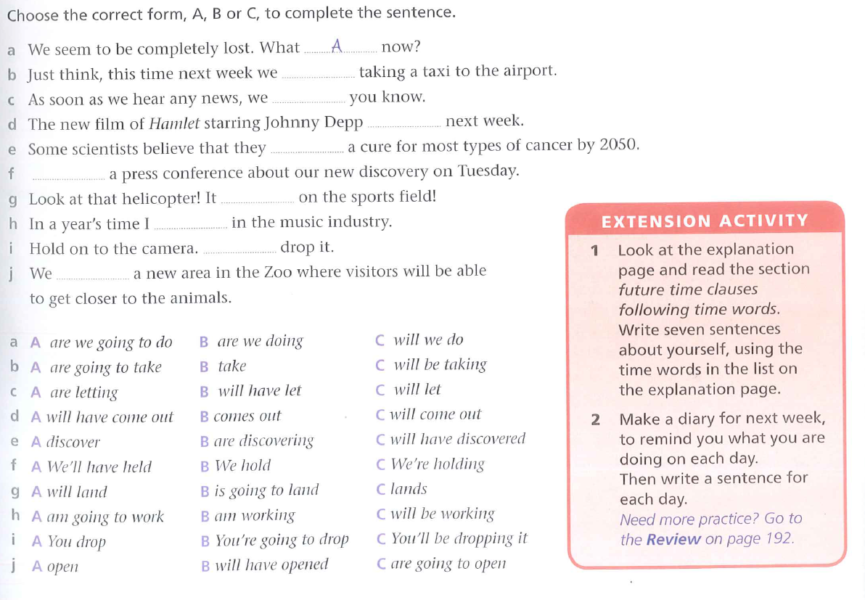

b-c, c-c, d-b, e-c, f-c, g-b, h-c, i-b, j-c

***Future:***

1) will be (is going to be), 2) will be sent, 3) will soon move, 4) will have been (will be), 5) will be walking, 6) Will he be able, 7) will he have had, 8) is coming/comes, will see/will be seeing

***Instructions***

suggested answers: 1d, 2b, 3e, 4a, 5c

You are a paramedic and you have just got a call. The person calling, Nina, found someone with a sudden cardiac arrest. Prepare instructions so that you can talk her through the procedure of giving CPR and using AED.

**1. Check Responsiveness**

* For an adult or older child, shout and shake the person to confirm consciousness. Do not use AED on a conscious person.
* For an infant or young child, pinch skin. Never shake a young child.

Continue reading below...

* Check breathing and pulse. If absent or irregular, prepare to use AED as soon as possible.

**2. Prepare to Use AED**

* Make sure the person is in a dry area and away from puddles or water.
* Check for body piercings or outline of an implanted medical device, such as a pacemaker or implantable defibrillator.
* AED pads must be placed at least 1 inch away from piercings or implanted devices.

**3. Use AED**

For newborns, infants, and children up to age 8, use a pediatric AED, if possible. If not, use an adult AED.

* Turn on the AED.
* Wipe chest dry.
* Attach pads.
* Plug in connector, if necessary.
* Make sure no one is touching the person.
* Push “Analyze” button.
* If a shock is advised, check again to make sure no one is touching the person.
* Push “Shock” button.
* Start or resume chest compressions.

**4. Continue CPR After Using AED**

* After 2 minutes of CPR, check the person’s heart rhythm. If it’s still absent or irregular, give another shock.
* If a shock isn’t needed, continue CPR until emergency help arrives or the person begins to move.
* Stay with the person until help arrives.