Cardiovascular System
Good Cardiovascular health is important in maintaining overall health and wellness. Cardiovascular Health is a new section, which will teach you how your heart and cardiovascular system work when healthy, and what happens when diseased. We will also explore disease prevention, therapeutic drug treatment, minimally invasive surgical procedures and open surgical procedures for treating diseases, which affect the heart and cardiovascular system.
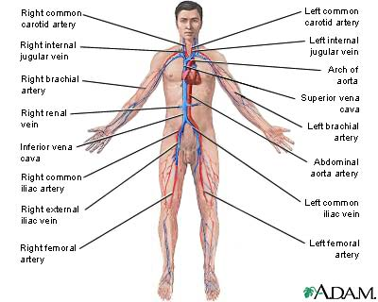
The main role of the cardiovascular system in the body is to transport oxygen to all tissues in the body and to remove, from these same tissues, metabolic waste products. The system itself consists of the blood, the medium for exchanging oxygen, nutrients and waste products throughout the body, the blood vessels, the pipes through which the blood flows and the heart, the pump which forces blood to flow through the blood vessels. First, let’s take a closer look at the components of blood.
Components of Blood
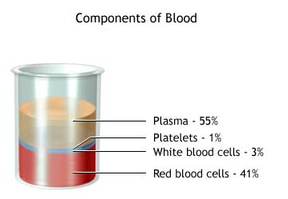
The average adult has between 5 to 6 litres of blood or blood volume. The blood carries oxygen and essential nutrients to all of the living cells in the body, and also transports waste products to systems that eliminate them. Most of the blood is made up of a watery, protein-laden fluid called plasma. A little less than half of this blood volume is composed of red and white blood cells (erythrocytes and leukocytes respectively), and other solid elements called platelets (thrombocytes).
Platelets are responsible for coagulation of blood at the point of an injury to a blood vessel. Without platelets, our blood would not be able to clot and haemorrhaging (uncontrolled bleeding) would result. Haemophilia is a genetic condition which results in individuals with no ability to clot. Also called bleeders, these individuals must periodically administer a clotting factor to their blood to prevent the constant bleeding which occurs.
How Blood Clots
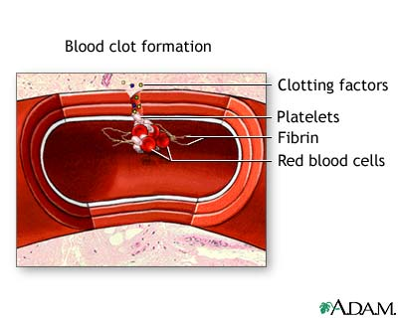
Let’s examine how platelets work to form clots. Here's a cut section of a small artery. The traffic going by includes red blood cells carrying oxygen; platelets, which come from white blood cell fragments; and clotting factors, which help the blood to clot. When a blood vessel becomes damaged, as shown here, the blood cells and plasma begin oozing out into the surrounding tissue. This begins the clotting process. Platelets immediately begin to adhere to the cut edges of the artery; they release chemicals to attract even more platelets. Eventually a platelet plug is formed, and the external bleeding stops.
Inside, the clotting factors take a much more active role by creating a cascade of clotting activity. The clotting factors cause strands of blood-borne material, called fibrin, to stick together and seal the inside of the wound. Eventually, the cut blood vessel heals, and the blood clot dissolves after several days.
While platelets play an important role in clotting, red blood cells carry on the important job of carrying oxygen and other nutrients to all the tissues of the body and carrying waste products to the organs which remove them from the body.
How Red Blood Cells Carry Oxygen
Red blood cells are the oxygen carriers. As they travel away from the heart, they traverse smaller and smaller arteries, finally arriving at the collections of microscopic blood vessels known as capillaries. Here, they exchange nutrients and oxygen for cellular waste products. The waste products are eventually eliminated from the blood stream through the urinary and respiratory systems.
The exchange of oxygen and nutrients between the red blood cells and the surrounding tissues occurs through a process called diffusion. In diffusion, when capillaries contain a high concentration of oxygen and nutrients, while the surrounding tissues contain a lower concentration. Oxygen and nutrients leave the capillaries and enter the tissues.
Conversely, when body tissues contain high concentrations of carbon dioxide and metabolic waste, while the capillaries contain a lower concentration, the waste products diffuse from the tissues into the capillaries and from there are carried by the venous system back toward the heart.
Blood Pressure
The red blood cells transport oxygen and waste products by flowing through the blood vessels. What causes blood to flow through the vessels is blood pressure. Just as water flows through pipes from areas of greater pressure to lesser, so too the blood flows through the body from areas of higher pressure to areas of lower pressure. Blood pressure is measured both as the heart contracts, which is called systole, and as it relaxes, which is called diastole. A systolic blood pressure of 120 millimetres of mercury is considered right in the middle of the range of normal blood pressures, as is a diastolic pressure of eighty. In common terms, this normal measurement would be stated as “120 over 80”.
Normal blood pressure is important for proper blood flow to the body’s organs and tissues. Each heartbeat forces blood to the rest of the body. The force of the blood on the walls of the arteries is called blood pressure. Blood pressure moves from high pressure near the heart to low pressure away from the heart. Blood pressure depends on many factors, including the amount of blood pumped by the heart. The diameter of the arteries through which blood is pumped is also an important factor. Generally, blood pressure is higher when more blood is pumped by the heart, and the diameter of an artery is narrow.
Systolic pressure is measured when the heart ventricles contract. Diastolic pressure is measured when the heart ventricles relax. Stressful situations can result in a temporary increase in blood pressure. If an individual were to have a consistent blood pressure reading of 140 over 90, he would be evaluated for having high blood pressure. If left untreated, high blood pressure can damage important organs, such as the brain and kidneys as well as lead to a stroke.
The Heart
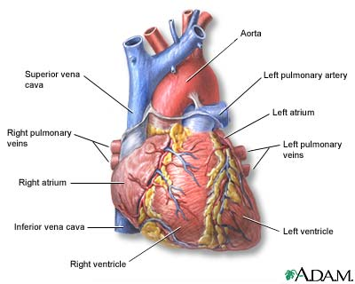
The pressure and flow of the blood arise from the beating heart muscle, which is the pump of the cardiovascular system. To understand how the heart works let’s take a brief look at the anatomy of the beating heart.
The heart is a four-chambered organ with four main vessels, which either bring blood to or carry blood away from the heart. The four chambers of the heart are: the right atrium, the right ventricle, the left atrium, and the left ventricle.
The great vessels that you see include the superior and inferior vena cava, which bring blood from the body to the right atrium. The pulmonary artery, which transports blood from the right ventricle to the lungs, and the aorta, the body’s largest artery, which transports oxygen-rich blood from the left ventricle to the rest of the body.
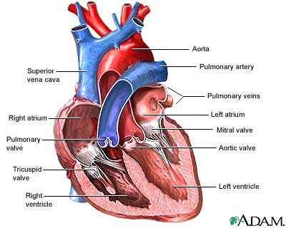
If you look carefully, you can see a series of one-way valves that keep the blood flowing in one direction. The blood first enters the heart into the right atrium. A contraction of the right atrium then forces blood through the tricuspid valve and into the right ventricle. When the right ventricle contracts, the muscular force pushes blood through the pulmonary semilunar valve into the pulmonary artery. The blood then travels to the lungs, where it receives oxygen. Next, it drains out of the lungs via the pulmonary veins, and travels to the left atrium. From the left atrium, the blood is forced through the bicuspid valve into the critically important left ventricle. The left ventricle is the major muscular pump that sends the blood out to the body systems. When the left ventricle contracts, it forces the blood through the aortic semilunar valves and into the aorta. From here, the aorta and its branches carry blood to all the tissues of the body.

