***1. The lymphatic system video: Look at the questions and answer them, then watch the video to see whether you answers were correct.***

see the video

Reading

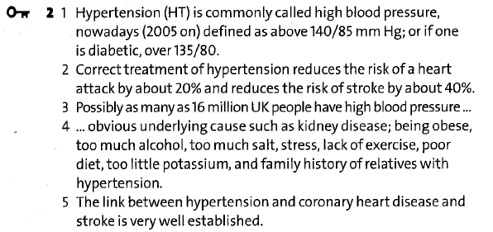

***4. Match the parts of sentences.***

You will need to stop -ing ‘strong advice’

Have you ever tried to… suggestion

Have you ever thought of -ing suggestion

I would strongly advise you to… ‘strong advice’

It is better for you if you… advice

You might want to… suggestion

You could try and do… suggestion

You are going to have to… ‘strong advice’

***5. Wordformation***

ABSORPTION, INCOMPLETE, HARDENING, FATTY, LOSS, IMPAIRMENT, DEATH, BLOCKAGE, SHORTNESS, ANXIETY, FAILURE, INFLAMMATORY

**Expressing opinion**

I think that/ I would say that …

Why don’t we…?

It seems to me that …

I’d like to point out…

I’m inclined to think that

The way I see it is that …

I’m convinced that …

As I see it …

As far as I am concerned…

I tend to favour the view that

I’m fairly certain that …

In my opinion/experience…

If you ask me, I would say that …

To my mind …

**Clarifying your ideas**

What I’m talking about is …

In other words …

What I said was …

What I (really) meant was …

(No) I didn’t mean that, what I wanted to say was …

What I was trying to say was …

Sorry, let me explain it again.

Sorry, I obviously didn’t make myself clear, what I wanted to say was …

**Agreeing**

I totally/fully/partly agree

I’d go along with that.

I couldn’t agree more.

No doubt about it.

Exactly. You have a very good point here.

I think so too.

Yes, definitely.

You’re quite right. I suppose so. I guess so.

So do I. Neither do I.

I think you’re right.

You may/could be right but …..

**Disagreeing**

I don’t think so.

But don’t you think that…?

I see what you mean, but…

That’s not always the case.

I suppose so, but…

I’m not so sure about that.

I wouldn’t say that.

I agree up to a point, but…

You can’t be serious! Rubbish!/Nonsense!