***1. Use the appropriate form of the word in brackets***

A common cold is usually __harmless__ . The symptoms are __runny__ or __stuffy__ nose, sore throat, __watery___ eyes. A common cold can be caused by one of more than 200 viruses; therefore symptoms tend to __vary___ . However, it is __unlikely___ that you will have a high fever and experience __significant___ fatigue. Symptoms of a common cold usually appear about one to three days after __exposure__ to a cold virus.

The most common causes of pneumonia are bacteria, viruses and **fungi**. You can also get it by _accidentally_ inhaling a liquid or chemical. If you have pneumonia, you may have __difficulty__ breathing and have a cough and a fever. The best _preventive__ measures include not smoking and wearing a mask when cleaning dusty or **mouldy** areas.

Bronchitis causes a cough, _shortness_ of __breathe___ and chest __tightness_ .

***2. Read the sentences and complete only one word into each gap.***

1. Most people recover __from___ a common cold _in___ about a week or two.

2. Pneumonia is usually caused _by_ an infection.

3. People most _at___ risk are older than 60.

4. Treatment depends __on_ what made you sick.

5. Bacterial infection accounts _for__ up to a quarter of all pneumonias.

6. If you smoke, quitting may prevent you __from___ getting the disease.

7. Treatment is based _on__ whether your symptoms are mild, moderate or severe.

***3. Speaking***

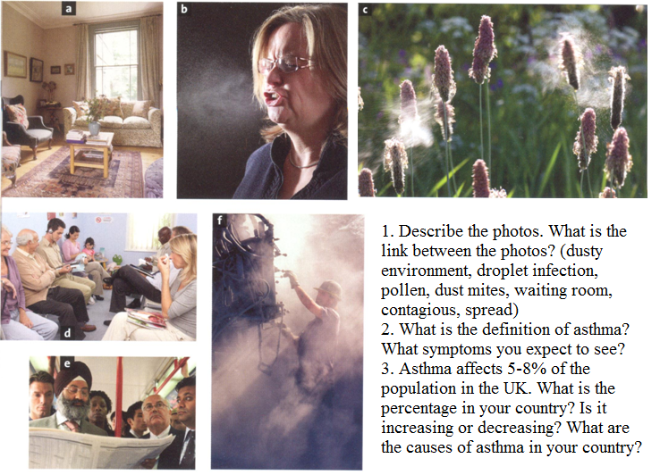

**Defining and non-defining relative clauses**

1. The woman who (that) lives next door is a doctor.

2. We chose the midwife (who, that) you recommended.

3. The patient whose kidney started to fail is slowly recovering.

1. My brother Rob, who lives in Australia, is a doctor.

2. We chose the midwife Ms Smith, who you recommended.

3. Liz, whose kidney started to fail, is slowly recovering.

***1. Decide which rules apply to defining and which to non-defining relative clause.***

**non-defining**

1. It is a clause which gives extra information which does not help us identify the person or thing.

5. ‘Who/what’ cannot be left out even if it is the object of the relative sentence.

6. It is separated by commas.

7. ‘That’ cannot be used in this clause.

**defining**

2. We can use ‘that, who, which,’ etc.

3. ‘Who/that/which’ can be left out if it is the object of the relative sentence.

4. Commas are not used.

8. It is a clause which helps us identify the person or thing that we are talking about.

***2. Complete a relative pronoun and write commas if necessary.***

1. Louis Pasteur ,___who______ discovered the principles of vaccination, died in 1895 near Paris.
2. People _who_______ are suffering from emphysema should give up smoking.
3. Acute bronchitis, __whose ___ symptom is a lingering dry cough, usually goes away on its own.
4. I live in London, ___which_____ has some fantastic parks.
5. I want some drops ___that/which_____ can be used with this decongestant.
6. Kidney transplant is a treatment ________ is given to people with renal failure.
7. The on/off switch, ___which_____ is at the back of the machine, is broken.
8. Patients ___who/that_____ have dialysis at home can get on with their lives more easily.
9. This is the x-ray of Mr. Brown, ___to whom_____ I gave some pain killers. (there is only one Mr. Brown in the hospital)
10. My brother, __who_____ lives in New York caught pneumonia. (I have only one brother)

**Study these two sentences:**

*I did not manage to learn everything for the exam, which is bad.*

*I have to go to the doctor, which means I won’t be able to see you.*

**We also use which to refer to the whole situation talked about in the sentence before the relative clause. In this case, we have to use a comma to separate the sentences.**

**Listening: How To Cope With The Common Cold**

*a) Discuss with your partner:*

I. How often do you catch a cold? In which part of the year do you usually catch a cold?

II. What are the most common cold symptoms? Which of them do you usually suffer from?

III. What’s the best treatment for a cold?

*b) Listen and write down 8 steps which help you cope with a cold.*

*c) Listen once more and fill in the gaps.*

**Step 1**: The earlier you catch a cold coming on, the earlier you can start helping your body to fight it_off__ (1) . Sneezing, a runny nose and a _cough_ (2) are usually the earliest presenting symptoms.

**Step 2:** Although we don't know why, high levels of stress seem to cause a big reduction in the immune system's ____effectiveness___ (3). Removing stress factors like the latest deadline will help your body to ____fight off__________ (4) the cold.

**Step 3:** Nothing will _cure__ (5) your cold, but there are medicines that can help to __relieve_ (6) your symptoms. Basic painkillers such as aspirin, paracetamol and ibuprofen can help reduce the discomfort of a _sore_ (7) throat, headache or high temperature. Nasal __decongestant___ (8) sprays are the best at relieving a _blocked_ (9) nose, although are only effective for 5-7 days, after which they can actually worsen the problem. Cough medicines are less effective, but can still have some ____impact__(10) on chesty and dry coughs.

**Step 4**: Hot drinks will give instant _relief__ (11) to a sore throat. Making yourself very spicy food or hot soup to eat also has a calming effect on a sore or tickly throat. Inhaling steam from very hot water can help to __loosen__ (12) a blocked nose, although be careful to avoid getting steam in your eyes. Using more pillows than normal in bed to prop up your head can also relieve ____congestion______ (13) and help you sleep.

**Step 5:** There is anecdotal evidence that ______supplements______ (14) such as extra Vitamin C help to _____boost______ (15) the immune system, although it is not advised that you take large amounts of any one vitamin or herbal remedy. Check the advice on the box for recommended ____dosage______ (16) levels.

**Step 6:** If you are a smoker, now is a good time to ___quit_____ (17). Smoking irritates the membranes in your nose further, causing your symptoms to get worse.

**Step 7:** The symptoms of a cold drain your body of ______moisture________ (18). To keep your body strong enough, make sure to regularly drink fluids throughout the day.

**Step 8:** Although colds usually do not leave you unable to do things, they will vastly decrease your ______stamina______ (19) and energy levels. Straining yourself beyond your body's reduced limits will only make you feel worse, and _____prolong_________ (20) your recovery time.

http://www.videojug.com/film/how-to-cope-with-the-common-cold

**Allergies: what are they and how to cope with them?**

**With your partner talk about the possible causes of allergies, their symptoms a treatment**

**causes treatments**

