Osteoporosis
A Read the text and complete the gaps with the sentences below.
a) Although it may affect either gender, it is most common in thin, light-complexioned females after menopause.
b) These include young women who have had their ovaries removed; women who have anorexia nervosa (self-starvation) that stopped their menstrual cycles; and women past menopause.
c) Each year in the United States, 200,000 senior citizens break their hips, more than 90% of the time as the result of an accident.
d) To reduce such loss, people in their mid-twenties and older should take in 1,000-1,500 milligrams of calcium daily
e) This disorder is associated with aging. Within affected bones, trabeculae are lost, and the bones develop spaces and canals.

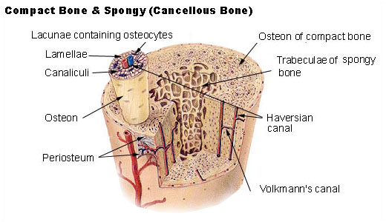
It is an all-too-familiar scenario. The elderly woman pulls herself out of bed, reaches for the night table for support, and misses. She falls, landing on her hip. A younger woman would pull herself up, and maybe ache for a few minutes and develop a black and blue mark by the next day. But the 80-year-old, with weakened, brittle bones, suffers a broken hip. ___________ (1).
In osteoporosis, the skeletal system loses bone volume and mineral content. ______________ (2). These enlarge and fill with fibrous and fatty tissues. Such bones easily fracture and may break spontaneously because they are no longer able to support body weight. For example, a person with osteoporosis may suffer a spontaneous fracture of the thigh bone (femur) at the hip or the collapse of sections of the backbone (vertebrae). Similarly, the distal portion of a forearm bone (radius) near the wrist may fracture as a result of a minor stress.
Osteoporosis causes many fractures in persons over forty-five years of age. ____________________ (3).
Factors that increase the risk of osteoporosis include low intake of dietary calcium and lack of physical exercise (particularly during the early growing years). However, excessively strenuous exercise in adolescence can delay puberty, which raises the risk of developing osteoporosis later in life for both sexes.
In females, declining levels of the hormone estrogen contribute to development of osteoporosis. The ovaries produce estrogen until menopause. Evidence of the estrogen-osteoporosis link comes from studies on women who have declining estrogen levels and increased risk of osteoporosis. _______________ (4). Drinking alcohol, smoking cigarettes, and inheriting certain genes may also increase a person's risk of developing osteoporosis.
Fortunately, osteoporosis may be prevented if steps are taken early enough. Bone mass usually peaks at about age thirty-five. Thereafter, bone loss may exceed bone formation in both males and females. __________ (5). An 8-ounce glass of non-fat milk, for example, contains about 275 milligrams of calcium. It is also recommended that people engage in exercise regularly, especially walking or jogging, in which the bones support body weight.

B Read the text again and answer the questions.
1 Which changes in the bone structure lead to osteoporosis?
2 Which parts of the femur and the radius are particularly vulnerable?
3 Which factors enhance the risk of developing osteoporosis?
4 What makes women more prone to contract osteoporosis?
5 What are the main forms of prevention?

Listening

A Listen and note what these numbers refer to:
10 million
99
75

B Listen and complete the gaps.
Resorption steals _______ (1) from bone to be recycled for use in other parts of the body. During resorption, scavenger cells with saw-tooth _________ (2) called osteoclasts attach to bone surfaces. There they tunnel into bone and regurgitate calcium into the blood _______ (3) for use of other body parts.
During formation, ________ (4) cells or osteoblasts move into the tunnels left by osteoclasts and release strands of _________ (5) into the holes, effectively filling them.

C Complete the table:
Osteoporosis |  | Causes
Primary | Type I
 | Type II
Secondary

