Diseases: what can go wrong with the cardiovascular system?
http://www.faqs.org/health/Body-by-Design-V1/The-Cardiovascular-System
The following are just a few of the many diseases and disorders that can impair the cardiovascular system or its parts.
Atherosclerosis is a general term for hardening of the arteries. Atherosclerosis is a condition in which fatty material and other substances accumulate on and in the walls of large arteries, impairing the flow of blood. Cholesterol, a fatlike substance produced by the liver, is an essential part of cell membranes and body chemicals. Normally, the body produces all the cholesterol it needs. Eating foods high in saturated fats (found mostly in animal products such as egg yolks, fatty meats, and whole milk dairy products) can cause an increase in blood cholesterol levels. The excess cholesterol not taken up by the cells accumulates on the walls of arteries. There it combines with fatty materials, cellular waste products, calcium, and fibrin to form a waxy build-up known as plaque, which can either partially or totally obstruct blood flow.
Coronary artery disease arises when atherosclerosis occurs in the coronary (heart) arteries. When the blood flow in these arteries is restricted, the heart muscles do not receive the proper amount of blood and oxygen. Chest pain or pressure, called angina, may occur. If the blood flow is blocked, cardiac muscle cells begin to die and a heart attack may result. If blood flow is blocked in any cerebral (brain) arteries, brain cells quickly begin to die and a stroke may result. Depending on what area of the brain has been affected, a stroke may cause memory loss, speech impairment, paralysis, coma, or death.
Heart attack or myocardial infarction (MI) or acute myocardial infarction (AMI) is the interruption of blood supply to part of the heart, causing some heart cells to die. This is most commonly due to occlusion (blockage) of a coronary artery following the rupture of atherosclerotic plaque in the wall of an artery. The resulting ischemia (restriction in blood supply) and oxygen shortage, if left untreated for a sufficient period of time, can cause damage or death (infarction) of heart muscle tissue (myocardium). Classical symptoms of acute myocardial infarction include sudden chest pain (typically radiating to the left arm or left side of the neck), shortness of breath, nausea, vomiting, palpitations, sweating, and anxiety. Approximately one quarter of all myocardial infarctions are silent, without chest pain or other symptoms. A heart attack is a medical emergency.
Heart failure is a condition that can result from any structural or functional cardiac disorder that impairs the ability of the heart to fill with or pump a sufficient amount of blood throughout the body. Therefore leading to the heart and body's failure.
Hypertension is high blood pressure. It is normal for blood pressure to be elevated for brief periods because of exercise, emotional stress, or a fever. Consistent arterial blood pressure measuring 140/90 or higher, however, is hypertension. The condition, the most common one affecting the cardiovascular system, is a serious one. Although it shows no symptoms, hypertension should be treated. If left unchecked, it can lead to atherosclerosis, heart attack, stroke, or kidney damage. Hypertension most often strikes African Americans, middle-aged and elderly people, obese people, heavy alcohol drinkers, and people suffering from diabetes or kidney disease.
Ischaemic heart disease (IHD), or myocardial ischaemia, is a disease characterized by reduced blood supply to the heart muscle, usually due to coronary artery disease (atherosclerosis of the coronary arteries). Its risk increases with age, smoking, hypercholesterolaemia (high cholesterol levels), diabetes, hypertension (high blood pressure) and is more common in men and those who have close relatives with ischaemic heart disease. Symptoms of stable ischaemic heart disease include angina (characteristic chest pain on exertion and decreased exercise tolerance). Unstable IHD presents itself as chest pain or other symptoms at rest. Diagnosis of IHD is with an electrocardiogram, blood tests, cardiac stress testing or a coronary angiography. Depending on the symptoms and risk, treatment may be with medication or coronary artery bypass surgery.
Inflammatory heart disease involves inflammation of the heart muscle and/or the tissue surrounding it.
Endocarditis – inflammation of the inner layer of the heart, the endocardium. The most common structures involved are the heart valves.
Inflammatory cardiomegaly, pathological enlargement of the heart due to different reasons
Myocarditis – inflammation of the myocardium, the muscular part of the heart.
Obstructions:
Thrombosis is the formation of a blood clot (thrombus) inside a blood vessel, obstructing the flow of blood through the circulatory system. When a thrombus occupies more than 75% of surface area of the lumen of an artery, blood flow to the tissue supplied is reduced enough to cause symptoms. More than 90% of obstruction can result in a complete lack of oxygen, and infarction, a type of cell death.
Embolism occurs when an object (embolus) migrates from one part of the body (through circulation) and causes a blockage (occlusion) of a blood vessel in another part of the body. This is in contrast with a thrombus, which forms at the blockage point within a blood vessel and is not carried from somewhere else.
Valvular heart disease is disease process that affects one or more valves of the heart. The valves in the right side of the heart are the tricuspid valve and the pulmonic valve. The valves in the left side of the heart are the mitral valve and the aortic valve.
Aortic valve stenosis (AS) is a valvular heart disease caused by the incomplete opening of the aortic valve. The aortic valve controls the direction of blood flow from the left ventricle to the aorta. When in good working order, the aortic valve does not impede the flow of blood between these two spaces. Under some circumstances, the aortic valve becomes narrower than normal, impeding the flow of blood.
Lymphatic System
As blood circulates, some of its fluid components push out of the capillary bed into the surrounding tissue. This material forms lymph, a special protein-containing tissue fluid that bathes the cells. Lymphatic vessels reabsorb part of this lymph to return it to the circulation, thereby maintaining tissue fluid balance. The lymphatics also engage in absorption of fats and other substances from the digestive tract. Lymph node structures along the route of the lymphatics filter out foreign materials and disease-causing agents from the general circulation. Other lymphatic system structures include the tonsils, spleen, and thymus.
Capillary hydrostatic pressure: fluid diffusion and reabsorption
Capillary hydrostatic pressure (filtration pressure) forces fluid out of the blood capillaries. Hydrostatic pressure results from the heart forcing blood through the narrow arterial part of capillaries. The fluid contains oxygen and nutrients that move into the surrounding tissue where they are less concentrated. Similarly, the tissue contains carbon dioxide and waste products that move into the capillaries where they are less concentrated. This process of substances moving from areas of higher concentration to areas of lower concentration is diffusion.
Fluid reabsorption begins in the lymph capillaries that are throughout the body near blood capillaries. Lymph capillaries are small microscopic tubes that collect extracellular fluid. The walls of lymph capillaries comprise loosely joined cells. The overlapping edges of the cells form mini-valves that allow extracellular fluid to pass into the capillary and prevent fluid from flowing back into the tissue. Unlike blood capillaries, lymph capillaries are blind-end tubes that lead away from the tissue.
Lymph vessels
Lymph travels through the lymph capillaries to small lymph vessels. Like veins, the walls of lymph vessels have smooth muscle that contracts and propels lymph away from the tissues. Lymph vessels contain valves that prevent lymph from flowing backward.
The lymph vessels converge into two main collecting ducts: the shorter right lymphatic duct and the longer thoracic duct. The right lymphatic duct drains lymph from the right side of the head, neck, thorax, and right upper extremity into the right subclavian vein. Lymph from the rest of the body flows into the thoracic duct that empties into the left subclavian vein. The thoracic duct begins in the abdomen as an expanded sac called the cisterna chyli. When lymph empties into the veins, it forms plasma (the liquid part of blood).
Lymph organs: nodes, nodules, spleen, thymus gland, tonsils
The lymphoid organs are the lymph nodes, spleen, thymus, and groups of lymph nodules in both the oral cavity (tonsils) and small intestine, and appendix (Peyer's patches). A connective tissue capsule surrounds the lymph nodes. The nodes have an outer cortex and inner medulla. Within the medulla is the germinal center that produces lymphocytes. These infection-fighting white blood cells produce antibodies that identify and destroy antigens.
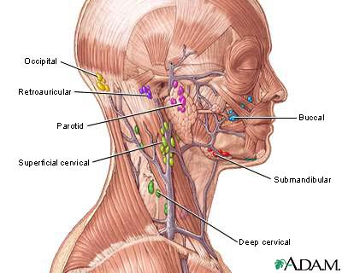
Designed like filters, lymph nodes remove antigens (foreign bodies) from lymph. Each lymph node has several sinuses (inner chambers) that contain lymphocytes. Lymph nodes also contain macrophages that help clear the lymph of bacteria, cellular debris, and other foreign material. Macrophages attack, ingest (engulf), then kill antigens in a process called phagocytosis. Small extensions of the macrophage pull the antigen inside.
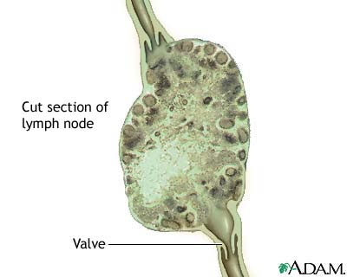
Lymph nodules are groups of lymphocytes arranged in round clusters. Many lymph organs contain lymph nodules within their substances. Unlike lymph nodes, they cannot filter lymph.
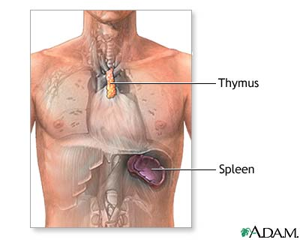
The spleen is the largest lymphoid organ. It has two types of tissue: the red pulp, which contains many red blood cells (erythrocytes) and macrophages; and the white pulp, which stores lymphocytes. The macrophages in the red pulp remove foreign substances and damaged or dead erythrocytes and platelets from the blood. And, the red pulp stores platelets, which are important for blood clotting. The lymphocytes within the white pulp are used for the body immune system.

In the thymus gland lymphocytes become specialized. The thymus plays an important role in lymphocyte specialization and immunity.
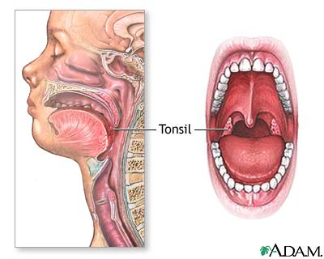
The tonsils are paired lymph nodules in the oral cavity. These patches of lymph tissue produce lymphocytes. The location of each pair (palatine, pharyngeal, and lingual) determines its name. The tonsils protect the throat and respiratory system. Sometimes, the tonsils cannot remove all the invading microorganisms and become infected. If the infection is severe and chronic, the tonsils may require tonsillectomy (surgical removal).

