Basic classification | System name | Organs in the system | Functions
Body coverings
Support and movement
Transport

B Match the body parts with the corresponding adjectives:
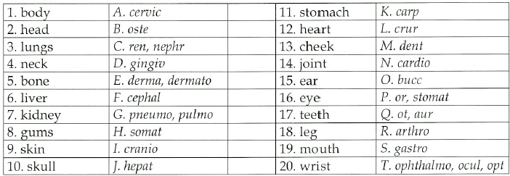
C Put these into plural:
1 bursa 6 analysis
2 alveolus 7 appendix
3 cranium 8 apex
4 carcinoma 9 foramen
5 criterion 10 phalanx

D Complete the text:
