CZECH FOR FOREIGNERS III

**TALKING MEDICINE /LEKCE 1: LIDSKÉ TĚLO I**

[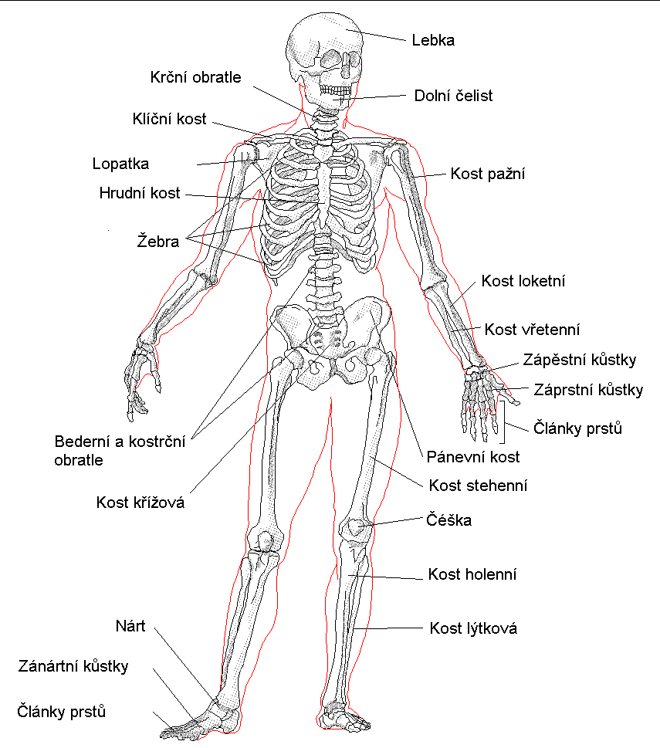](http://www.google.cz/url?sa=i&rct=j&q=&esrc=s&frm=1&source=images&cd=&cad=rja&uact=8&ved=0CAcQjRxqFQoTCJvtsrGdp8gCFUGaFAodRKcAQw&url=http%3A%2F%2Fvsedoskoly.jex.cz%2Fmenu%2Fprirodopois%2Fkostra&psig=AFQjCNEqdjLPCTCm3z1P56KIo8RabSUT1Q&ust=1443993510388697)

[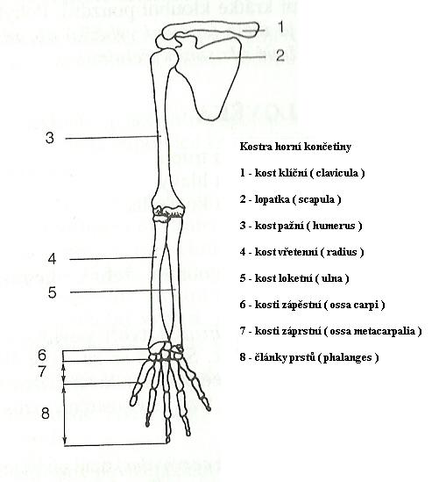](http://www.google.cz/url?sa=i&rct=j&q=&esrc=s&frm=1&source=images&cd=&cad=rja&uact=8&ved=0CAcQjRxqFQoTCJvtsrGdp8gCFUGaFAodRKcAQw&url=http%3A%2F%2Fis.muni.cz%2Fth%2F358587%2Flf_b%2FBakalarska_prace_Katerina_Valentova_tisk2.doc&psig=AFQjCNEqdjLPCTCm3z1P56KIo8RabSUT1Q&ust=1443993510388697)

[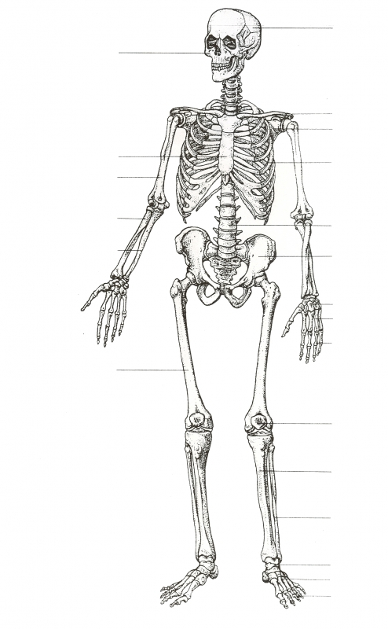](http://skolajecna.cz/biologie/Sources/Photogallery_Textbook.php?intSource=0&intPhotogallerySectionId=10000&intPhotogalleryLastSectionId=10000&intPage=1)

***Translate into Czech.***

|  |  |  |  |
| --- | --- | --- | --- |
| skeleton |  | right elbow |  |
| bone |  | pelvis |  |
| join |  | hip joint |  |
| tendon |  | collar bone/clavicula |  |
| muscle |  | humerus |  |
| cranium |  | cuboid bone/ulna |  |
| vertebra |  | thigh bone/femur |  |
| vertebral column |  | calf bone/fibula |  |
| spinal cord |  | shin bone/tibia |  |

***Translate into Czech.***

|  |  |  |  |
| --- | --- | --- | --- |
| blood |  | sense of sight |  |
| vein |  | sense of hearing |  |
| artery |  | sense of smell |  |
| vessel |  | sense of touch |  |
| valve |  | sense of taste |  |