Clinical haematology worksheet

Blood video
1 Blood is actually a ___________ of cells suspended in a slightly-yellowish __________ called plasma.
2 Plasma is __________ up mostly of water, but it also contains ___________, sugars, hormones and ___________.
3 RBC make up __________ of your blood. They’re round and look a little like a _______________ .
4 Their main job is to ____________ oxygen to the other cells of the body and to take away the carbon dioxide as a ____________ product.
5 RBC only live for __________, but healthy bone marrow produces __________ RBC every hour.
6 WBC fight infection from __________, __________, all those nasty ___________ that can cause disease.
7 When at last they find the invader _______________, they quickly move in for the kill.
8 Platelets are small pieces of _______________ or cytoplasm whose job it is to plug ______________ in a vessel’s walls.
9 Platelets form a plug that stops the loss of blood within _______________ minutes.
10 A platelet plug will last for only ___________________ hours.

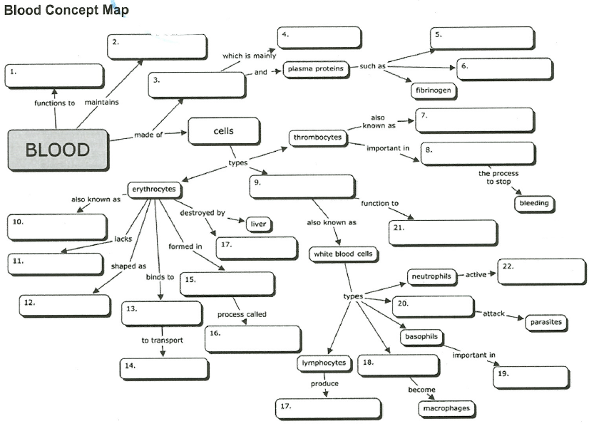

Blood reading
Complete with the words in the box:
concentration parameters bloodstream fluid number differential circulate sample volume characteristics
The complete blood count (CBC) is a test that evaluates the cells that ___ (1) in blood. Blood consists of three types of cells suspended in ___ (2) called plasma: white blood cells (WBCs), red blood cells (RBCs), and platelets (PLTs). They are produced and mature primarily in the bone marrow and, under normal circumstances, are released into the _____ (3) as needed.
A CBC is typically performed using an automated instrument that measures various ____ (4), including counts of the cells that are present in a person's _______ (5) of blood. The results of a CBC can provide information about not only the _______ (6) of cell types but also can give an indication of the physical _______ (7) of some of the cells. A standard CBC includes the following:
- Evaluation of white blood cells: WBC count; may or may not include a WBC _______ (8)
- Evaluation of red blood cells: RBC count, hemoglobin (Hb), hematocrit (Hct) and RBC indices, which includes mean corpuscular volume (MCV), mean corpuscular hemoglobin (MCH), mean corpuscular hemoglobin _______ (9) (MCHC), and sometimes red cell distribution width (RDW). The RBC evaluation may or may not include reticulocyte count.
- Evaluation of platelets: platelet count; may or may not include mean platelet ______ (10) (MPV) and/or platelet distribution width (PDW)

Blood test results and fill-in
Haematology lab report
Full blood count (FBC) | Value | Range | Unit
Haemoglobin (Hb) | 143 | 115-165 | g/L
Haematocrit (HCT) | 0.224 | 0.37-0.47 | L/L
Mean cell volume (MCV) | 72.5 | 78.0-98.0 | fL
White cell count (WCC) | 7.4 | 4.0-11.0 | 10⁹/L
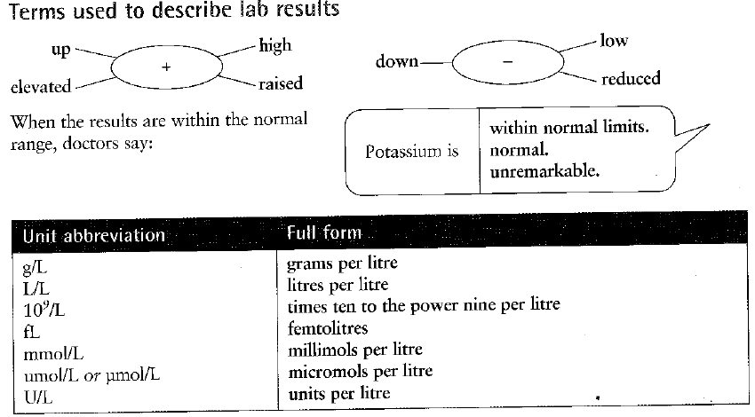
Complete the sentences describing the results of the report above:
1 Haemoglobin is ____________ ____________ _______________, one hundred and forty-three ________ litre.
2 Haematocrit is ______________, 0.224 __________ ______________ litre.
3 Mean cell volume is _______________, 72.5 ___________.
4 White cell count is _____________, 7.4 ______________________________________________

