**1. Listening – In the hospital**

***1. Answer the questions below with your partner, then watch the video and decide if you would like to work in such a hospital and why/why not.***

1. How do you imagine an ideal doctor? What should his/her characteristics be?
2. What do you imagine doing yourself ten years from now? What will your working day look like?

***2. Discuss these questions with your partner then watch the video again and complete the missing answers.***

1. Who is the first scheduled patient and what is his/her health problem?
2. What is the condition of the two sisters in the ward?
3. What research project does Annika participate in?
4. What was wrong with the patient in ICU?
5. What is the cause for the code blue call?

a) a baby girl (Brin), who is 5 months old, suffers from severe cataract since birth

b) they both suffer from cystic fibrosis c) national allergy research project

d) brain stem tumour e) training for doctors, they should treat a mannequin baby for seizure

***3. Complete the words from the listening.***

1. s________ – another word for operative procedure
2. c_______ – a disease of the eye, the clouding of the lens gradually causes vision loss
3. c________ – a physician specializing in the treatment of patients, not in other areas such as research
4. w______ – another word for hospital department
5. I_______ – a hospital department where critically ill or injured people are treated
6. s_______ – convulsion, e.g. an epileptic s. is abnormal activity in the brain
7. m______ – an artificial body for practicing medical procedures
8. life-t______ – a situation that endangers life

surgery, cataract, clinician, ward, ICU-intensive care unit, seizure, mannequin, life-threatening

**2. Hospital staff**

**1. Match the relevant hospital staff to the numbers in the picture, there are two which you do not need.**

[əˈniːsθətɪst]

[ˌkɑːdiːˈɒlədʒɪst]

[kənˈsʌltənt]

[læb tekˈnɪʃən]

[ˈmɪdˌwaɪf]

[ˌpiːdɪəˈtrɪʃən]

[ˌpærəˈmedɪk]

[ˈfɑːməsɪst]

[ˌfɪzɪəʊˈθerəpɪst]

[ˈpɔːtə]

[ˌreɪdɪˈɒlədʒɪst]

[rɪˈsepʃənɪst]

[skrʌb nɜːs]

[ˈdentɪst]

[ˈsɜːdʒən]

[fɪˈzɪʃən]

[ˈdʒenrəl prækˈtɪʃənə]

[ˌɒbsteˈtrɪʃən]

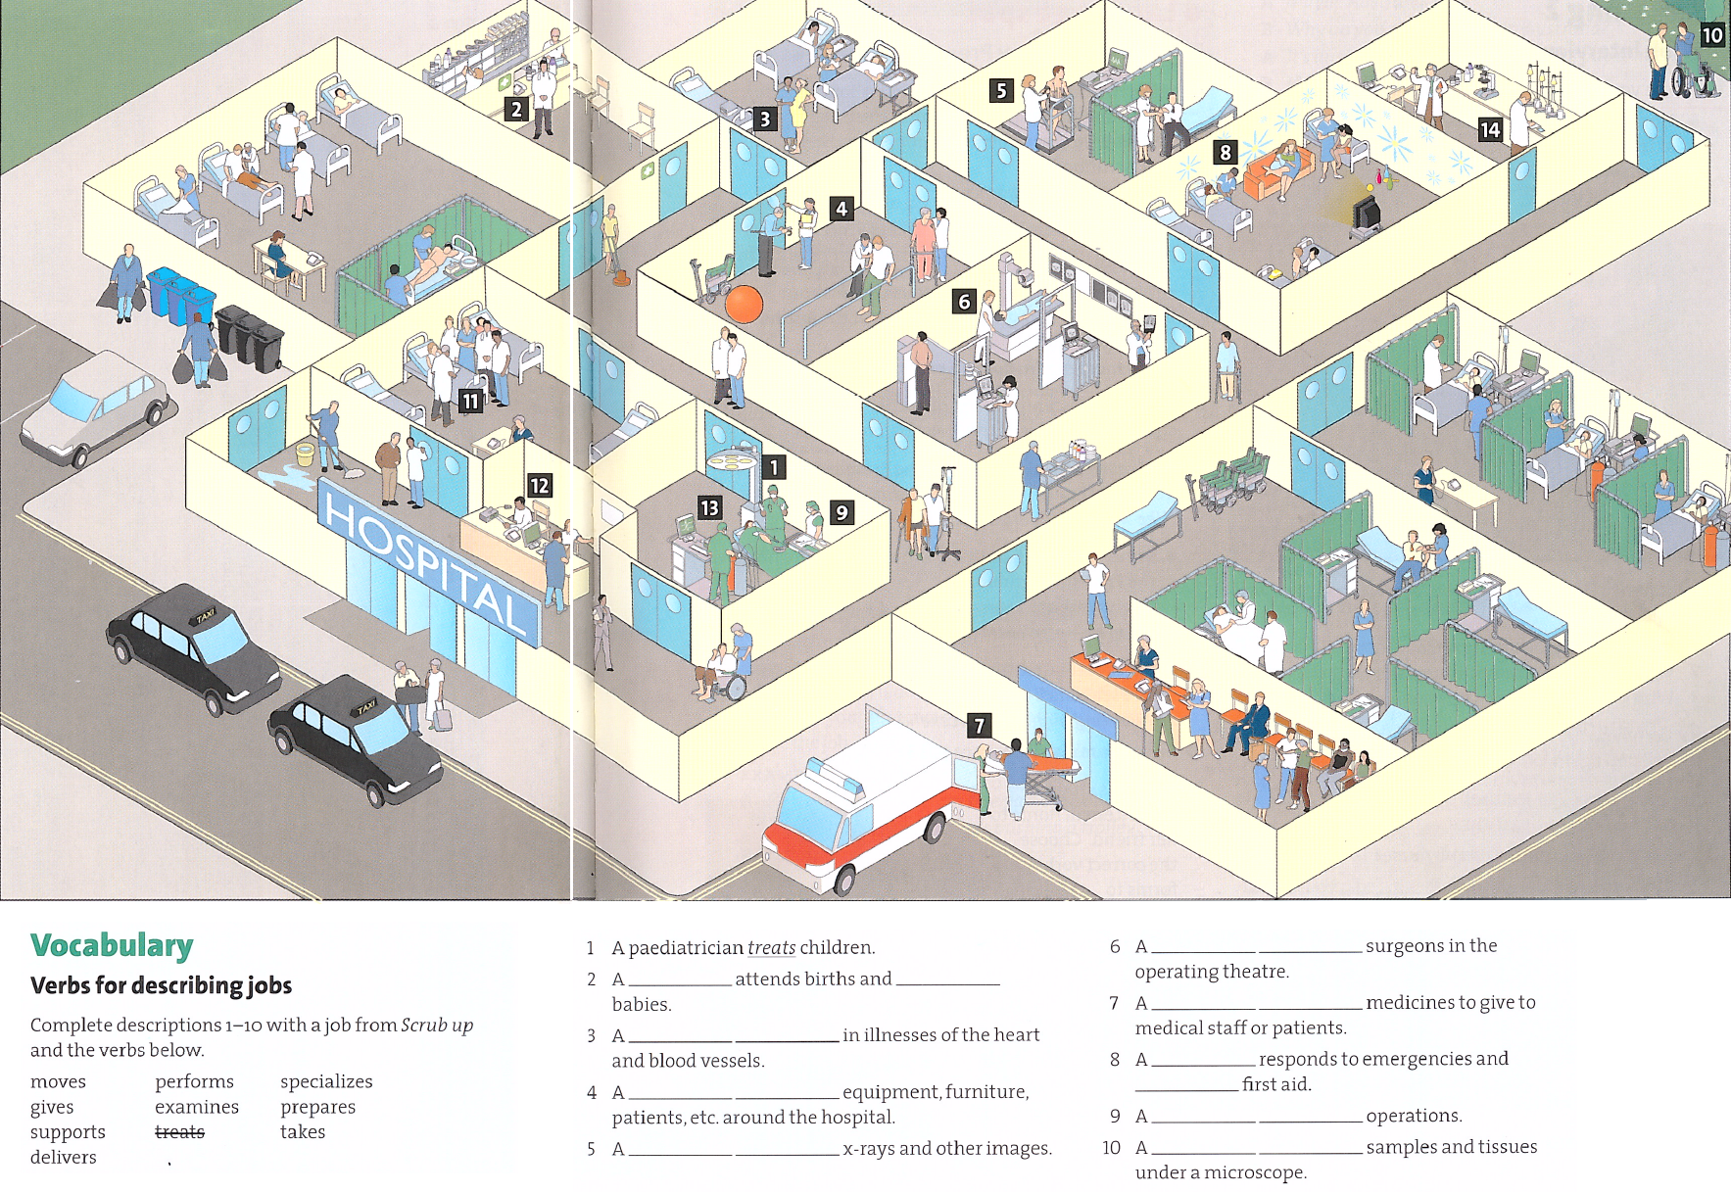

Key: Vocabulary 2. midwife (an obstetrician), delivers; 3. cardiologist, specializes; 4. radiologist, takes; 5. scrub nurse, supports; 7. pharmacist, prepares; 8. paramedic gives; 9. surgeon performs; 10. lab technician, examines

**General**

inpatients

outpatients

consulting room

operating theatre

ward (e.g. isolation ward)

ward round

walker

crutches

wheel chair

ambulance

stretcher

drip feed

X-rays

ultrasound

trolley

**Departments**

A&E Accident and emergency

Anaesthesiology

Cardiology

Dermatology

Ear nose and throat (ENT)

Gastroenterology

General surgery

Gynaecology

Haematology

ICU Intensive care unit

Neurology

Nutrition and dietetics

Obstetrics

Oncology

Ophthalmology

Orthopaedics

Paediatrics

Pathology

Pharmacy

Physiotherapy

Radiotherapy

Renal unit (Nephrology)

Urology

**4. IPPA**

***1. Read the text and complete the missing words.***

When you perform 1.___ physical assessment, you will use four techniques: inspection, palpation, percussion, and auscultation. Use them in this sequence unless you 2. ___ performing an abdominal assessment. Palpation and percussion can alter bowel sounds, so you would inspect, auscultate, percuss, and then palpate an abdomen.

1. Inspection – Inspect 3. ___ body system using vision, smell, and hearing 4. ___ assess normal conditions and deviations. Assess for colour, size, location, movement, texture, symmetry, odours, and sounds.

2. Palpation requires 5. ___ to touch the patient with different parts of your hands, using varying degrees 6. ___ pressure. Because your hands are your tools, keep your fingernails short and your hands warm. 7. ___ gloves when palpating mucous membranes or areas in contact with body fluids. Palpate tender areas last.

3. Percussion involves tapping your fingers or hands quickly and sharply against parts of the patient's body to help you locate organ borders, identify organ shape and position, and determine 8. ___ an organ is solid or filled 9. ___ fluid or gas. 10. ___ is a direct and indirect percussion. To carry 11. ___ indirect percussion:

▪ Press the distal part of the middle finger of your nondominant hand firmly 12. ___ the body part.

▪ Keep the rest of your hands off the body surface.

▪ Flex the wrist of your nondominant hand.

▪ Using the middle finger of your dominant hand, tap quickly and directly over the point where your other middle finger touches the patient's skin.

▪ Listen to 13.___ sounds produced.

4. Auscultation involves listening for various lungs, heart, and bowel sounds with a 14.___.

▪ Provide a quiet environment.

▪ Make sure the area to 15.___ auscultated is exposed (a gown or bed linens can interfere 16.____ sounds.)

▪ Warm the stethoscope head in your hand.

▪ Close your eyes 17._____ help focus your attention.

1 a, 2 are, 3 each, 4 to, 5 you, 6 of, 7 wear, 8 if, 9 with, 10 there, 11. out. 12. on, 13. the, 14. stethoscope, 15. be, 16. with, 17. to