*Exercise 1*

at, from, in, with, in, with, at, at

***Vocabulary***

**1. Look at these adjectives. Do you know the meaning of all of them? With your partner create sentences with each of them and if possible find an antonym and form a noun.**

efficient

oxygen-enriched

digestible

consciously controlled = voluntary

fatigued = worn out=exhausted

responsible

connective

possible

suggested answers

efficient - inefficient, efficiency

oxygen-enriched – oxygen-deprived (oxygen-poor), deoxygenated, with low level of oxygen; (oxygen-enrichment)

digestible - indigestible, digestion, digestivity

!digested (undigested) vs. digestible

consciously controlled=voluntary - unconsciously, consciousness; involuntary, volunteer, voluntariness

fatigued=worn out=exhausted - lively, fresh, energetic; fatigue, exhaustion

responsible - irresponsible, responsibility

connective - disconnective; connection, connectivity

possible - impossible, possibility

**Verbs: do you see any synonyms or near synonyms?**

take in

absorb

dispose of

consist of

be composed of

allow

nourish

comprise

made up of

remove

add

bite

clot

exhale

permit

breathe (!breath)

expel

chew

affect

stop bleeding

excrete

influence

feed

inhale

take in and absorb dispose of, remove, expel, excrete

consist of, be composed of, comprise, be made up of allow, permit nourish, feed bite, chew clot, stop bleeding exhale, breathe, inhale affect, influence

1. **Body cavities**

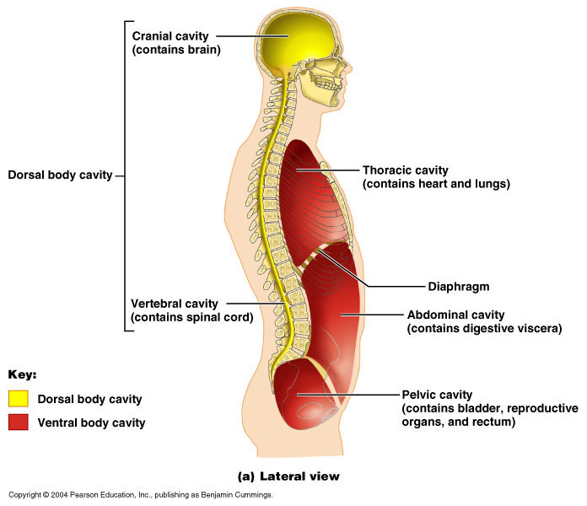

1. **Body Planes**

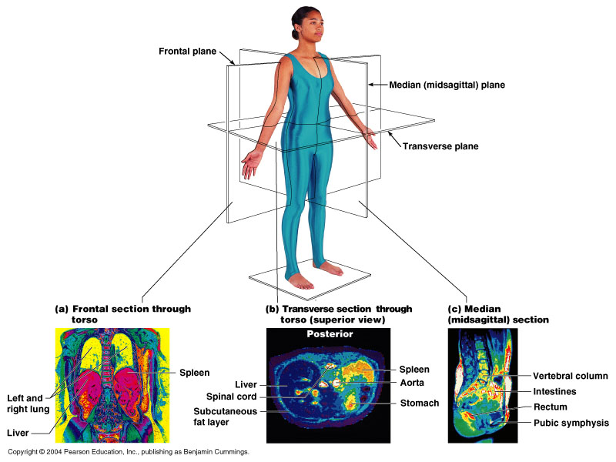

1. **Directional terms**

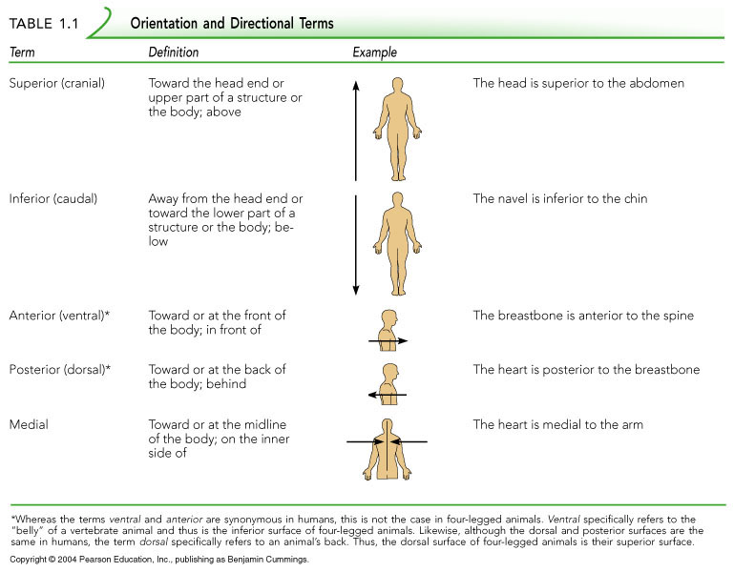

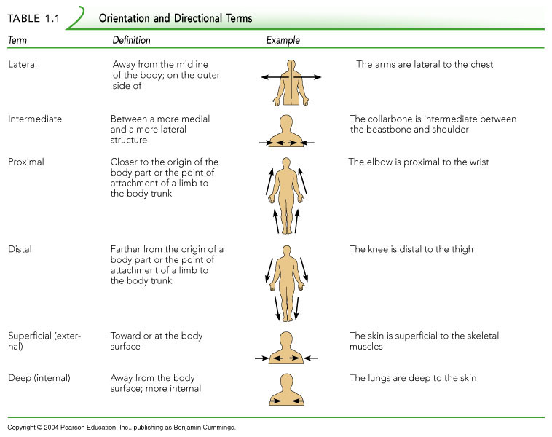

http://homepage.smc.edu/wissmann_paul/anatomy1textbook/1anatomytextch1.html

|  |  |  |  |  |
| --- | --- | --- | --- | --- |
| abdomen | abdominal |  | front of elbow | antecubital |
| arm | brachial |  | groin | inguinal |
| armpit | axillary |  | head | cephalic |
| back | dorsal |  | hip | coxal |
| back of head | occipital |  | cheek | buccal |
| back of knee | popliteal |  | chest | pectoral |
| between hips | sacral |  | chin | mental |
| breast | mammary |  | instep | tarsal |
| breastbone | sternal |  | leg | crural |
| buttocks | gluteal |  | lower back | lumbar |
| ear | otic |  | navel | umbilical |
| elbow | cubital |  | neck | cervical |
| finger | digital |  | reproductive organs | genital |
| foot | pedal |  | sole | plantar |
| forearm | antebrachial |  | spinal column | vertebral |
| forehead | frontal |  | thigh | femoral |
|  |  |  | wrist | carpal |

2. Complete the sentences:

The ___ventral (abdominal and pelvic)_______ cavity contains the digestive, excretory, and reproductive organs.

The ____dorsal/vertebral______ cavity contains the spinal cord.

The ___ventral/thoracic_______ cavity contains the heart, lungs, and associated structures.

The ____dorsal/cranial______ cavity contains the brain.

3. Complete the sentences:

The ____median/midsagittal______ plane divides the body into a right and left half.

The ____transverse/horizontal/cross-section______ plane divides the body/organs into upper and lower portions.

The ____sagittal/parasagittal______ plane divides the body into an unequal right and left side.

The ___frontal/coronar_______ plane divides the body into an anterior and posterior portion.

3. Match the corresponding terms and their directions.

1-L, 2-H, 3-D, 4-G, 5- F, 6-J, 7-I, 8-C, 9-E, 10-B, 11-K, 12-A

**5. see the table above**