**Circulatory quiz**

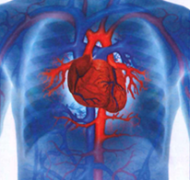

**1. How much does an average adult heart weigh?**

A. 225 grams B. 450 grams C. 900 grams

**2. Which heart rate is normal for a resting newborn baby?**

A. 80bpm B. 140 bpm C. 180bpm

**3. How much blood do we have in our bodies?**

A. 5 liters b. 7 liters C. 9 liters

**4. How long does it take for the blood to get around the body when the person is resting?**

A. 20 seconds B. 60 seconds C. 120 seconds

**5. What percentage of blood is water?**

A. 62% B. 78% C. 88%

**6. What causes the ‘lub DUB lub DUB’ sounds that you hear through the stethoscope?**

A. blood leaving the ventricles

B. electrical impulses

C. opening and closing valves

**7. What should the maximum heart rate be for a twenty-year old when exercising?**

A. 160 bpm B. 200 bpm C. 240 bpm

**8. Whose hearts beat faster?**

A. women’s B. men’s C. both the same

**9. When was the first successful heart translation carried out?**

A. 1947 B. 1967 C. 1987

**10. What percentage of the body’s blood is held in the heart at any moment?**

A. 7% B. 17 % C. 70%

1A, 2B, 3A, 4B (70 millilitres/heartbeat * 75 heartbeats a minute=5250 ml, 5b, 6c, 7b, 8a, 9b, 10 A

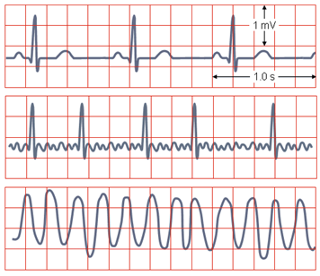**Talk to your partner. What is in the picture, and how does it relate to the cardiovascular system?**

***1. Match the words with their synonyms or definitions***

1-i, 2-m, 3-l, 4-c, 5-a, 6-d, 7-b, 8-e, 9-j, 10g, 11-h, 12-f, 13-k

**2. Listen, answer the questions and describe the curve. What happens in the individual phases?**

Key a) action potential, electrical activity of the heart, b) ECG/EKG

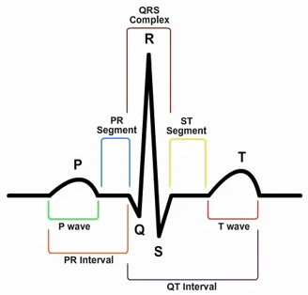Any beat begins in the right atrium, SA (sinoatrial) node sends action potential

P wave - atrial systole - depolarization and contraction of atrial muscle cells

PR segment - time after atrial systole and before contraction of ventricles, electrical signals enter the ventricles via AV (antrioventricular) node in interatrial septum,

QRS complex - ventricular systole- el. signal goes to the Bundle of His, Bundle branches, Purkinje fibres, ventricular muscles depolarize and contract very rapidly. Atrial repolarisation is hidden, but occurs as well

ST segment - signal passes out of the ventricles, which start to relax

T-wave - ventricular diastole

ST segment - ventricles are depolarized

QT - de- and repolarisation of the ventricles

**Patient care** 1. d, 2. c, 3g, 4e, 5a, 6f, 7b

***3. Listening: answer the following questions.***

See the transcript

***4. Complete the gaps according to what you have heard in the listening.***

See the transcript

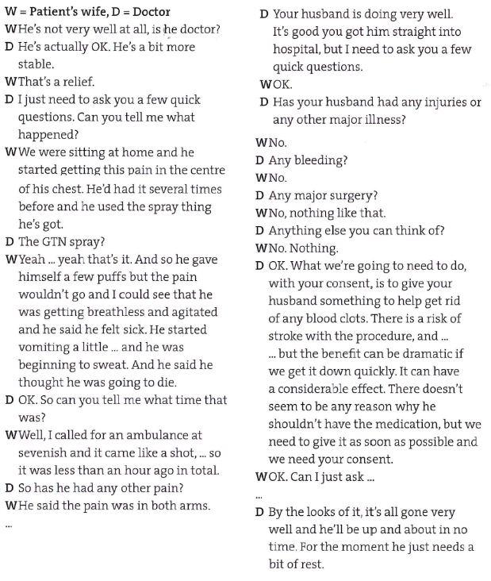

1. 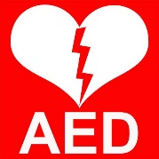What does the abbreviation AED stand for?
2. What is the difference between heart attack and sudden cardiac arrest?
3. What are the chances that defibrillation will be successful after 2, 4, 8 and 11 minutes? Have a guess.
4. automated external defibrillator
5. SCA is often confused with a heart attack, but in reality is a separate crisis in itself. Heart attack is a plumbing problem usually caused by a blocked artery; however, cardiac arrest is an electrical problem where the heart is not pumping oxygenated blood to vital organs. http://www.aeds.com.au/Sudden-Cardiac-Arrest.html

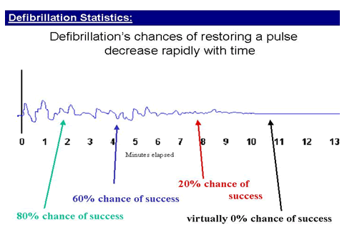

**Complete the parts of the text that were left out:**

a) such as a pacemaker or implantable defibrillator

b) give another shock

c) shout and shake the person to confirm consciousness

d) and away from puddles or water

e) until emergency help arrives

f) push

g) wipe

h) resume

i) If absent or irregular

j) if possible

**1. Check Responsiveness**

* For an adult or older child, 1 _____. Do not use AED on a conscious person.
* For an infant or young child, pinch skin. Never shake a young child.

Continue reading below...

* Check breathing and pulse. 2______, prepare to use AED as soon as possible.

**2. Prepare to Use AED**

* Make sure the person is in a dry area 3______.
* Check for body piercings or outline of an implanted medical device, 4.____.
* AED pads must be placed at least 1 inch away from piercings or implanted devices.

**3. Use AED**

For newborns, infants, and children up to age 8, use a pediatric AED, 5._____. If not, use an adult AED.

* Turn on the AED.
* 6. ____ chest dry.
* Attach pads.
* Plug in connector, if necessary.
* Make sure no one is touching the person.
* 7.____ “Analyze” button.
* If a shock is advised, check again to make sure no one is touching the person.
* Push “Shock” button.
* Start or 8._____ chest compressions.

**4. Continue CPR After Using AED**

* After 2 minutes of CPR, check the person’s heart rhythm. If it’s still absent or irregular, 9._____.
* If a shock isn’t needed, continue CPR 10. _____ or the person begins to move.
* Stay with the person until help arrives.

**1. Check Responsiveness**

* For an adult or older child, shout and shake the person to confirm consciousness. Do not use AED on a conscious person.
* For an infant or young child, pinch skin. Never shake a young child.

Continue reading below...

* Check breathing and pulse. If absent or irregular, prepare to use AED as soon as possible.

**2. Prepare to Use AED**

* Make sure the person is in a dry area and away from puddles or water.
* Check for body piercings or outline of an implanted medical device, such as a pacemaker or implantable defibrillator.
* AED pads must be placed at least 1 inch away from piercings or implanted devices.

**3. Use AED**

For newborns, infants, and children up to age 8, use a pediatric AED, if possible. If not, use an adult AED.

* Turn on the AED.
* Wipe chest dry.
* Attach pads.
* Plug in connector, if necessary.
* Make sure no one is touching the person.
* Push “Analyze” button.
* If a shock is advised, check again to make sure no one is touching the person.
* Push “Shock” button.
* Start or resume chest compressions.

**4. Continue CPR After Using AED**

* After 2 minutes of CPR, check the person’s heart rhythm. If it’s still absent or irregular, give another shock.
* If a shock isn’t needed, continue CPR until emergency help arrives or the person begins to move.
* Stay with the person until help arrives.

***Future:***

1) will be (is going to be), 2) will be sent, 3) will soon move, 4) will have been (will be), 5) will be walking, 6) Will he be able, 7) will he have had, 8) is coming/comes, will see/will be seeing

***Instructions***

suggested answers: 1d, 2b, 3e, 4a, 5c

You are a paramedic and you have just got a call. The person calling, Nina, found someone with a sudden cardiac arrest. Prepare instructions so that you can talk her through the procedure of giving CPR and using AED.

**A song for you:**

https://www.youtube.com/watch?v=mDSFxcf2UgQ

**The future**

There are several ways of talking about future:

|  |  |
| --- | --- |
| 1. SIMPLE FUTURE  will + verb (will go) | A. something that has been planned or arranged |
| 2. PRESENT SIMPLE  verb (go, goes) | B. an action which leads up to a given point in the future but is not necessarily finished at that point |
| 3. PRESENT CONTINUOUS  be + verb+ing (is going) | C. talking about future after **if**, **before**, **after**, **as soon as**, **when** and future timetabled events |
| 4. FUTURE CONTINUOUS  will + be + verb+ing (will be going) | D. an action that will have finished at a given point in the future |
| 5. FUTURE PERFECT  will + have + verb in PP  (will have gone) | E. the future in general and in main clause of a first conditional sentence |
| 6. FUTURE PERFECT CONTINUOUS  will + have + been + verb+ing  (will have been going) | F. action that will be happening at a given point in the future |
| 7. Going to | G. for talking about personal plan or intention, for making prediction, especially when this has already started to happen; for decision about the future |

Can you make an example for each of these possibilities?

1. WILL=SIMPLE FUTURE - the future in general and in main clause of a first conditional sentence

*The presentation will finish at about 4 o’clock.*

*If it finishes earlier, there will be more time for questions.*

2. PRESENT SIMPLE - talking about future after **if**, **before**, **after**, **as soon as**, **when**

- future timetabled events

*When he gets here, could you let me know?*

*Dr Carlin’s train leaves London at 1:30 and gets into Oxford at 2:10.*

3. PRESENT CONTINUOUS - something that has been planned or arranged

*We are sending out invitations over the next couple of weeks.*

4. FUTURE CONTINUOUS - an action that will be happening at a given point in the future

*This time next week, you will be flying back to the USA.*

5. FUTURE PERFECT - an action that will have finished at a given point in the future

*By the end of the year you will have learned enough English to be able to work in a hospital.*

6. FUTURE PERFECT CONTINUOUS - an action which leads up to a given point in the future but is not necessarily finished at that point

*This is a long presentation. By five o’clock, Dr Schwartz will have been talking for an hour and half.*

7. Going to + infinitive – for talking about personal plan or intention, for making prediction, especially when this has already started to happen; for decision about the future

For more look at the Future – basic and advanced