***1. Match the words with their synonyms or definitions***

|  |  |
| --- | --- |
| 1. action potential | 1. to describe |
| 1. trace | 1. to cause |
| 1. propagation | 1. “production” |
| 1. generation | 1. An electrical device that has electrodes attached to the heart to electrically stimulate the heart to beat normally. |
| 1. to depict | 1. the transmission of something, e.g. an electrical signal |
| 1. pacemaker | 1. to happen |
| 1. to induce | 1. a small mass of tissue in the form of a swelling or a knot |
| 1. conduction | 1. a dividing wall |
| 1. to proceed | 1. A brief electrical signal transmitted along a nerve or muscle fiber following stimulation |
| 1. node | 1. to continue |
| 1. septum | 1. the combination of two or more things, merging |
| 1. to occur | 1. spreading |
| 1. amalgamation | 1. a visible mark, such as a footprint; evidence or an indication of the former presence or existence of something |

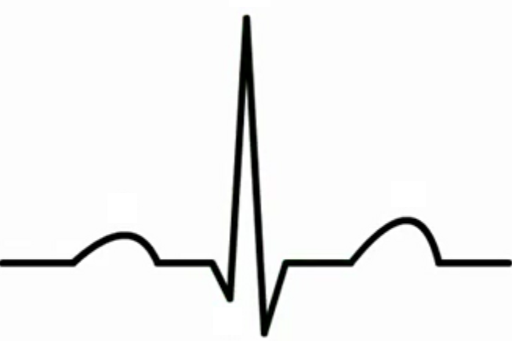**2. Listen, answer the questions and describe the curve. What happens in the individual phases?**

a) The contraction of the heart muscle is caused by __________.

b) The abbreviation for electrocardiogram is ___________ or _____________.

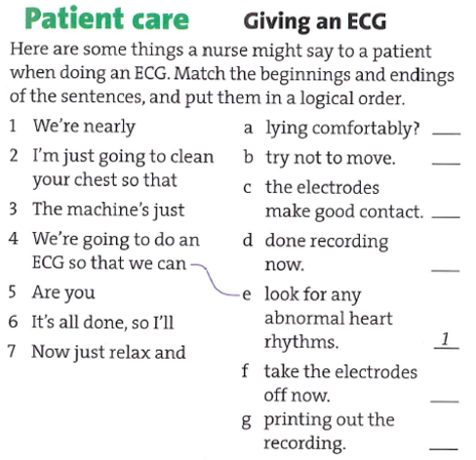

***3. Listening: answer the following questions.***

Where did he have the pain?

What symptoms did he have?

When did they call the ambulance?

Did he have any major surgery?

What are the pros and cons of the treatment the doctor suggests?

***4. Complete the gaps according to what you have heard in the listening.***

D: He’s actually OK. He is a bit more stable.

W: That’s a _____________.

W: We _____________ (sit) at home and he _____________ (start) getting this pain in the centre of his chest. He _____________ (have) it several times before and he _____________ (use) the spray thing he has got.

W: And so he _____________ (give) himself a few puffs but the pain wouldn’t go and I _____________ (can) see that he _______________ (get) breathless and agitated…

D: What we’re going to do, with your _____________ , is to give your husband something to help get rid of any _____________ …

D: By the looks of it, it’s all gone very well and he’ll be _____________ in no time. …

