***1. The lymphatic system video: Look at the questions and answer them, then watch the video to see whether you answers were correct.***

1. Why is sometimes the lymphatic system referred to as the immune system?
2. Where is the excessive fluid which leaks during diffusion collected?
3. What happens to lymph in lymph nodes?
4. Why do doctors feel your lymph nodes when they examine you?
5. Where is the thymus located and what is its function?
6. Which lymphatic organ helps the organism to get rid of old red blood cells?
7. How can spleen help you if you are haemorrhaging?
8. What makes the lymph move?

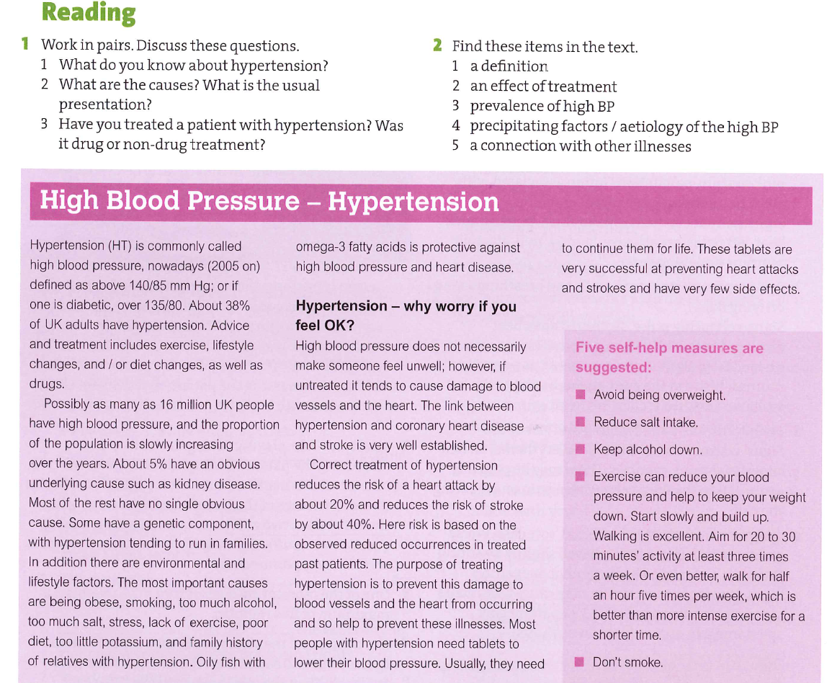

***3. Patient with hypertension***

You have a patient with hypertension. Her name is Ms Sweet, she is 52 years old. She is 162 cm tall and weighs 112 kg. She enjoys eating junk food, and gave up swimming 5 years ago because she has too much work both in her job and at home. She is an occasional smoker and cannot live with at least 5 cups of coffee a day. What would you recommend to her?

***4. Match the parts of sentences below and finish them so that you give advice to Ms Sweet. Which of these sentences are suggestions and which ‘strong advice’?***

You will need of -ing

Have you ever tried to…

Have you ever thought and do…

I would strongly have to…

It is better for to stop -ing

You might want to…

You could try you if you…

You are going to advise you to…

***5. Complete each sentence with a word made from the word given in brackets.* *The word must be spelled correctly.***

1. The lymphatic system engages in ____­­­____________ of fats. (ABSORB)
2. Aortic valve stenosis is a disease caused by ____­­­____________ opening of the aortic valve. (COMPLETE)
3. Atherosclerosis is a general term for ____­­­____________ of the arteries. (HARD)
4. It endangers a person’s life if ____­­­____________ materials accumulate on the walls of arteries. (FAT)
5. A stroke may cause memory ____­­­____________ (LOSE), speech ____­­­____________ (IMPAIR) or even ____­­­____________ (DIE).
6. The rupture of atherosclerotic plaque may cause ____­­­____________ of a coronary artery. (BLOCK)
7. Heart attack often presents as chest pain, ____­­­____________ (SHORT) of breath and ____­­­____________ (ANXIOUS).
8. Hypertension may cause kidney ____­­­____________ (FAIL).
9. ____­­­____________ heart disease affects the heart muscle. (INFLAME)

***6. Language of discussion***

Expressing opinion Clarifying your ideas

Agreeing Disagreeing