**Key: Digestive system disorders**

**Answer the questions:**

What are cavities and how can we treat them?

What is a gastric ulcer?

What are the symptoms of cirrhosis?

How large can a gallstone be?

**Find equivalents for the words in the reading “Digestive system”:**

large intestine, stools, sphincter, appendix, masticate, carbohydrates, oesophagus, deglutition, trachea

Key

large intestine - colon

stool - faeces

sphincter - muscular ring

appendix - blind gut

masticate - chew

carbohydrates - starches

oesophagus - gullet

deglutition - swallowing

trachea - windpipe

**Match the words with their definition:**

|  |  |
| --- | --- |
| **pulp** | a) dental carries |
| **chill** | b) to clean, purify |
| **fatigue** | c) being tired, exhausted |
| **enamel** | d) to expel stomach gas noisily through the mouth |
| **binge eating** | e) the feeling of being sick, sometimes involves vomiting |
| **to purge** | f) likely to suffer from a particular illness |
| **laxatives** | g) a part of a tooth that is disrupted before dental caries arise |
| **pus** | h) belly button |
| **to irritate** | i) to hurt a part of your body, making it painful, red, or swollen |
| **to burst** | j) a thick yellow liquid that forms in flesh that has an infection |
| **cavities** | k) “to explode” |
| **susceptible to** | l) attractive and interesting, pleasant |
| **nausea** | m) pills that stimulate bowel movements |
| **appealing** | n) runny (liquid) faeces |
| **heartburn** | o) the inside of a tooth |
| **to belch** | p) eating too much at once, usually junk food |
| **diarrhoea** | q) a feeling of cold, with shivering |
| **navel** | r) a type of indigestion, the burning sensation eases by eating baking soda (sodium bicarbonate) |

Key

|  |  |  |
| --- | --- | --- |
| **pulp** | | the inside of a tooth |
| **chill** | | a feeling of cold, with shivering |
| **fatigue** | | being tired, exhausted |
| **enamel** | | a part of a tooth that is disrupted before dental caries arise |
| **binge eating** | | eating too much at once, usually junk food |
| **to purge** | | to clean, purify |
| **laxatives** | | pills that stimulate bowel movements |
| **pus** | | a thick yellow liquid that forms in flesh that has an infection |
| **to irritate** | | to hurt a part of your body, making it painful, red, or swollen |
| **to burst** | | “to explode” |
| **cavities** | | dental carries |
| **susceptible to** | | likely to suffer from a particular illness |
| **nausea** | | the feeling of being sick, sometimes involves vomiting |
| **appealing** | | attractive and interesting, pleasant |
| **heartburn** | | a type of indigestion, the burning sensation eases by eating baking soda (sodium bicarbonate) |
| **to belch** | to expel stomach gas noisily through the mouth | |
| **diarrhoea** | runny (liquid) faeces | |
| **navel** | belly button | |

***Complete the correct preposition***

As an individual ages, body systems became susceptible to disease.

This eating disorder occurs chiefly in women.

Tooth decay results from the action of bacteria that live in the plague.

Before 1980’s, it was believed that ulcers were caused by several factors which resulted in excess stomach acid.

Alcohol interferes with the absorption of nutrients.

Diabetes mellitus patients break down stored fat for energy with difficulty.

The condition of developing gallstones tends to run in families.

The sores are generally referred to as peptic ulcers.

Duodenal ulcers account for about 80 % of all digestive ulcers.

***Complete the text with a word made from the word given in brackets.***

See the reading + check pronunciation of the words e.g. on http://www.howjsay.com/

**Diabetes**

What do you know about diabetes, its symptoms and treatment?

Do you know anyone with diabetes?

***Listening. Listen to the talk on diabetes and answer the questions.***

6%; energy and growth; level of sugar/glucose; thirsty; obesity; the immune system; juvenile; women with personal or family history of diabetes or those of non-Caucasian origin

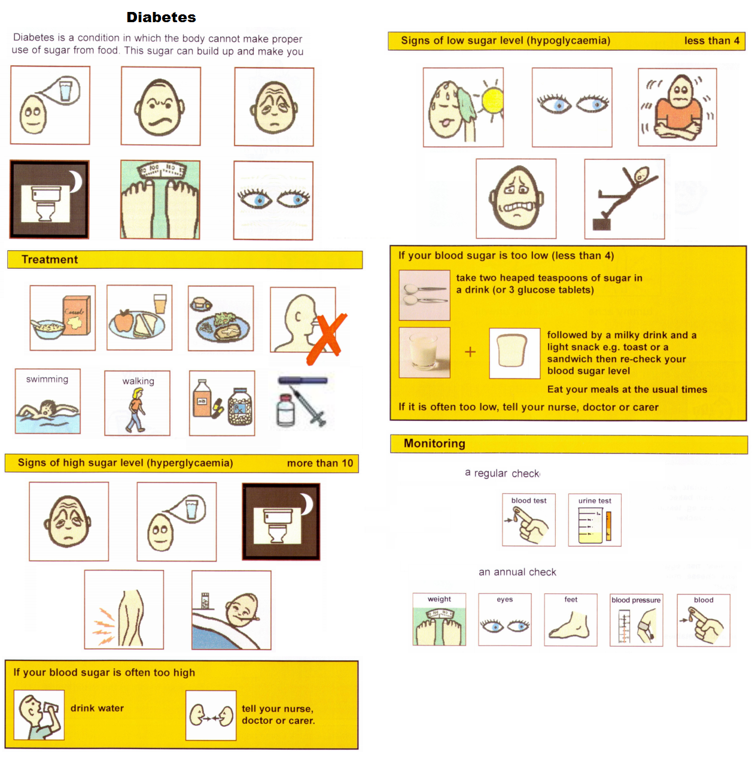

stomach ache moody tired regular meals thirsty diabetic pen blurred vision loss of weight going to the toilet a lot headache good food regular activity medication syringe feeling unwell

**Passive**

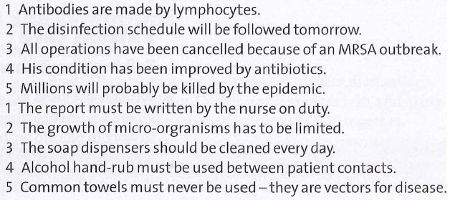

**3. Complete *with* wherever possible, otherwise by:**

The patient was hit by a car.

During the robbery, an old lady was hit with a baseball bat.

The window was broken with a stone.

Several buildings were damaged by the hurricane.

The patient was cured by the new medication.

We use with for objects which perform an action, the object is used deliberately for a purpose.

We use by for persons or for objects to show that the action carried out was accidental.

***4. Rewrite the sentences so that you start with the words given.***

The patient with gastritis is being looked after.

The policemen were shot at.

Your blood sample was carried away by the nurse.

Jane was made to write the test again.

The doctors were made to work 20 hours shifts.

***5. Transform these sentences with the respective form of the verb “to have” and do not use the underlined words.***

I have my blood measured twice a day.

I can’t talk to you now, I am having my tooth taken out/removed.

Karin has her nose altered.

He had his appendix removed.

Tim had his nose broken while…

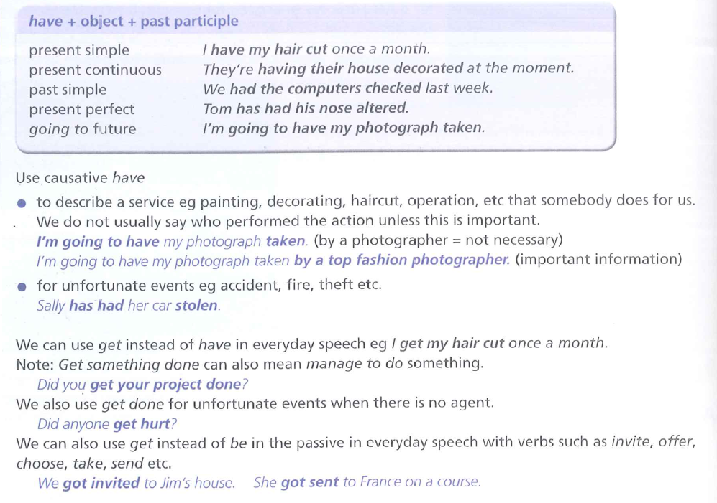

For more on passives look at xBasic passive and x Advanced passive