Make sure that you know these words:

MUCOUS MEMBRANE

URETHRA

DANDRUFF

SEBACEOUS GLAND

GROIN

CLAWS

RICKETS

TO SHIVER

LAYER

NERVE ENDING

PIMPLE

SWEAT GLAND

SCALES

ARMPIT

PATCH

NAIL BED

TO CONSTRICT

SUFFICIENT

1. Describe the pictures.

2. What physical function does the skin perform?

mole, birth mark, goose pimples, Braille’s script, sweat,…

**1. Complete the correct preposition:**

1. Skin is structurally distinct ____from___ mucous membranes.
2. Hair follicles are lined ____with____ cells that synthesise the proteins that form hair.
3. Eccrine glands are linked __to___ the sympathetic nervous system.
4. Hair, horns and nails are derived ___from__ skin.
5. Nails consist ___of__ keratinized epidermal cells.
6. The primary function of skin is to serve __as___ a barrier.
7. Skin damaged ___by__ burns is less effective __at___ preventing fluid loss, often resulting __in__ a possibly life threatening problem if not treated.

**2. Fill in the word in brackets in the appropriate form.**

1. Genetics controls some features of hair: ___baldness_____ /bald/ and texture.
2. Nail bed is ____thickened_____ /thick/ to form a lunula.
3. Skin functions include _____protection_____ /protect/, ______regulation_____ /regulate/ of body temperature and ____sensory_____ /sense/ reception.
4. Skin prevents water and extracellular fluid ____loss____ /lose/.
5. Melanocytes protect from the _____damaging______ /damage/ effects of ultraviolet radiation.
6. When a microbe penetrates the skin the ____inflammatory_______ /inflame/ response occurs.
7. Water can be lost due to ____evaporation_______ /evaporate/.
8. The hypothalamus also causes ___dilatation____ /dilate/ of the blood vessels of the skin.

**Types of questions**

Have you been working hard?

Yes, I have been working hard.

What time does the film begin?

The film begins at 8 o’clock.

How many people came to the meeting?

10 people came to the meeting.

Who do you want to speak to?

I want to speak to the doctor

Which job has Ann applied for?

Ann has applied for the job at Mercy’s hospital.

2) Use the cues to make questions

a. Have you fallen over?

b. Are you hurt? Did you hurt yourself?

c. What do you think is the problem?

d. Who was/is around when pain set/sets in?

e. Could you describe what happened to me?

f. How long have you had the chest pain? (looking at the patient holding his chest)

g. Are there any other things you would like to talk about?

h. What else are you concerned about?

i. What colour was the phlegm colour?

The skin

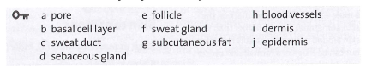

Phrasal verbs



Listening

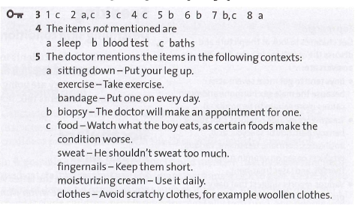

Transcript

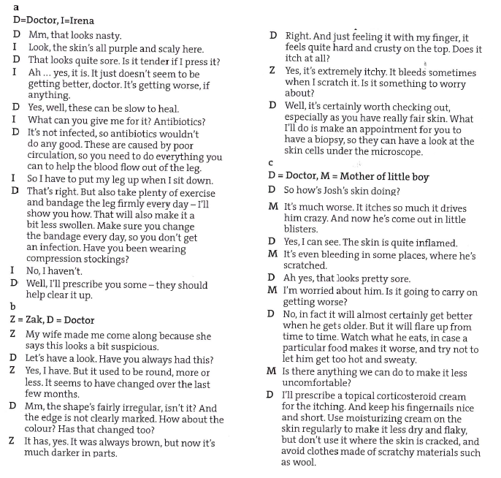

Burns

Have you ever got burned or scalded? How did you treat your injury?

Do you know anyone with severe burns?

What might be the feelings of a burn survivor?

How can doctors/nurses help him or her to adapt?

Reading

