Gastrointestinal system anatomy

Reading revision

A Listen and write the medical term for:
1 mouth and gullet
2 process of chewing and breaking down of food
3 portion of chewed food
4 process of changing food into substances you need
5 rhythmic contractions of the muscle layers
6 flowing back of the liquid contents of the stomach

7 the muscular output of the stomach
8 folds (in the stomach)
9 thick fluid-like substance of partly digested food
10 liver cells
11 small ducts
12 passing faeces

B Highlight the key word(s) in each question and give an answer.

What are the parts of the stomach?
Which enzymes are mentioned?
What happens in the duodenum?
What happens in the jejunum?
What does the bicarbonate in the pancreatic juice do?
What are the main functions of the liver?
Where is the ileocecal valve? What is its function?
What is the main function of the large intestine?
Which enzyme is mainly present in saliva?
Which part of the DS prevents reflux of the stomach contents?
What is the function of the minor and major papillae?
Where is the bile stored?
Where do the common bile duct and the pancreatic duct join?
Describe the parts of the large intestine.
What are the hepatic and splenic flexures?

Physical examination
A In pairs, think about WHY physical examination is done. WHAT does it include? HOW do you prepare for it as a patient?

B Match the verbs with the various objects or parts of the body:
1 take off a) a deep breath
2 strip to b) your wrist
3 lie on c) your arm
4 give me d) your clothes
5 straighten e) your arms by your sides
6 stick out f) the couch/table
7 hold g) your breath
8 take h) the waist
9 put i) your tongue

C Match the instructions in column A with the phrases which should follow them in column B.
A B
1 I’d like to examine you. a) Stick your tongue out for me.
2 Give me your wrist. b) Look up for me, please.
3 Let’s take your blood pressure. c) Would you take off your clothes.
4 Let’s take a look at your eyes. d) Breathe out quietly.
5 Turn your head. e) I’m going to take your pulse.
6 Open your mouth. f) I want to check the pulse in your neck.
7 I want to listen to your heart. h) Will you straighten your arm for me, please.

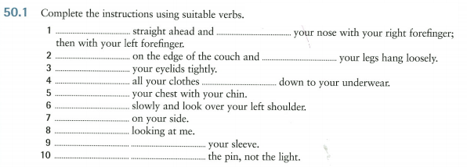

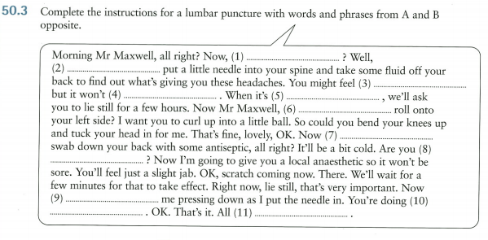

Physical examination – abdomen
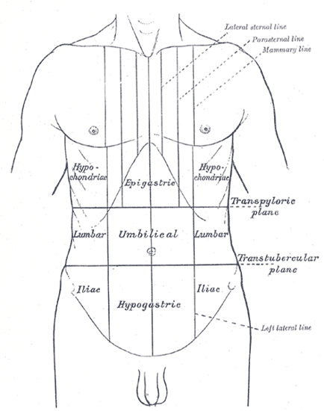
Read the text and complete the gaps.
Note ___ (1) the abdomen is distended by fluid or gas. The presence of fluid can be ___ (2) by demonstrating shifting dullness: percuss, or tap, first with the patient ___ (3) supine – flat on their back; then ask the patient to lie on one side and percuss again. ___ (4) fluid is present, the dull note heard ___ (5) percussion moves. Palpate each region, feeling for tenderness – pain when touched, or masses – palpable enlargement of tissue. Note also ___ (6) guarding or rigidity, shown ___ (7) contraction of the abdominal muscles. Guarding may be ___ (8) to tenderness or anxiety and can be reduced if the patient is persuaded to relax. Rigidity, ___ (9), is constant and is caused by peritoneal irritation. Rebound tenderness is pain when the palpating hand is suddenly removed. It is a ___ (10) of peritonitis. Listen for bowel sounds.

