Gastrointestinal system II

A Reading revision

B Endoscopy: procedure, passive voice
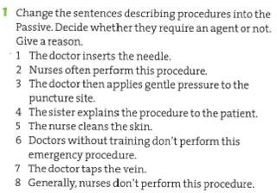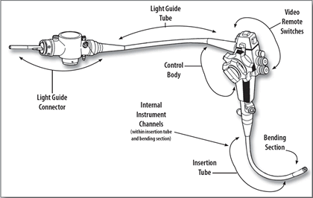
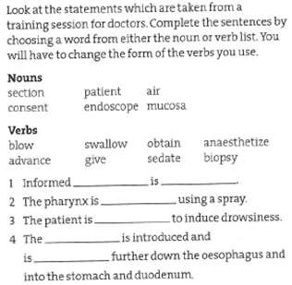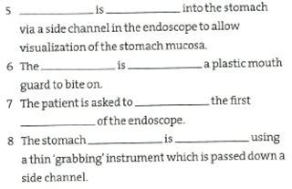
2 Complete each gap with one of the words from the box. Then listen and decide if the statements are true or false.
take biopsy lining recovery sedation gastroscopy perforation transfusion throats tissues surgery gag examination awake
1 Gastroscopy allows doctors to examine the __________of the gastrointestinal track, down to the stomach.
2 Before____________, doctors send information to their patients.
3 Taking samples of ______________means that there is a problem.
4 Patients mustn’t eat at least 8 hours before the_______________.
5 Half of the patients stay _____________during the procedure.
6 All patients have their ______________anaesthetized.
7 ______________is performed to make patients go to sleep.
8 The procedure doesn’t ____________more than 7 minutes.
9 The ___________reflex is eliminated by anaesthetics.
10 After the procedure, patients are taken to a ______________lounge.
11 The risk of ________________is one in ten thousand.
12 Bleeding after a _______________is more common than perforation.
13 Patients with bleeding need blood ____________________and are hospitalised for about a week.
14 In most cases of bleeding, _________________is not necessary.

Explaining a procedure (cleft sentences)
A Change the explanations to be going to and simplify the medical terms. Where indicated, use an expression with What.
1 A sample is taken from the bowel.
2 Next, the end of the intestines is attached to an opening on the abdomen. (What…)
3 A sample is taken from the cervix.
4 After that, a tube is passed through the urethra. (What…)
5 The glands are then removed from the axilla. (What…)
6 Next, a sample is removed from the lung. (What…)
7 After that, a tube is advanced down past the prostate into the bladder. (What…)
8 A dye is then injected into the pancreatic and bile ducts to visualize them. (What…)
9 The muscle is repaired with a mesh.

B Work in pairs. Decide which statement in A might be said during one of these tests and procedures.
a ___ cystoscopy
b ___ radical mastectomy
c ___ colonostomy
d ___ colonoscopy
e ___ colposcopy
f ___ ERCP (endoscopic retrograde cholangiopancreatography)
g ___ catheterization
h ___ bronchoscopy
i ___ herniorraphy

C In pairs, prepare a short dialogue between doctors explaining the endoscopy procedure. Use expressions with What.

Additional passive voice exercises
