HUMAN BODY SYSTEMS revision

CHOOSING A SPECIALTY
A Complete the gaps with a correct preposition.
I haven’t decided what to specialise ____ (1) yet. I need more experience before I decide, but I’m quite attracted ___ (2) the idea of paediatrics because I like working with children. I’d certainly prefer to work with children than, say, elderly patients – so I don’t fancy geriatrics. I was never very interested ___ (3) detailed anatomy, so the surgical specialties like neurosurgery don’t really appeal ___ (4) me. You have to be good ____ (5) your hands, which I don’t think is a problem for me – I’ve assisted ____ (6) operations several times, and I’ve even done some minor ops ____ (7) myself – but surgeons have to be able to do the same thing again and again _____ (8) getting bored, like tying off cut arteries and so on. I don’t think that would be a problem for me, but they need to make decisions fast and I’m not good _____ (9) that. I like to have time to think, which means surgery’s probably not right ____ (10) me.
B The study of or dealing with…
muscular and skeletal system problems care and treatment of the feet
cancers poisonous substances
the aging process X-rays
diseases and the changes they cause blood
heart diseases urinary tract
pregnancy and childbirth hormones
children and their diseases female reproductive system
body’s resistance to infections eyes and eye diseases
skin and its diseases ears, nose and throat
nervous system and its disorders stomach and intestines

C Discussion/reasons/preferences

BODY REGIONS MEDICAL TERMINOLOGY
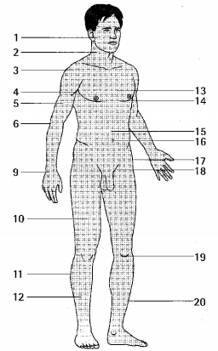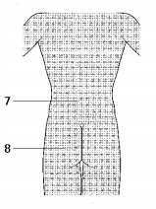

MEDICAL EXAMINATION
1 Imagine a routine check-up at the doctor’s. What are the four basic medical examination procedures?
2 What are vital signs?

PRESENTING A COMPLAINT
1 What do you do if you feel pain? What does your reaction/action depend on?
2 What would you ask a patient who has come with a complaint?
3 SOCRATES
S____________, O_______________, C_______________, R __________________, A __________________, T___________________, E________________________, S______________________
4 What are the expected tenses when asking or talking about pain?
