Muscular system worksheet

Reading revision
1 Muscular dystrophy refers to diseases involving progressive non________ degeneration of muscles. (INFLAME)
2 The ________ of both legs and the lower part of the body is known as paraplegia. (PARALYSE)
3 The skeletal muscles are under ________ control. (VOLITION)
4 The point of ________ of the muscle to the bone it moves is called the insertion. (ATTACH)
5 Quadriplegia is a disease affecting all four ________ (EXTREME)

Muscles typology
A Determine the muscle type and complete with WHICH/THAT/WHOSE.
biceps triceps striated non-striated skeletal flexor cardiac visceral
antagonist agonist extensor synergist

1 Any muscle ______ contraction serves to bend a joint or limb.
2 Any muscle ______ stretches or extends an arm, leg, or other bodily part.
3 Any muscle ______ has three heads or origins.
4 Any muscle ______ has two heads or origins.
5 Muscle in the heart _______ makes the heartbeat.
6 Muscle attached to a bone, _______ makes a limb move.
7 Type of muscle _______ is found in involuntary muscles.
8 Type of muscle found in skeletal muscles _______ movements are controlled by the central nervous system.
9 Muscle in the walls of the intestines ________ makes the intestine contract.
10 Any muscle ________ opposes the action of another.
11Any muscle ________ acts with another and increases the effectiveness of both.
12 Any muscle ________ action is opposed by another muscle.

B Use of English – read the text and complete each gaps with ONE word.
Bodybuilding has _______ (1) a popular sport worldwide. Once considered only for men, it is now enjoyed by thousands of women as well. Participants ______ (2) this sport combine diet and specific weight training to develop maximum muscle mass and minimum body fat, with their major goal _____ (3) a well-balanced, complete physique. An uninformed, untrained muscle builder can build some muscles and ignore _______ (4) ; the result is a disproportioned body. Skill, training, and concentration are required ____ (5) build a well-proportioned, muscular body and to know which exercises build a large number of muscles and _____ (5) are specialized to build certain parts of the body.
Is the old adage "no pain, no gain" correct? Not really, over-exercising can cause small tears in muscles, ________ (6) soreness. Torn muscles are weaker muscles, and it can take up to 3 weeks to repair the damage, _______ (7) though the soreness may only last 5 to 10 days.
Bodybuilders concentrate on increasing skeletal muscle mass. Endurance tests conducted several years ago demonstrated that the cardiovascular and respiratory abilities of bodybuilders were _______ (8) to those abilities in normal, healthy persons, untrained in a sport. ________ (9), more recent studies indicate that the cardiorespiratory fitness of bodybuilders is comparable to that of other well-trained athletes. The difference between the results of the new studies and the older studies is attributed to modern bodybuilding techniques _____ (10) include aerobic exercise and running, as well as "pumping iron".
Bodybuilding has its own language. Bodybuilders refer to the "lats", "traps", and "delts" rather than the latissimus dorsi, trapezius, and deltoids. The exercises also have special names ______ (11) as "lat pulldowns", "preacher curls", and "triceps extensions".

Muscles pathologies
A Match the conditions with their definitions.
1 endomyocardial fibrosis a) waste of muscular tissue, usually the result of a loss of efferent innervation
2 fibrositis b) a group of inherited disorders in which strength and muscle bulk decline
3 cramp c) formation of fibrous tissue in the heart muscle
4 atrophy d) generalized muscle aching, soreness; inflammation of fibrous tissue
5 muscular dystrophy e) a painful spasmodic muscular contraction

B Muscular atrophy
Complete the gaps:

1 Some of the earliest signs of aging are: __________, __________,__________,_________,__________,__________
2 When do we achieve the biggest muscle mass?
3 Before reaching 80 years of age, some people can lose up to _________________ of muscle mass. Most people will lose _____________________ of muscle mass.
4 The loss of muscle mass includes: __________________________ and __________________________________
5 Doctor LeBrasseur and his team put emphasis on maintaining skeletal muscle health in four aspects. Name these and give examples:

Medical examination
A Complete the dialogue with appropriate questions.
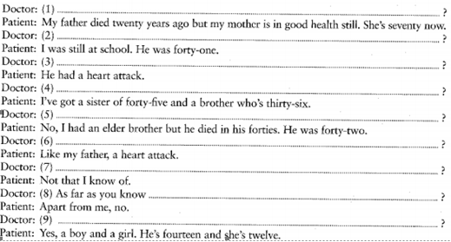
B Now it is your turn to write the social history of a hypothetical patient:
Home:
Family:
Occupation:
Personal interests:
Habits:

