P10 Clinical microbiology I – general
To study: Sampling, specimen transport (from textbooks, www etc.)
From spring term: Microscopy

Task 1: Indications for microbiological examination
For following casuistries, fill in the table.
❶ Fill in always the case description (left column).
❷ Try to find out your solution. Try to structure your answer as follows:
Microbiological examination: yes/no
- yes → select a specimen
- no → select other steps, e. g. direct treatment – what antibiotics etc.)
❸ After the three minute limit, write down a correction according to the teacher’s explanation.
 | Description of a case | Your solution ( 3 minutes) | Correction according to the teacher’s explanation
a
b
c
d

Task 2: Swabs and vessels
Observe the swabs in your table and fill in their “identity cards”.
Name: Plain swab
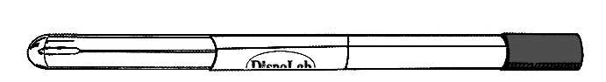 | Stick material | plastic, wood, aluminium
 | Swab material | synthetic cotton
Practical use:

Name: Swab with Amies transport medium
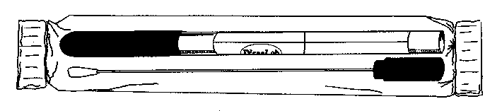 | Stick material |  | plastic or aluminium
 | Swab material |  | synthetic cotton
 | Medium |  | Amies (Stuart, Cary Blair)
Note: The medium may contain charcoal (then it is black); without charcoal, it would be colourless.
Practical use:

Variant with aluminium stick is used for

Name: Fungi-Quick swab
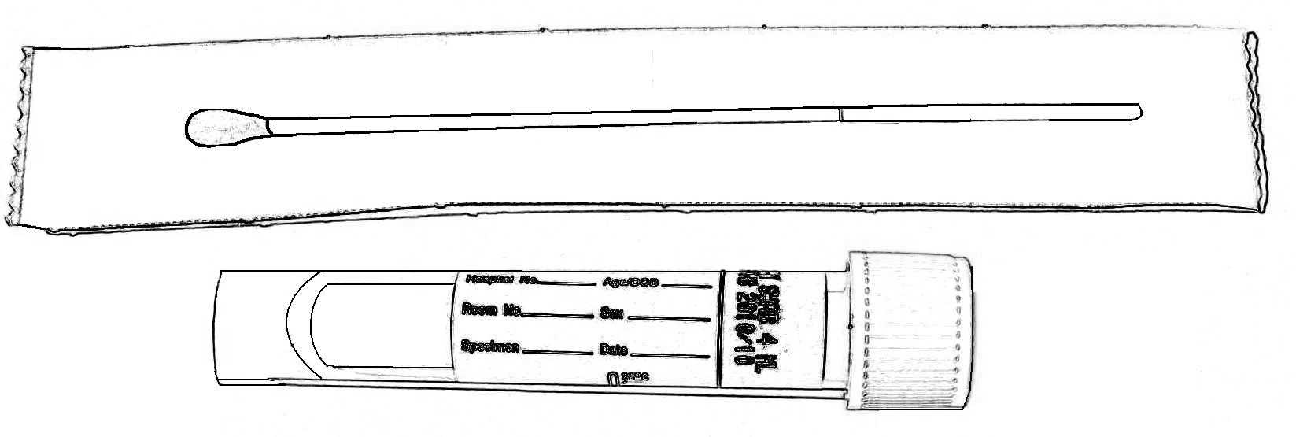 | Stick material |  |  | plastic
 | Transport medium colour |  | colourless
 | Cap colour
Practical use:

Name: C. A. T. swab
 | Stick material |  |  | plastic
 | Transport medium colour |  | colourless
 | Cap colour
Practical use:

Name: Common test tube for microbiology
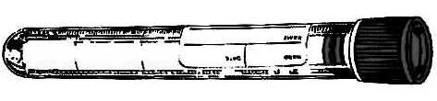 | Sterile? (yes or no)
 | Description | made of polystyrene, 16 × 100 mm, 10 ml
Practical use:

Name: Sputum test tube
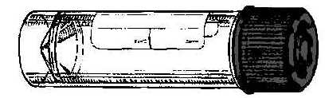 | Sterile? (yes or no)
 | Description | made of polystyrene or polypropylene,  26 × 92 mm, 30 ml
Practical use:

Name: Stool container
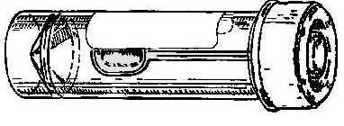 | Sterile? (yes or no)
 | Description | made of polypropylene,  26 × 82 mm, 30 ml
Practical use:

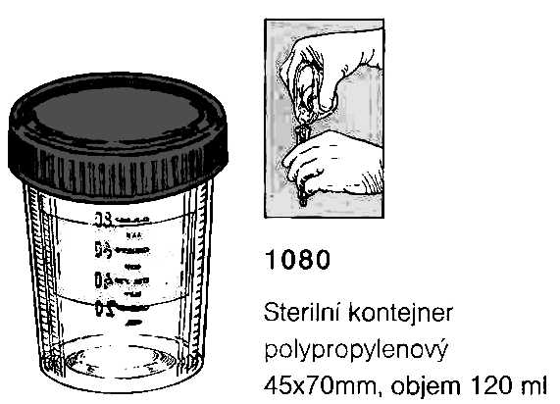
Name: Sampling vessel for urine
 | Sterile? (yes or no)
 | Description | made of polypropylene,  45 × 70 mm, 120 ml
Practical use:

Task 3: Other sampling methods than swabs and vessels
Fill in the following table:
Sampling method | Typical example(s) of use
smear on a slide
imprint with an agar
moulage method
uricult

Task 4: The order form

a) Filling in the order form
Fill in the following order form with a patient name and data and the requested examination related to the disease, according to a card that has been given to you by the teacher.
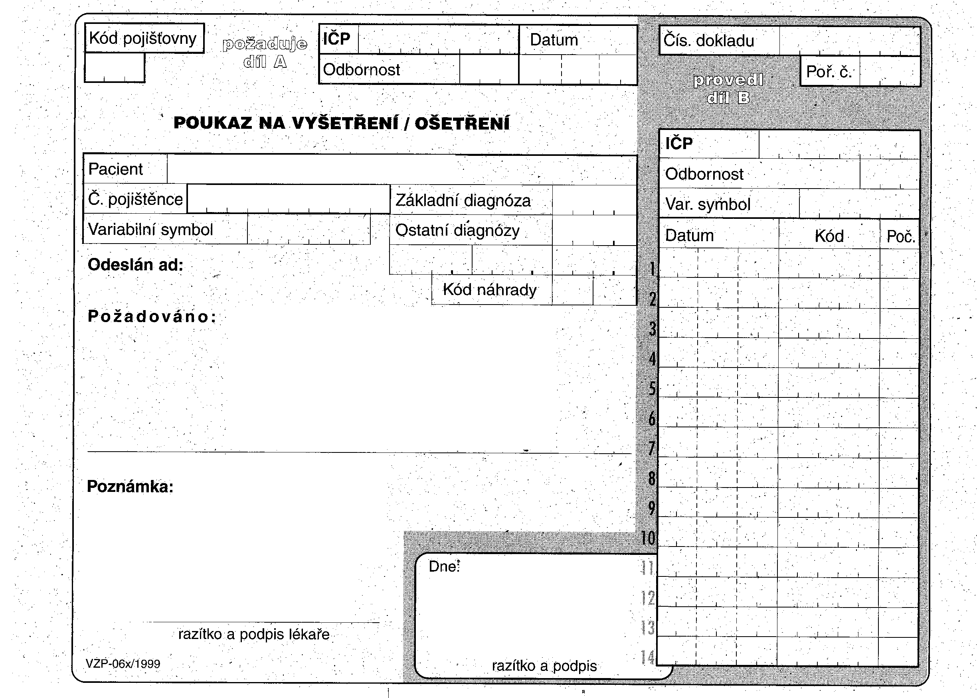

b) Order form common mistakes
To each of the following order forms write down what is wrong. There are some mistakes at filling in the order form, but you should also identify improperly requested examinations.
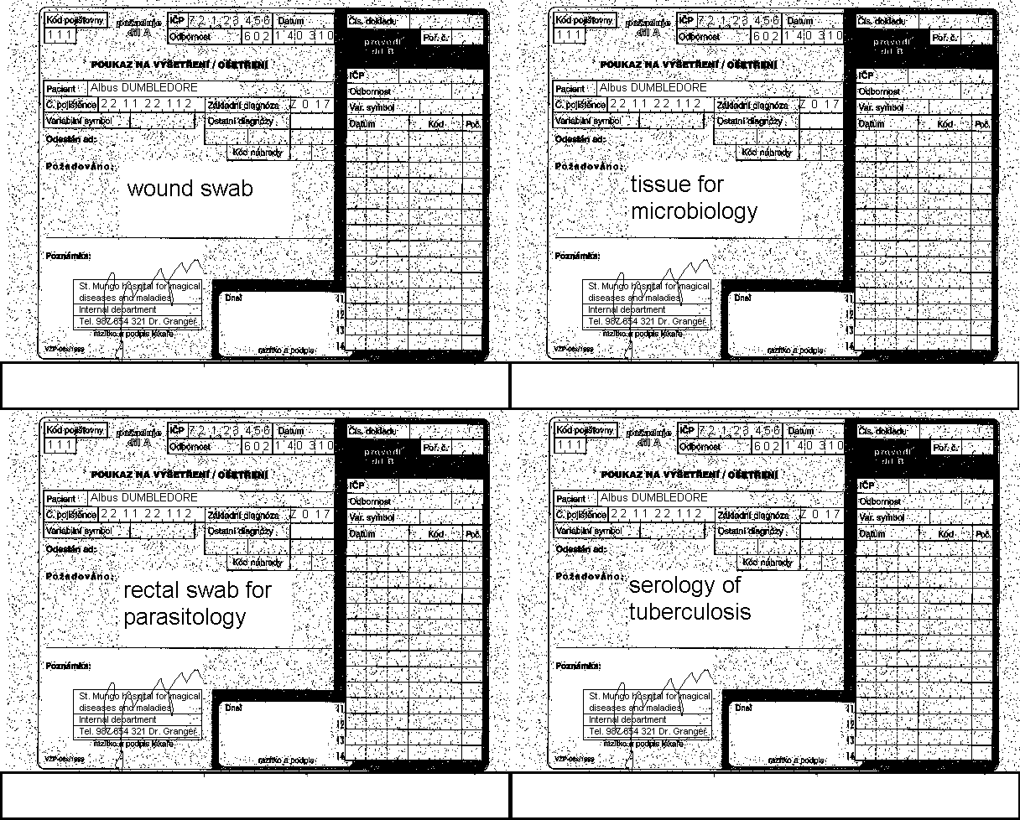
Tissue for syphilis cultivation

Task 5: Interpretation

a) Direct diagnostic interpretation
Using the table in the slideshow, write likely interpretation for thirteen various findings written on cards available on your table. Use terms “pathogen”, “common flora”, “accidental finding”, “colonization” and “contamination”

Finding | Interpretation

b) Indirect diagnostic interpretation
Interpret several clinical situations with data given on the card. Do not forget to make your interpretation on the base of both clinical findings and laboratory results (clinical findings)
Rewrite from the card (simplify the sentences) |  | Conclusion
Clinical situation | Serology examination results | Conclusion

Notes (correction of your conclusion done by the teacher)

