***1. Use the appropriate form of the word in brackets***

A common cold is usually ____ /HARM/. The symptoms are ____ /RUN/ or ____ /STUF/ nose, sore throat, _____ /WATER/ eyes. A common cold can be caused by one of more than 200 viruses; therefore symptoms tend to _____ /VARIETY/. However, it is _____ /LIKE/ that you will have a high fever and experience _____ /SIGNIFY/ fatigue. Symptoms of a common cold usually appear about one to three days after _____ /EXPOSE/ to a cold virus.

The most common causes of pneumonia are bacteria, viruses and **fungi**. You can also get it by _______ /ACCIDENT/ inhaling a liquid or chemical. If you have pneumonia, you may have ______/DIFFICULT/ breathing and have a cough and a fever. The best _____ /PREVENT/ measures include not smoking and wearing a mask when cleaning dusty or **mouldy** areas.

Bronchitis causes a cough, ____ /SHORT/ of _____ /BREATHE/ and chest ______ /TIGHT/.

***2. Read the sentences and complete only one word into each gap.***

1. Most people recover _____ a common cold ____ about a week or two.

2. Pneumonia is usually caused ___ an infection.

3. People most ____ risk are older than 60.

4. Treatment depends ___ what made you sick.

5. Bacterial infection accounts ___ up to a quarter of all pneumonias.

6. If you smoke, quitting may prevent you _____ getting the disease.

7. Treatment is based ___ whether your symptoms are mild, moderate or severe.

***3. Speaking***

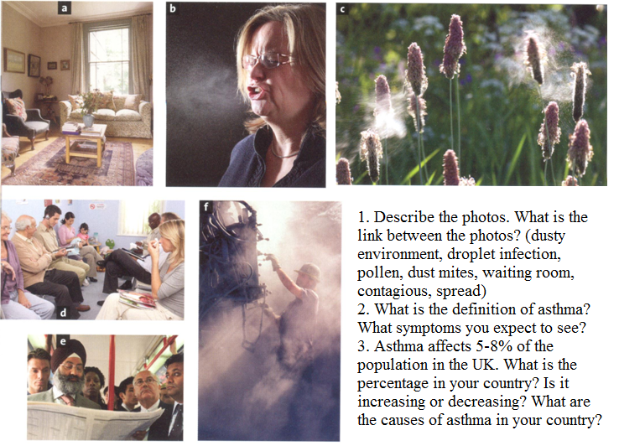

**Defining and non-defining relative clauses**

1. The woman who (that) lives next door is a doctor.

2. We chose the midwife (who, that) you recommended.

3. The patient whose kidney started to fail is slowly recovering.

1. My brother Rob, who lives in Australia, is a doctor.

2. We chose the midwife Ms Smith, who you recommended.

3. Liz, whose kidney started to fail, is slowly recovering.

***1. Decide which rules apply to defining and which to non-defining relative clause.***

1. It is a clause which gives extra information. Such information does not help us identify the person or thing to which the sentence relates. 2. We can use ‘that, who, which,’ etc.

3. ‘Who/that/which’ can be left out if it is the object of the relative sentence.

4. Commas are not used. 5. ‘Who/what’ cannot be left out even if it is the object of the relative sentence.

6. It is separated by commas. 7. ‘That’ cannot be used in this clause.

8. It is a clause which helps us identify the person or thing that we are talking about.

***2. Complete a relative pronoun and write commas if necessary.***

1. Louis Pasteur _________ discovered the principles of vaccination died in 1895 near Paris.
2. People ________ suffer from emphysema should give up smoking.
3. Acute bronchitis _________ symptom is a lingering dry cough usually goes away on its own.
4. I live in London ________ has some fantastic parks.
5. I want some drops ________ can be used with this decongestant.
6. Kidney transplant is a treatment ________ is given to people with renal failure.
7. The on/off switch ________ is at the back of the machine is broken.
8. Patients ________ have dialysis at home can get on with their lives more easily.
9. This is the x-ray of Mr. Brown ________ I gave some pain killers.
10. My brother _______ lives in New York caught pneumonia.

**Listening: How To Cope With The Common Cold**

*a) Discuss with your partner:*

I. How often do you catch a cold? In which part of the year do you usually catch a cold?

II. What are the most common cold symptoms? Which of them do you usually suffer from?

III. What’s the best treatment for a cold?

*b) Listen and write down 8 steps which help you cope with a cold.*

*c) Listen once more and fill in the gaps.*

**Step 1**: The earlier you catch a cold coming on, the earlier you can start helping your body to fight it _______ (1) . Sneezing, a runny nose and a ______ (2) are usually the earliest presenting symptoms.

**Step 2:** Although we don't know why, high levels of stress seem to cause a big reduction in the immune system's ___________ (3). Removing stress factors like the latest deadline will help your body to ______________ (4) the cold.

**Step 3:** Nothing will ________ (5) your cold, but there are medicines that can help to _________ (6) your symptoms. Basic painkillers such as aspirin, paracetamol and ibuprofen can help reduce the discomfort of a _________ (7) throat, headache or high temperature. Nasal ________________ (8) sprays are the best at relieving a _________ (9) nose, although are only effective for 5-7 days, after which they can actually worsen the problem. Cough medicines are less effective, but can still have some __________(10) on chesty and dry coughs.

**Step 4**: Hot drinks will give instant _____________ (11) to a sore throat. Making yourself very spicy food or hot soup to eat also has a calming effect on a sore or tickly throat. Inhaling steam from very hot water can help to _________ (12) a blocked nose, although be careful to avoid getting steam in your eyes. Using more pillows than normal in bed to prop up your head can also relieve __________ (13) and help you sleep.

**Step 5:** There is anecdotal evidence that ____________ (14) such as extra Vitamin C help to ___________ (15) the immune system, although it is not advised that you take large amounts of any one vitamin or herbal remedy. Check the advice on the box for recommended __________ (16) levels.

**Step 6:** If you are a smoker, now is a good time to ________ (17). Smoking irritates the membranes in your nose further, causing your symptoms to get worse.

**Step 7:** The symptoms of a cold drain your body of ______________ (18). To keep your body strong enough, make sure to regularly drink fluids throughout the day.

**Step 8:** Although colds usually do not leave you unable to do things, they will vastly decrease your ____________ (19) and energy levels. Straining yourself beyond your body's reduced limits will only make you feel worse, and ______________ (20) your recovery time.