1. Describe the pictures.

2. What physical function does the skin perform?

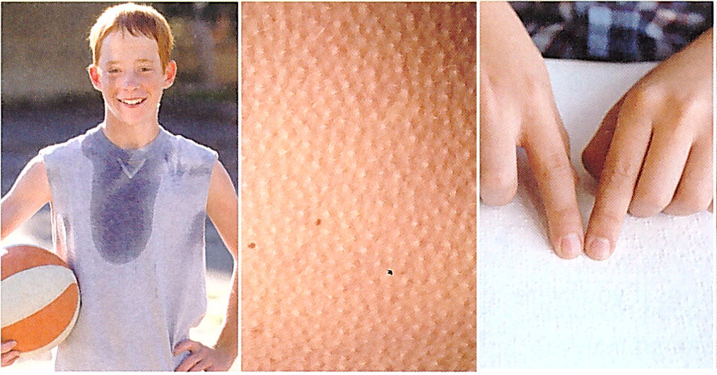

***1. Complete the correct preposition:***

1. Skin is structurally distinct _______ mucous membranes.
2. Hair follicles are lined ________ cells that synthesise the proteins that form hair.
3. Eccrine glands are linked _____ the sympathetic nervous system.
4. Hair, horns and nails are derived _____ skin.
5. Nails consist _____ keratinized epidermal cells.
6. The primary function of skin is to serve _____ a barrier.
7. Skin damaged _____ burns is less effective _____ preventing fluid loss, often resulting ____ a possibly life threatening problem if not treated.

***2. Fill in the word in brackets in the appropriate form.***

1. Genetics controls some features of hair: ________ /bald/ and texture.
2. Nail bed is _________ /thick/ to form a lunula.
3. Skin functions include __________ /protect/, ___________ /regulate/ of body temperature and _________ /sense/ reception.
4. Skin prevents water and extracellular fluid ________ /lose/.
5. Melanocytes protect from the ___________ /damage/ effects of ultraviolet radiation.
6. When a microbe penetrates the skin the ___________ /inflame/ response occurs.
7. Water can be lost due to ___________ /evaporate/.
8. The hypothalamus also causes ______________ /dilate/ of the blood vessels of the skin.

***1) Make question so that the underlined word is the answer.***

Yes, I have been working hard.

The film begins at 8 o’clock.

Something terrible happened to me last night.

10 people came to the meeting.

I want to speak to the doctor.

Ann has applied for the job at Mercy’s hospital.

***2) Use the cues to make questions***

a. Have fall over?

b. you hurt?

c. What think the problem?

d. Who around when pain set in?

e. Could describe what happen me?

f. How long have chest pain? (looking at the patient holding his chest)

g. There any other things like to talk about?

h. What else you concern about?

i. The phlegm colour?

