Skin cancer. Complete the clauses which were left out back into the text. There is one which you do not need.
Skin cancer is the growth of abnormal skin cells ______. Skin cancer is the single most common type of cancer in humans. The cause of most skin cancers or carcinomas is unknown, ______.
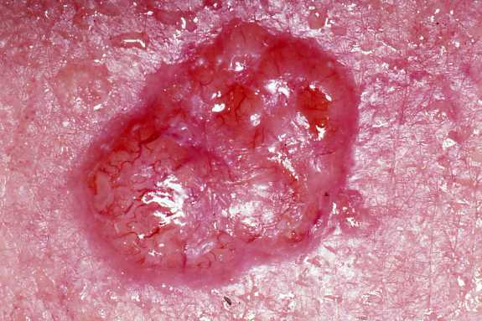
Basal cell carcinoma is the most common form of skin cancer, _____. It is also the least malignant or cancerous. In this form of skin cancer, basal cells in the epidermis are altered _____. They also spread, invading the dermis and subcutaneous layer. Shiny, dome-shaped lesions develop most often on sun exposed areas of the face. The next most common areas affected are the ears, the backs of the hands, the shoulders, and the arms. _____, 99 percent of patients recover fully.
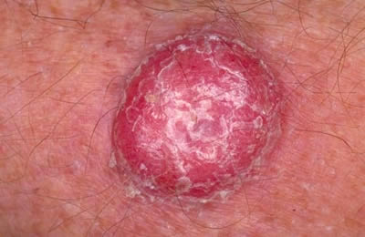
Squamous cell carcinoma affects the cells of the second deepest layer of the epidermis. Like basal cell carcinoma, ____: face, ears, hands, and arms. The cancer presents itself as a small, scaling, raised bump on the skin with a crusting center. _____ if not removed. If the lesion is caught early and removed surgically or through radiation, _____.
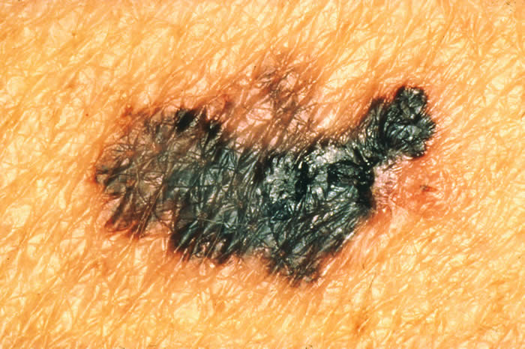
Malignant melanoma accounts for about 5 percent of all skin cancers, _____. It is a cancer of the melanocytes, cells in the lower epidermis that produce melanin. In their early stages, _____. Soon, they appear as an expanding brown to black patch. In addition to invading surrounding tissues, ______, especially the lungs and liver. Overexposure to the Sun may be a cause of melanomas, ______. Early discovery of the melanoma is key to survival. The primary treatment for this skin cancer is the surgical removal of the tumor or diseased area of skin. When the melanoma has spread to other parts of the body, _____.

- but overexposure to ultraviolet radiation in sunlight is a risk factor
- it is generally considered incurable
- capable of invading and destroying other cells
- the cancer spreads aggressively to other parts of the body
- but it is the most serious type
- tends to grow and spreads throughout the body
- the patient has a good chance of recovering completely
- this type of skin cancer also involves skin exposed to the sun
- when the lesion is removed surgically
- so that they no longer produce keratin
- accounting for about 75 percent of cases
- but the greatest risk factor seems to be genetic
- it grows rapidly and spreads to adjacent lymph nodes
- melanomas resemble moles
Vitiligo. Listen to the sound of the video and answer the questions with up to words.
https://www.youtube.com/watch?v=YSS_hzkoPxk
What happens to melanocytes in patients with vitiligo?
Melanocytes lose their ________________ or ________________
What are the two types of vitiligo mentioned in the video?
______________________ and _________________
What percentage of people with vitiligo have this disease in their family history?
________________
What hormonal changes can trigger vitiligo?
_________________
Which theory explains segmental vitiligo?
______________

Write the correct word.

A preparation, often in the form of a cream or lotion, used to protect the skin from the damaging ultraviolet rays of the sun. ______________

The dried crusty surface of a healing skin wound or sore is called _______

Loose scales of dry skin which are found in hair are called __________

A synonym for “to trigger” is “to ______ “

The red spots on an area of your skin is called a ___________ and it usually itches.

A piece of healthy skin which is surgically removed from one part of the body and put elsewhere in order to replace damaged or lost skin is called a skin _____.

Choose the correct option.

In epidemiology, a(n) _____ is an occurrence of disease greater than expected at a particular time and place

A) output B) incidence C) prevalence D) outbreak
Warts are ______________, which means that they can easily pass from person to person.
A) infected B) infecting C) contagious D) containing
_____ about 7 to 10 percent of the population, warts are particularly common among children.
A) effecting B) affecting C) exposing D) avoiding
Many nonprescription wart _______ are available that will remove simple warts.
A) prescriptions B) remainders C) remedies D) reliefs
When the over-the-counter treatment does not help, physicians use other treatments…
A) cash B) desk C) prescription D) counter
such as ______ the warts with liquid nitrogen.
A) frozen B) heating C) heated D) freezing

Herpes Infections. Complete only one word into each gap.
Cold _____________ are a very common health problem. More than 60 percent of Americans have _____________ it. Nearly 25 percent of these individuals have repeated outbreaks. This disease is also known _____________ oral herpes. It is usually caused _____________ herpes simplex virus 1 (HSV1).
Most people are first infected _____________ HSV1 before the age of ten. Once the virus enters the body, it remains there for life. They cause painful _____________ filled with fluid. They usually occur _____________ the lips. By contrast, _____________ sores usually occur on the tongue, inside the cheeks, or elsewhere inside the mouth.
Viruses that enter the body often go through a _____________ period, which is a stage during that the virus goes into hiding. It can _____________ found in cells, but it is not active. There are no external symptoms _____________ the virus is in the body.
At some point, however, the virus becomes active again. Any number of factors can trigger reactivation of _____________ virus. Physical or emotional shock is a common _____________. When the virus becomes active again, symptoms of the infection _____________, which means that they appear again.

Key: see the reading Integumentary system - disorders
Listening: function-are destroyed; segmental- non-segmental; 20; pregnancy; neural

sunscreen, scab, dandruff, cause, rash, graft

