Radiology Human Body Worksheet

Human body systems revision

How to become a radiology assistant
Fill the verbs from the box:
insert diagnose examine perform remove minimize performs treat analyse recover
Radiologists are physicians who use cutting-edge imaging technology to ___ (1) organs and tissues inside the body in gentle, non-invasive ways. Their expertise in physics, anatomy and the disease process allow them to ___ (2) injuries and illnesses so treatment can begin. A growing sub-group of these specialists called interventional radiologists ___ (3) surgical procedures under imaging guidance in order to ____ (4) damage to healthy tissue.
Radiologists generally work behind the scenes. They ____ (5) studies, make diagnoses and consult with physicians. In some cases, they get involved in the procedure in order to help prepare the patient. Interventional radiologists take imaging technology a step further: they use it to ____ (6) certain diseases and conditions. These professionals create electronic maps to guide their instruments. They ____ (7) catheters, ____ (8) malignant tissue and ____ (9) other delicate procedures. This gentle approach allows patients to ____ (10) faster and with fewer complications.
1 How would you describe the job of a radiologist?
2 What is the main diference between radiologists and interventional radiologists?
3 Which subjects in your study programme do you find most difficult?
4 Do you like your practical training? What do you do? Can you describe your daily routine?

General anatomy
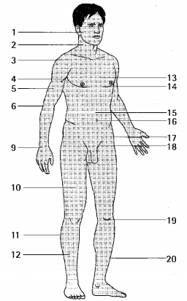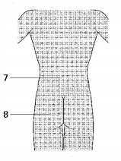

Examination

Grammar revision – present tenses
