Lymphatic and haematic system worksheet

1 Relative clauses revision

2 Lymphatic system review
A In pairs, discuss these questions:
1 Why is sometimes the lymphatic system referred to as the immune system?
2 Where is the excessive fluid which leaks during diffusion collected?
3 What happens to lymph in lymph nodes?
4 Why do doctors feel your lymph nodes when they examine you?
5 Where is the thymus located, and what is its function?
6 Which lymphatic organ destroys old red blood cells?
7 How can the spleen help if you are haemorrhaging?
8 What makes the lymph move?

B Match the terms from the box with their definitions below.
natural killer cell antibody B lymphocyte T lymphocyte antigen macrophages helper cell plasma cell
___________ a lymphocyte formed in the bone marrow from which it migrates to the thymic cortex to become an immunologically competent cell
___________ one of the two major classes of lymphocytes, which comprises 30% of circulating lymphocytes; responsible for antibody production (interacts with the appropriate CD4 T-helper cells
___________ a T cell that promotes the activation and functions of B cells and other T cells; its surface is marked by CD4 receptors
___________ white blood cells (activated monocytes) whose job is to destroy invading microorganisms
___________ small lymphocytes having cytotoxic activity against target cells coated with specific IgG antibody
___________ any substance capable of inducing a specific immune response
___________ an immunoglobulin molecule having a specific amino acid sequence which enables it to adhere to a specific antigen
___________ an antibody-producing lymphocyte derived from a B cell after reaction with a specific antigen

3 English medical terminology
1 tonsillectomy _____________________ 7 a post-mortem examination of a body _________________
2 splenectomy ______________________ 8 infection & swelling of the tonsils ____________________
3 thymectomy ______________________ 9 cutting/dissection of muscle tissue ____________________
4 laparoscopy ______________________ 10 surgical excision of a muscle _______________________
5 thymitis __________________________ 11 surgical incision of the heart ________________________
6 angiotomy ________________________ 12 removal of tissue (for diagnoses) ____________________

4 Pathologies

Part One: decide if these statements are true or false.
1 Hodgkin lymphoma is a cancer related with B lymphocytes and T lymphocytes.
2 Enlarged cervical lymph nodes are one of the signs of the disease.
3 Symptoms pointing to the disease might be of dermatological nature.
4 In some cases, biopsy of Reed-Sternberg cells is necessary.
5 The goals of the treatment do not include fight against inflammation.

Part Two: answer the questions

What does the staging evaluation consist of?
Why is the evaluation performed?
When are both chemotherapy and radiation treatment necessary?
What is a durable remission?
Do all Mayo Clinic patients have a 100% good outcome?

5 Revision
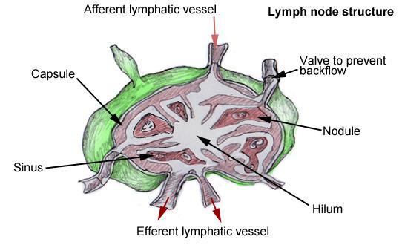
Lymph nodes are bean-shaped structures that are widely distributed throughout the lymphatic pathway, providing a filtration mechanism for the lymph before it rejoins the blood stream. ____ (1) Lymph nodes constitute a main line of defence by hosting 2 types of immunoprotective cell lines, T lymphocytes and B lymphocytes.
Lymph nodes have 2 distinct regions, the cortex and the medulla. ____ (2) At the centre of the follicles is an area called germinal centres that predominantly host B-lymphocytes while the remaining cells of the cortex are T-lymphocytes. Vessels entering the lymph nodes are called afferent lymphatic vessels and, likewise, those exiting are called efferent lymphatic vessels.
Extending from the collagenous capsule inward throughout the lymph node are connective tissue trabeculae that incompletely divide the space into compartments. Deep in the node, in the medullary portion, the trabeculae divide repeatedly and blend into the connective tissue of the hilum of the node. ___ (3) Within this framework, a delicate arrangement of connective tissue forms the lymph sinuses, within which lymph and free lymphoid elements circulate.
A subcapsular or marginal sinus exists between the capsule and the cortex of the lymph node. Lymph passes from the subcapsular sinus into the cortical sinus toward the medulla of the lymph node. ___ (4) From there, lymph is collected into several efferent vessels that run to other lymph nodes and eventually drain into their respective lymphatic ducts

Complete the gaps with one of these sentences.
a) Thus the capsule, the trabeculae, and the hilum make up the framework of the node.
b) Medullary sinuses represent a broad network of lymph channels that drain toward the hilum of the node.
c) The cortex contains follicles, which are collections of lymphocytes.
d) They are arranged in an overlapping pattern, so that pressure from the surrounding capillary forces at these cells allows fluid to enter.
e) The average human body contains approximately 600-700 of them, predominantly concentrated in the neck, axillae, groin, thoracic mediastinum, and mesenteries of the GI tract.

