Integumentary system worksheet

A Skin anatomy

A Fill in the missing words or figures:
1 Cutis is the Latin expression for ………………….
2 Corium is another word for …………………
3 The skin makes up for …………% of the overall body weight
4 The skin is ……………….mm thick.
5 The renewal cycle of skin cells takes ……….. days.

B Write each term from the box in its category:
loose connective tissue eccrine sweat glands Ruffini corpuscles stratum lucidum free nerve endings veins stratum spinosum basal layer Merkel cells elastic layer sebaceous glands Langerhans cells Meissner’s corpuscles hair follicles papillary layer stratum corneum
adipose cells arteries lymph channels nerves stratum granulosum

Epidermis
Dermis
Hypodermis

C Answer these questions:
1 The video mentions some factors the skin protects us against. Which?
2 In which part of the skin are keratinocytes and what is their function?
3 In which part of the skin are melanocytes and what is their function?

B Skin (gap-fill)
The skin is a vital organ ____ (1) covers the entire outside of the body, forming a protective barrier ____ (2) pathogens and injuries from the environment. The skin is the body's largest organ; covering the entire outside of the body, it is ____ (3) 2 mm thick and weighs approximately six pounds. It shields the body against heat, light, injury, and infection. The skin also helps ____ (4) body temperature, gathers sensory information from the environment, stores water, fat, and vitamin D, and plays a role in the immune system protecting us ____ (5) disease.
The colour, thickness and texture of skin vary over ____ (6) body. There are two general types of skin; thin and hairy, ____ (7) is more prevalent on the body, and thick and hairless, ____ (8) is found on parts of the body ____ (9) are used heavily and are exposed to a large amount of friction, ____ (10) the palms of the hands or the soles of the feet.

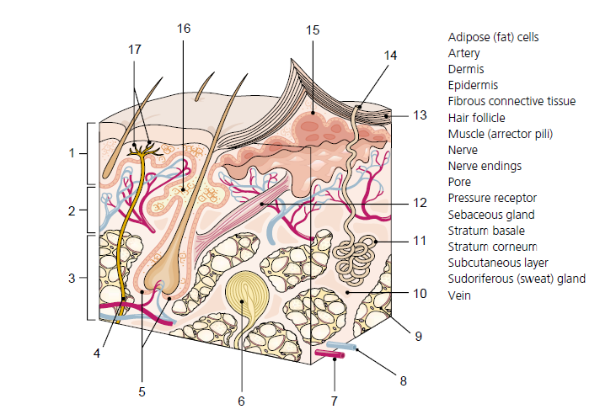

C Tattoo
From infectious diseases to allergic reactions, tattoos carry many risks but one often overlooked safety hazard is how tattoos react to MRI scans.
MRI (Magnetic Resonance Imaging) machines are used to locate tumours and other abnormalities within the human body using extremely strong magnets. Along with these magnets, an MRI machine uses radio frequency waves to make protons in the body's cells react, emitting signals that show up as a grayscale image, according to the National High Magnetic Field Laboratory at the University of Florida.
Tattoos can hinder an MRI scan depending on the ingredients used in the tattoo ink and the size of the tattoo. Since there are currently no FDA-approved tattoo inks, determining which chemicals were used in a tattoo can be tricky. But experts say that some ink colours cause more of a reaction than others.
The dye used in red tattoo inks contains iron (for example, think of the colour rust), which is magnetic and very susceptible to the magnetic fields used in MRI machines, said Moriel NessAiver, a physicist who teaches MRI safety in Baltimore.
"Since iron can conduct electricity, loops of current are induced when the magnetic fields are rapidly changing during the imaging process," NessAiver told Life's Little Mysteries. "Any time you have a current flowing, as in a wire or other metal, that metal can get hot enough to burn."
If the tattoo is in the shape of a loop, it can act like an antenna, and can also get increasingly hotter as the ink pigments pick up more energy from the magnets, according to NessAiver. The reaction can result in swelling of the tattooed skin and its surrounding area, as well as the flesh feeling hot and irritated.
The most serious reactions result in first and second-degree burns, according to a 2009 study conducted by Italian scientists and published in the International Journal of Environmental Research and Public Health.
Tattoos near the eyes are particularly of concern, as the area can be very sensitive to excess heat. The FDA's Office of Cosmetics and Colours warns those with permanent facial tattoos (such as eyeliner, eyebrow and lip liner tattoos) to consult with their doctor and MRI technician regarding possible burn risks so that precautions can be taken.
While any metallic substance poses a health risk when MRI machines are involved (that's why people with cardiac pacemakers and inner ear implants that contain metal parts cannot get MRIs), the FDA assures that tattoo burns from MRI machines "seem to occur only rarely and apparently without lasting effects."
"Best advice is, don't get a tattoo," NessAiver said. "If you have them and need an MRI scan, be sure to tell your doctor and the MRI technologists so they can evaluate the risk versus the benefit. If your tattoo's ink does not have any iron in it, then it should be pretty safe."

Read the text and decide if these statements are TRUE or FALSE.
1 The danger of MRI reaction to tattoos is often neglected.
2 MRI works on the principles of magnetism only.
3 Tattoos of any colour react with the same intensity.
4 Circular tattoos can cause more damage than straight ones.
5 The most common tattoo injury is a burn.
6 Facial tattoos prevent patients from having an MRI scan.
7 According to the FDA, tattoo burns are not very common.
8 The best prevention is to have a tattoo with no iron in it.

Based on the information from the text, prepare a short dialogue telling the patient with a tattoo about risks of getting an MRI.

D Present perfect

