**1 Write the words fitting these definitions:**

1. microscopic cellular membrane projections increasing the surface area of the small intestine
2. the first and shortest segment of the small intestine
3. the largest section of the small intestine. It is the chief of nutrient absorption in the digestive system.
4. the pulpy acidic fluid which passes from the stomach to the small intestine, consisting of gastric juices and partly digested food
5. a pair of soft tissue masses located at the rear of the throat
6. enzyme that helps digest carbohydrates. It is made in the pancreas and the glands that make saliva.
7. the hard glossy substance that covers the crown of a tooth
8. macromolecular biological catalysts
9. the lymphatic vessels of the small intestine which absorb digested fats
10. liver cells
11. a circular muscle that normally maintains constriction of a natural body passage or orifice and which relaxes as required by normal physiological functioning
12. the opening from the stomach into the duodenum
13. small organs containing the taste receptor cells also known as gustatory cells
14. the yellowish calcified tissue that makes up the bulk of all teeth
15. a process by which substances are produced and discharged from a cell, gland, or organ for a particular function in the organism or for excretion
16. a pouch connected to the junction of the small and large intestines

**2 Describe the processes using the provided words**

ingestion: masticate, deglutition, saliva, secrete, bolus, mucus, soft, sphincter, rugae

digestion – stomach: churn, juice, acid, bolus, chyme, mucus, ulcer, pylorus, nutrient, absorb

digestion and absorption – small intestine: duodenum, bile, wall, emulsify, protein, carbohydrate, jejunum, ileum, villi, blood, lacteal

**3 Complete the sentences.**

1. She’s just had her first baby. She’s in the m________ w________.
2. She cut her arm and she needs some s________. She’s at the c________ department.
3. He’s having his operation. He’s at the o________ t________.
4. I had to go to the hospital for a check-up. They have a nice o________ d________.
5. The doctor thinks he might have broken a bone, but he needs to do an X-________ first.
6. The footballer was unconscious, so they laid him down on a s________ and rushed him to the hospital.
7. Unfortunately, he is still in a c________ condition and we don’t know when he’ll be s________.
8. She suffered only m________ injures, and we can expect her f________ recovery soon.

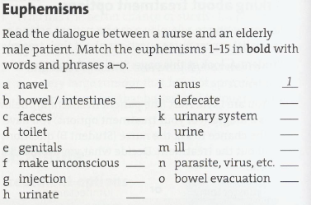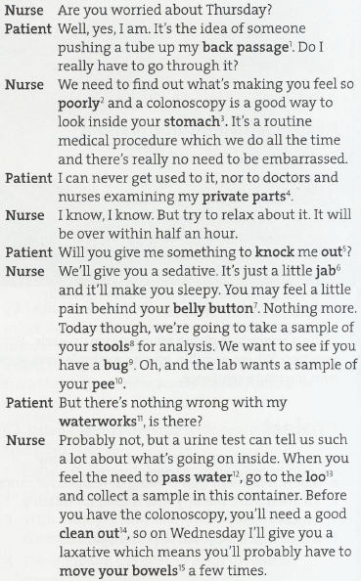

**LISTENING**

**1 Listen to a staff nurse pass on information about a new patient at a shift handover. Answer the questions about the patient.**

1 How old is Anita?

2 How long is she in for observation?

3 What is her weight?

4 What illness does her mother think Anita has?

5 What is Anita obsessed with?

**2 Complete these symptoms that the staff nurse mentions:**

