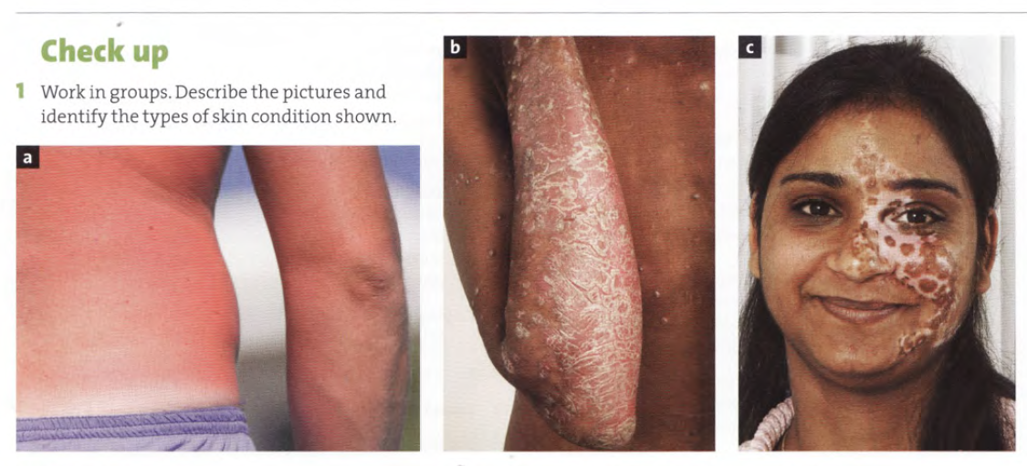
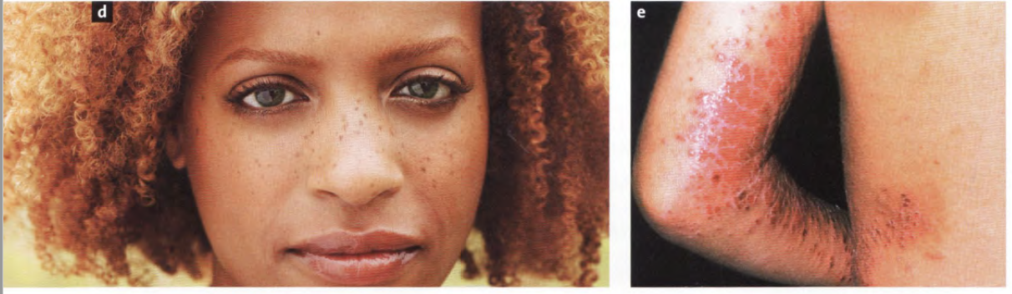
Identify the types of skin condition. What are the causes of each?
a. ______________ the cause of ______________
b. ______________ the cause of ______________
c. ______________ the cause of ______________
d. ______________ the cause of ______________
e. ______________ the cause of ______________

1 Fill in the common words in the table:
spot | lump | birthmark | scab | spot | wart
small blister | blister | scales | boil | scar | mole

Medical term | Common word | Features
macule |  | not raised above the surface of the skin
papule |  | raised above the surface of the skin
nodule |  | a large papule
vesicle |  | filled with fluid
bulla |  | a large vesicle
pustule | ---- | filled with puss
crust |  | dried blood etc. on the surface of the skin
scales |  | a thin layer of epidermis separated from the skin
cicatrix  (plural: cicatrices) |  | a mark on the skin after healing
naevus |  | a coloured skin lesion present at birth
fleshy naevus |  | a raised brown naevus
verruca |  | a nodule produced by HPV
furuncle |  | a large pustule, or skin abscess

2 Fill in the medical terms and the type of force.
incision | abrasion (2x) | contusion | laceration | penetrating wound

Common word | Medical term | Type of force: blunt/sharp
bruise
cut
graze
scratch
stab wound
tear

REVISION
1 Match the internal organs with their descriptions:
1. kidney | a) a tube or cavity, with its surrounding membrane and muscles, that connects the mouth and nasal passages with the oesophagus
2. lung | b) a muscular organ in the body where food is digested
3. liver | c) either of a pair of small organs which take away waste matter from the blood to produce urine
4. pharynx | d) a large gland located behind the stomach that secretes pancreatic juice and insulin
5. brain | e) a small organ where bile (a fluid produced by the liver) is stored and concentrated before it is released into the small intestine
6. intestine | f) either of the two breathing organs in the thoracic cavity
7. stomach | g) a large dark-red oval organ on the left side of the body between the stomach and the diaphragm that produces cells involved in immune response
8. pancreas | h) the organ inside the head which controls thought, memory, feeling, and activity
9. gallbladder | i) a large organ which cleans the blood and produces bile
10. spleen | j) a long tube leading from the stomach which takes waste matter from the body while it is being digested

2 Decide to which systems the following words refer:
tibia | embolus | nonstriated | subcutaneous | whooping
chyme | impacted | wheezy | thymus | tartar
platelet | binge | bolus | cancellous | scale

Can you explain what exactly the words refer to?

