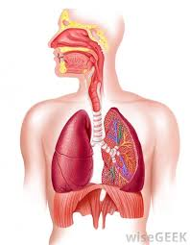
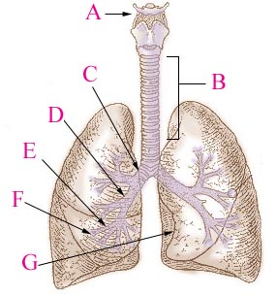
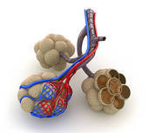
What are the causes, symptoms and treatment of coryza, pneumonia, asthma, bronchitis, emphysema, sinusitis, and lung cancer?
Name the individual parts of the respiratory system.
Describe the process of breathing including gas exchange – which parts are involved and how?
Describe the location and funcion of cilia, pharynx, cardiac notch, vocal cords, bronchioles and diaphragm.
What are the nouns derived from admit, convalesce, immunise, provide, sedate, stammer, stitch, suppress?
Explain the meaning of the following phrasal verbs in medical context: break down, bring up, cough up, drop off, get around, get over, go down, knock out, look after, pass out, pick up, prop up.

