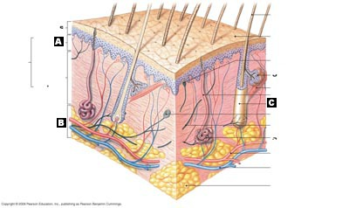
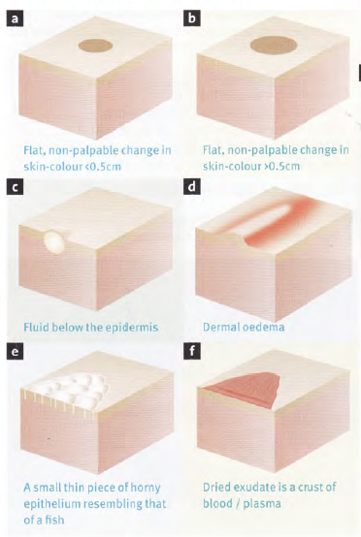
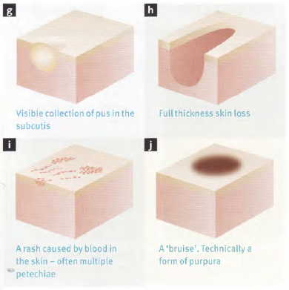
Name the layers of the skin and describe what they contain.
What is the difference between a partial-thickness and full-thickness injury?
What are the functions of the skin?
What lesions are in the diagram?
crust purpura wheal
ecchimosis pustule scale
macule ulcer vesicle
patch
Describe the causes, symptoms and treatment of acne, athlete’s foot, burns, seborrheic dermititis, contact dermititis, psoriasis, basal cell carcinoma, squamous cell carcinoma, malignant carcinoma, vitiligo, hand warts, foot warts, flat warts, and cold sores.

