**Unit 3 Skeletal system**

**Task 1 Complete the following verbs in the correct form:**

*compose comprise consist contain divide make protect serve*

Skeletal system ___________ of about 206 bones. The bones ___________ as a shield and ___________ the vital internal organs from injury. They are ___________ of minerals, organic matter and water. In the bones, there is red and yellow bone marrow, the yellow marrow ___________ fat cells. The spinal column is ___________ up of vertebrae and spinal discs and it is ___________ into several parts, e.g. cervical and thoracic. The upper limb ___________ humerus, ulna and radius.

**Task 2 Label the diagram with the following expressions:**

radius

mandible

fibula

skull

scapula

lumbar vertebrae

cervical vertebrae

thoracic vertebrae

lumbar vertebrae

rib

humerus

ulna

sacrum

tibia

ischium

patella

ilium

sternum

coccyx

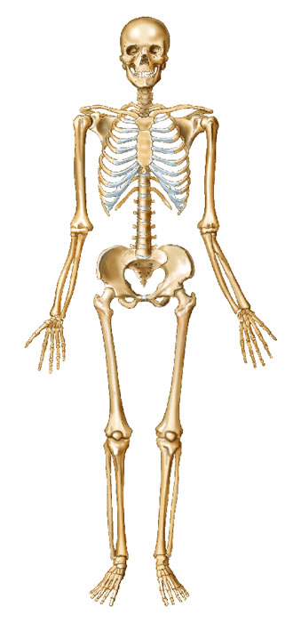

**Task 3 Can you match the terms with their definitions?**

*ligament tendon cartilage joint*

1. a cord or band of strong white fibrous tissue that connects a muscle to a bone
2. the strong tissue that is important especially in joints to prevent the bones from rubbing against each other
3. the site of the junction or union of two or more bones of the body; its primary function is to provide motion and flexibility to the frame of the body
4. a band of fibrous tissue connecting bones or cartilages, serving to support and strengthen joints

**Task 4 Check the meaning of the expressions below, then watch a video and answer the questions.**

*attach exposure storage spongy surface perform a function perpendicular to sth. cushion springiness purposeful embedded range of motion*

1. What is the skeleton?
2. What are the two main structures of the skeleton? How are they lined up?
3. How many named bones are there?
4. What is one of the biggest bones? What is the smallest bone?
5. What are the primary functions of the skeleton?
6. What are the types of the bones? What are their functions?

### Task 5 Complete the gaps with the correct form of the words in brackets.

### Bones pathologies

Treatment of fractures. Complete the gaps with the correct form of the word in brackets.

When the fragments of a ……………………. (break) bone heal and join together, they unite. ……………………(unite) maybe promoted, or helped, by reducing the fracture – replacing the fragments in their ………….….. (anatomy) position if they are displaced. After …………..…. (reduce), ……………… (excess) movement of the bone is prevented by ………….. (fix) – either external, for example a splint or plaster of Paris cast, or internal, for example a pin or plate and screws. A displaced fracture which is not reduced may result in …………… (unite) – incomplete or incorrect union.

**Task 6 The Passive Voice**

**Change the sentences from active to passive.**

Example:

ACTIVE: Fleming discovered penicillin. PASSIVE: Penicillin was discovered by Fleming

1. They applied morphine.

PASSIVE: ,.............................................

1. The doctor is using a bronchoscope to inspect the inside of the lungs.

PASSIVE: ……………………………….

1. They are going to refer the patient to a consultant.

PASSIVE: ………………………………….

1. The lab has found traces of the drug in the blood sample.

PASSIVE:............................................................

1. They can treat a high proportion of cancers by surgery.

PASSIVE: ……………………………………..

1. They will have to amputate his toes.

PASSIVE: ……………………………………….

1. The doctor has anaesthetized the patient.

PASSIVE: ……………………………………….

1. That hospital is developing a new procedure for dealing with Parkinson's disease.

PASSIVE: ……………………………………….

1. You should heat the solution to 25°.

PASSIVE: ……………………………………….

(Based on the Dictionary of Medicine, 2nd Ed. 1994. Peter Collin Publishing. ISBN 0-948549-36-X.)