**Unit 7 Digestive system**

**Task 1**

1. **What parts of the digestive system do you know? In pairs, write down as many as possible.**
2. **Order these steps in the process of digestion by numbering them 1-7.**

a. Salivary glands in the mouth produce enzymes. ___

b. Digestive juices which include powerful acid attack food in the stomach. ___

c. When the food is in the small intestine, juices from the pancreas and bile from the gall bladder dissolve undigested fat.____

d. Food, in a liquid paste form, enters the colon where it removes water. ____

e. Bowel movement expels faeces. _____

f. The first swallow starts the muscle action and pushes food through oesophagus.___

g. The food, now in a semi-solid state, slowly empties into the small intestine.____

**Task 2 Listening**

(How the food you eat affects your brain: <https://www.youtube.com/watch?v=xyQY8a-ng6g>) Play 0:01 – 3:00

**Discuss: What kind of diet do you consider to be the healthiest?**

**Watch the video and answer the questions:**

* What is the brain matter made up of?
* Why are omega 3 and 6 superstars among fats? What food can we get them from? What are the bad fats?
* How do amino acids affect us?
* How can we prevent mood swings?
* Give examples of micronutrients. Why are they useful? What happens if there is a deficiency?

**After you watch:**

**Do you understand the collocations? Use them in sentences.**

*to compromise health susceptible to disease mental decline trace amounts cognitive development*

**Task 3 Case study**

**Read the case history and answer the questions.**

1. What signs and symptoms made Mrs Jobarti realize that she had a problem?
2. What treatment did the healer give her?
3. What did the doctor recommend?
4. What happened to Mrs Jobarti’s stool samples?

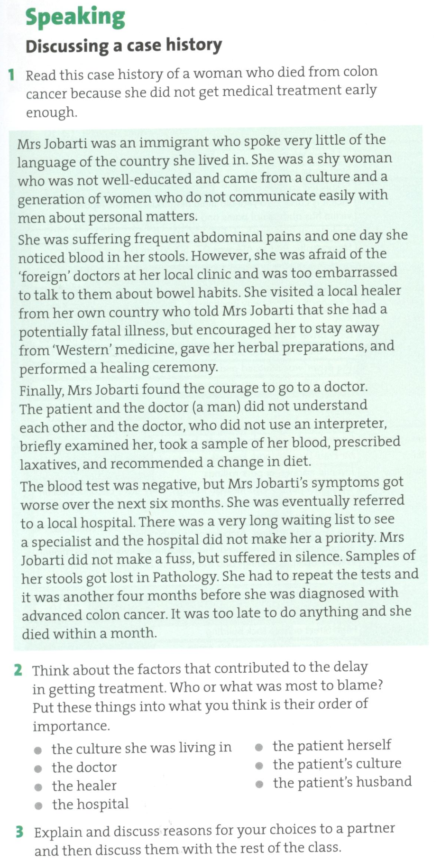

**Speaking – Useful phrases.**

**Complete the phrases with the words given.**

**Expressing opinion**

***in*** ***fa****r* ***way*** ***would*** ***say*** ***point*** ***seems***

I think that/ I would ______ that …

It ______ to me that …

I’d like to ________ out…

The ______ I see it is that …

I’m convinced that …

As ____ as I am concerned…

_______ my opinion/experience…

If you ask me, I _____ say that …

**Clarifying your ideas**

***trying make was talking let***

What I’m _____ about is …

What I (really) meant _______ …

What I was _______ to say was …

Sorry, _______ me explain it again.

Sorry, I obviously didn’t ______ myself clear, what I wanted to say was …

**Agreeing**

***so about point more be***

I totally/fully/partly agree

I couldn’t agree _______.

There is no doubt ________ it.

Exactly. You have a very good _____ here.

I think _____ too.

Yes, definitely.

You may/could _____ right but …..

**Disagreeing**

***say think sure case serious so mean up***

I don’t think ____.

But don’t you ______ that…?

I see what you­­ _______, but…

That’s not always the ________.

I suppose so, but…

I’m not so ______ about that.

I wouldn’t ______ that.

I agree ______ to a point, but…

You can’t be _______! Rubbish!/Nonsense!

**Task 4 Word formation**

**a) Give examples of nouns with the following suffixes:**

-er/-or:

-er and –ee:

-(t)ion/-sion:

-ition/-ation:

-ness:

-ment:

-ity:

-ance/-ence:

-y:

**b) Form noun from the verbs:**

free choose grow know laugh lose

marry please sell speak think friend

appear behave constipate

1. **Form nouns from the following verbs, then fill the gaps in the exercise below with suitable forms of the words.**

***absorb, consume, contract, convert, detoxify, eliminate, expand, ingest, secrete, stimulate***

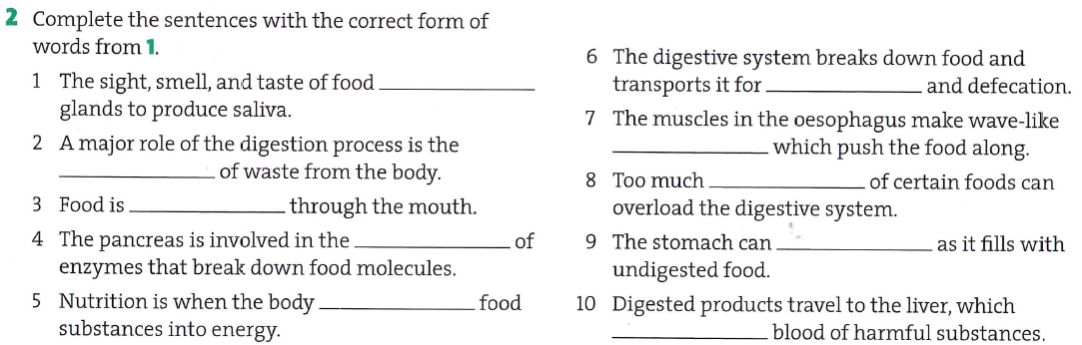

**Task 5 What do you call…?**

* runny (liquid) faeces
* a type of indigestion, the burning sensation eases by eating baking soda (sodium bicarbonate)
* the feeling of being sick, sometimes involves vomiting
* a feeling of cold, with shivering
* being tired, exhausted
* pills that stimulate bowel movements
* eating too much at once, usually junk food
* the condition of being unable to get rid of waste material from the bowels easily