Povinná literatura předmětu CZECH FOR FOREIGNERS V a VIII (2016/2017)
Autumn semester | Spring semester
 1st-4th week
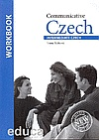  4th-15th week | 1th-15th week
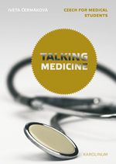



Multilingual website
to study Czech
This website will help you to acquire the basics of Czech, the second most frequently used western Slavic language, as well as medical terminology, all online and all for free.

