ELECTROCARDIOGRAPHY (ECG)

The heart is a muscular organ, which pumps blood through the blood vessels of the circulatory system. Blood provides the body with oxygen and nutrients, as well as assists in the removal of metabolic wastes. The heart is located in the middle compartment of the chest.

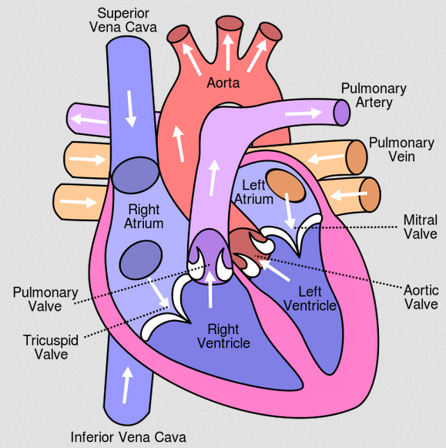In humans the heart is divided into four chambers: upper left and right atria; and lower left and right ventricles. Commonly the right atrium and ventricle are referred together as the *right heart* and their left counterparts as the *left heart*. The heart is enclosed in a protective sac, the pericardium, which also contains a small amount of fluid. The wall of the heart is made up of three layers: epicardium, myocardium, and endocardium.

The heart pumps blood with a rhythm determined by a group of pacemaking cells in the sinoatrial node. These generate a current that causes contraction of the heart, traveling through the atrioventricular node and along the conduction system of the heart. The heart receives blood low in oxygen from the systemic circulation, which enters the right atrium from the superior and inferior venae cavae and passes to the right ventricle. From here it is pumped into the pulmonary circulation, through the lungs where it receives oxygen and gives off carbon dioxide. Oxygenated blood then returns to the left atrium, passes through the left ventricle and is pumped out through the aorta to the systemic circulation−where the oxygen is used and metabolized to carbon dioxide.

Effective blood flow with minimal demand for energy requires synchronized cardiac cycles. The impulse for the contraction of heart cells (cardiomyocytes) is the formation of action potential (excitation) on the cell’s plasma membrane. Cardiomyocytes create functional syncytium, this means that the cells are electrically connected (not isolated). Action potential formed in a certain part of the myocardium extends to the whole heart.

There are two types of cells within the heart:

* the cardiomyocytes
* the cardiac pacemaker cells.

Cardiomyocytes make up the atria (the chambers in which blood enters the heart) and the ventricles (the chambers where blood is collected and pumped out of the heart). These cells are responsible for contraction. The cardiac pacemaker cells ensure the formation of action potential and its extension in the heart to the cardiomyocytes. The cardiac pacemaker cells are determined by three basic characteristics of heart activity:

**1. Automaticity.** Some cardiac fibers have the capability of self-excitation, a process that can cause automatic rhythmical discharge and contraction. This is especially true of the fibers of the heart’s specialized conducting system, including the fibers of the sinus node. For this reason, the sinus node ordinarily controls the rate of beat of the entire heart.

**2. Autonomy.** Impulses for contraction produced in the heart itself. Nervous or humoral mechanisms of regulation may regulate only frequency and cardiac contractility. Heart is able to work even outside the organism in case of constant nutrients and oxygen supply.

**3. Rhytmicity.** Impulses are generated regularly with a certain frequency.

**SPECIALIZED EXCITATORY AND CONDUCTIVE SYSTEM OF THE HEART**

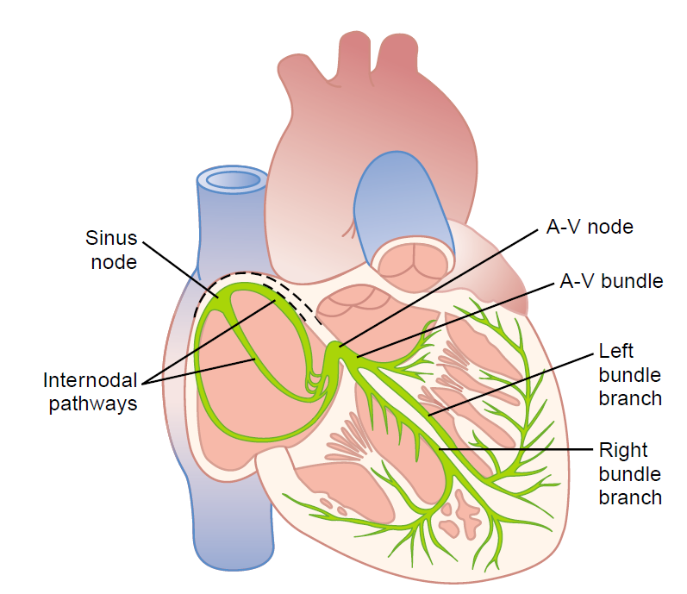

Figure shows the specialized excitatory and conductive system of the heart that controls cardiac contractions. The figure shows the sinus node (also called sinoatrial or S-A node), in which the normal rhythmical impulse is generated; the internodal pathways that conduct the impulse from the sinus node to the atrioventricular (A-V) node; the A-V node, in which the impulse from the atria is delayed before passing into the ventricles; the A-V bundle, which conducts the impulse from the atria into the ventricles; and the left and right bundle branches of Purkinje fibers, which conduct the cardiac impulse to all parts of the ventricles.

**ACTION POTENTIAL OF CARDIAC CELLS**

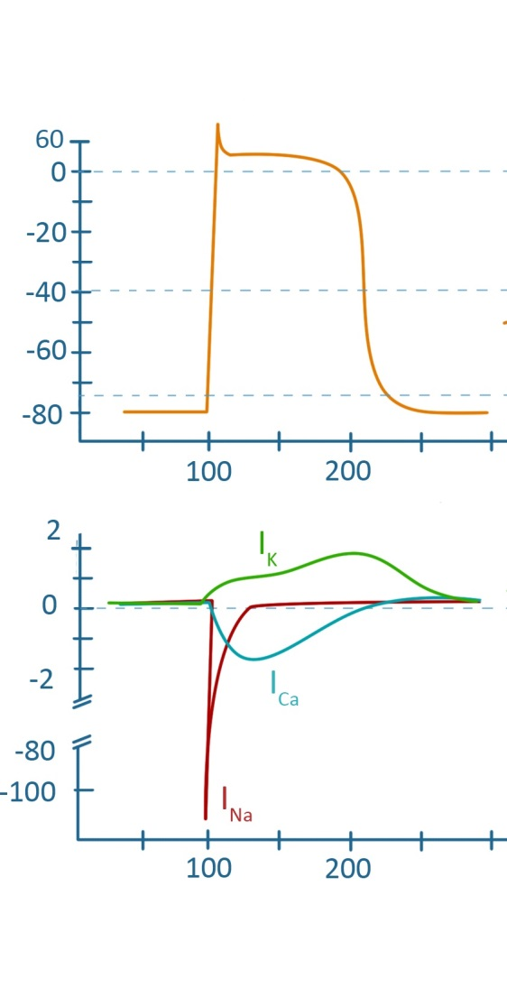Excitable cells respond to adequate stimulus stereotypical electrical responses that we call action potential. Action potential varies according to the type of heart cells and its localization. The action potential is the result of a fine balance between the flowing ion currents.

mV

ACTION POTENTIAL OF CARDIOMYOCYTE

Myocardial fibers have a resting membrane potential of approximately –80 mV.

µA

time, ms

The transmembrane action potential of single cardiac muscle cells is characterized by:

* rapid depolarization (phase 0),
* an initial rapid repolarization (phase 1),
* a plateau (phase 2),
* a slow repolarization (phase 3),
* resting membrane potential (phase 4).

time, ms

The initial depolarization is due to Na + influx through rapidly opening Na + channels (the Na + current, I Na). The inactivation of Na + channels, activation of K+ channels and efflux of K+ ions contributes to the rapid repolarization phase. Ca 2+ influx through more slowly opening Ca 2+ channels (the Ca 2+ current, I Ca) and balance between Ca 2+ and K+ ions produce the plateau phase. Repolarization is due to net K + efflux through multiple types of K + channels.

**ACTION POTENTIAL OF THE CARDIAC PACEMAKER CELLS**

mV

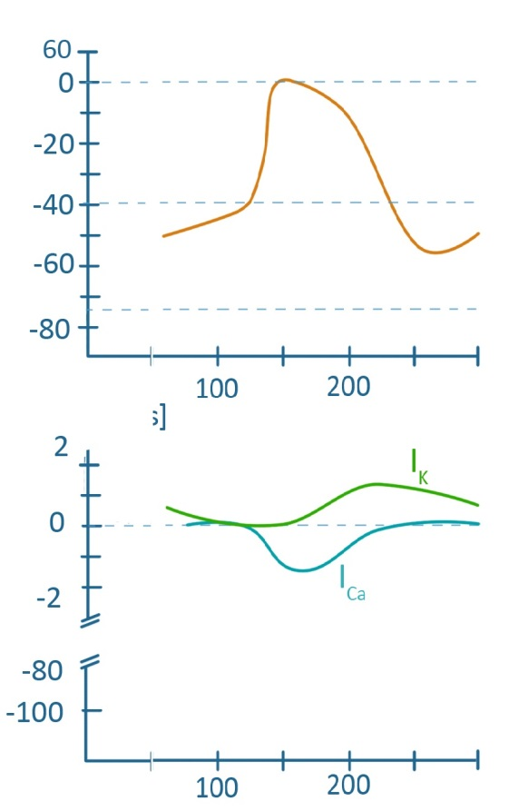Morphology of the action potential SA and AV node differs from the action potential of cardiomyocytes. The most striking difference is the inability to maintain a stable resting membrane potential and significantly slower depolarization.

*Slow diastolic depolarization*. Nodal cells are unable to maintain a constant value of the resting membrane potential. The main reason is the absence of I K (the K+ current), and a relatively high background sodium current. The maximum value of membrane voltage, which cells are able to achieve, is called as the maximum diastolic potential (MDP) and its value is about -50 mV. After reaching the maximum diastolic potential the potassium channels, that responsible for repolarization, are closing and also the calcium channels of T-type are opening. This increases flow of cations into the cell and cause a gradual shift membrane voltage to more positive values - slow diastolic depolarization (SDD).

µA

time, ms

*Depolarization and repolarization.* SDD shifts a membrane voltage of nodal cells to electric zero until it reaches a value about -40 mV. At this membrane voltage value calcium L-type channels are opening. This leads to Ca 2+ influx and to the rapid depolarization. Follow inactivating calcium channels with the opening of fast and slow delayed potassium current cause l repolarization of the nodal cells.

time, ms

**THE ELECTROCARDIOGRAM**

The electrocardiogram (ECG) is a continuous record of cardiac electrical activity obtained by placing sensing electrodes on the surface of the body and recording the voltage differences generated by the heart. The ECG may be recorded by using an active or exploring electrode connected to an indifferent electrode at zero potential (unipolar recording) or by using two active electrodes (bipolar recording).

**Three bipolar limb leads.**

Bipolar leads give the potential difference between two active electrodes placed at different sites. Electrodes of the traditional bipolar limb leads are placed on the left arm, right arm, and left leg. The potential difference between each combination of two of these electrodes give leads I, II, and III.

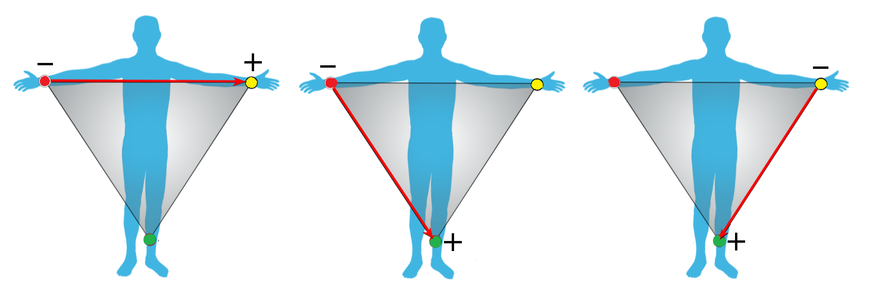

***Lead I***. To recording limb lead I, the negative terminal of the electrocardiograph is connected to the right arm and the positive terminal to the left arm.

***Lead II***. To record limb lead II, the negative terminal of the electrocardiograph is connected to the right arm and the positive terminal to the left leg.

***Lead III***. To record limb lead III, the negative terminal of the electrocardiograph is connected to the left arm and the positive terminal to the left leg.

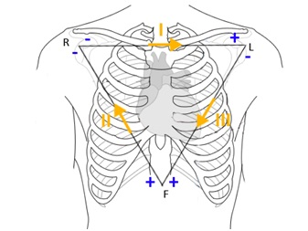Einthoven’s Triangle. In image, the triangle, called Einthoven’s triangle, is drawn around the area of the heart. This illustrates that the two arms and the left leg form apices of a triangle surrounding the heart. The two apices at the upper part of the triangle represent the points at which the two arms connect electrically with the ﬂuids around the heart, and the lower apex is the point at which the left leg connects with the ﬂuids.

Einthoven’s Law. Einthoven’s law states that if the electrical potentials of any two of the three bipolar limb electrocardiographic leads are known at any given instant, the third one can be determined mathematically by simply summing the ﬁrst two (but note that the positive and negative signs of the different leads must be observed when making this summation).

**Unipolar lead**

Unipolar lead is the pair of electrical conductors giving the potential difference between an exploring electrode and a reference input, sometimes called the indifferent electrode. The reference input comes from a combination of electrodes at different sites, which is supposed to give roughly zero potential throughout excitation of the heart. Assuming this to be the case, the recorded electrical activity is the result of the influence of cardiac electrical activity on the exploring electrode. By convention, when the exploring electrode is positive relative to the reference input, an upward deflection is recorded.

**Augmented unipolar limb leads**

The exploratory electrode for an augmented limb lead is an electrode on a single limb. The reference input is the two other limb electrodes connected together. Lead aVR gives the potential difference between the right arm (exploring electrode) and the combination of the left arm and the left leg (reference). Lead aVL gives the potential difference between the left arm and the combination of the right arm and left leg. Lead aVF gives the potential difference between the left leg and the combination of the left arm and right arm.

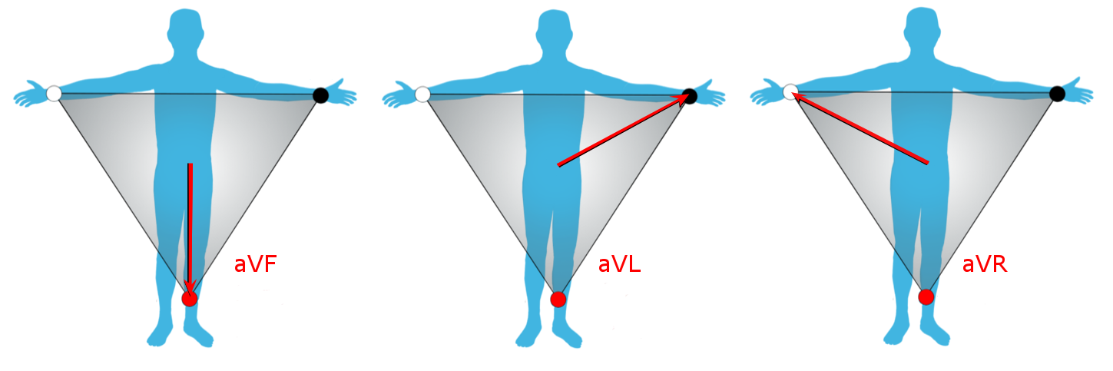

**Chest leads (precordial leads)**

The exploring electrode for the precordial or chest leads is the single electrode placed on the anterior and left lateral chest wall. For the chest leads, the reference input is obtained by connecting the three limb electrodes. The observed ECGs recorded from the chest leads are each the result of voltage changes at a specified point on the surface of the chest. Unipolar chest leads are designated V1 to V6 and are placed over the areas of the chest.

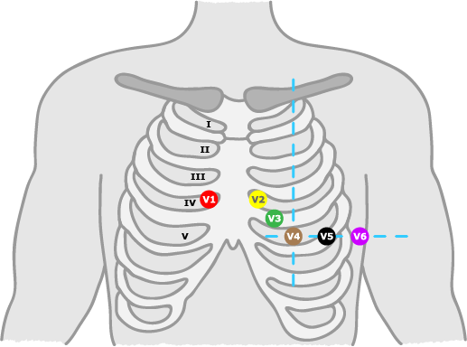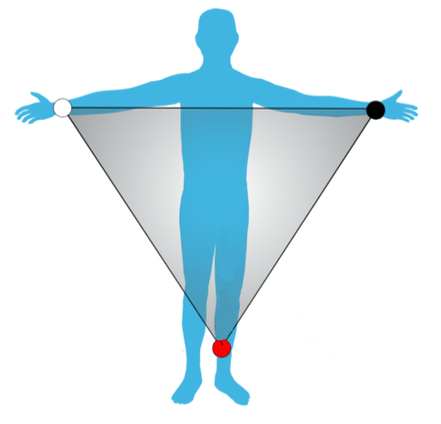

V1 – V6

ECG CURVE

A standard 12-lead ECG, including six limb leads and six chest leads, it means that we use 10 electrodes (3 limb electrodes, 6 chest electrodes and 1grounding electrode). Whole measurements in healthy person are provided at the II lead.

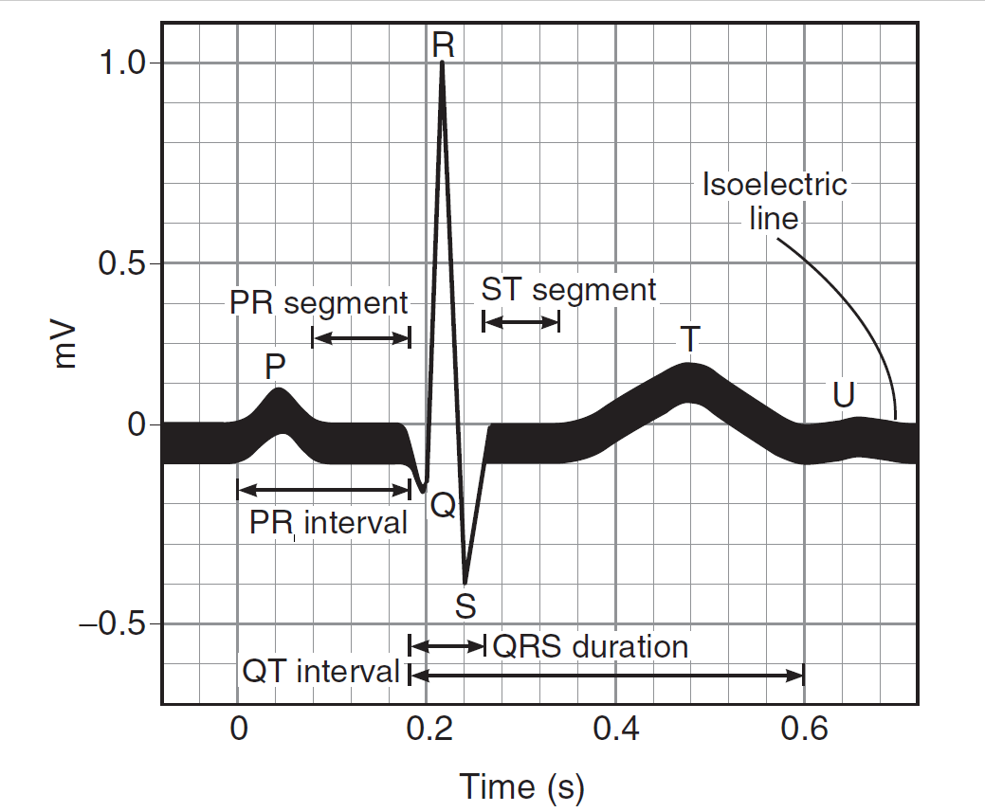

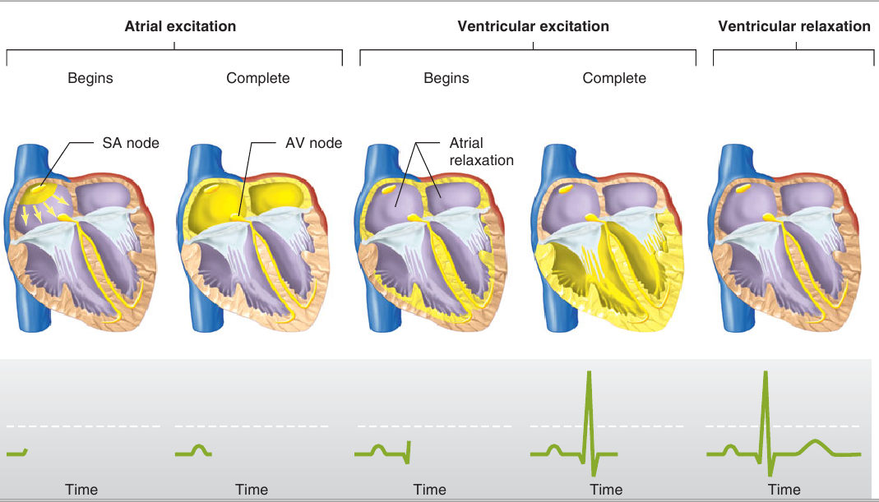

**the T wave**

The T wave represents the repolarization of the ventricles.

It is generally upright in all leads except aVR and lead V1.

|  |  |
| --- | --- |
|  | **QRS complex**  The QRS complex represents the rapid depolarization of the right and left ventricles. The ventricles have a large muscle mass compared to the atria, so the QRS complex usually has a much larger amplitude than the P-wave. |

**the P wave**

The p-wave represents depolarization of the atria. Atrial depolarization spreads from the SA node towards the AV node, and from the right atrium to the left atrium.

# AIM:

# Practically acquire ECG recording, its evaluation for clinical practice.

# EQUIPMENT:

# Set of standard limb electrodes, 6 chest single-use electrodes with connectors to cables or electrodes with fastening belt, connecting cables, PC, ECG gel, cotton-wool, examination bed, ECG ruler.

# PROCEDURE:

Clean the skin of the examined subject with the alcohol and spread ECG contact gel on the electrodes. Place the single-use electrodes on the corresponding places. Connect all electrodes by connecting cables, which are marked with respective letter and – in case of limb electrodes – by respective color.

*The places for fixing the electrodes*

Limb leads: red electrode: right hand wrist

yellow electrode: left hand wrist

green electrode: left foot

black electrode: right foot

Chest leads: V1 4th intercostal space right from the sternum

V2 4th intercostal space left from the sternum

V4 5th intercostal space in the left medioclavicular line

V3 between V2 a V4

V5 5th intercostal space in the left front axillar line

V6 5th intercostal space in the left medial axillar line

# Working with PC:

1. Start program ECG-Seiva (icon with heart)

2. Press button **Ins** and set name and surname of experimental subject; other values are not relevant for practical. Confirm by pressing **CTRL+Enter**. Press twice “**Beru na vědomí**”.

3. By pressing **F4**activate ECG recording.

4. Press **F4** to start 10 sec ECG recording; it is necessary for experimental subject to stay calm. Registration will terminate automatically.

5. Print the record by pressing **F6**.

6. To return to the main menu, press Alt+F4. For examination of next experimental subject, repeat the procedure from step 2.

7. Terminate the program by repeated pressing of **Alt+F4**

##### EVALUATION OF ECG RECORD:

**1. Heart rhythm:** is heart rhythm regular? YES (heart rhythm is regular)

NO (heart rhythm is irregular)

**Rhythm source:** is each QRS complex preceded by P wave? YES (sinus rhythm)

NO (idiopathic rhythm)

**2. Heart rate:** from PC:…………………………………………………………..

calculation from paper peed (25mm/s)……………………………

evaluation according to ECG ruler………………………………..

**3. Duration of:** RR interval…………………………………

PQ interval………………………………….

QRS complex……………………………….

QT interval………………………………….

Interesting task: estimate Sokolow - Lyon index [S wave (V1 or V2) + R (V5 or V6)]: ….……………………………………………………………………………………………….

(> 35 mm = left ventricle hypertrophy)

Construct **electrical axis** of the heart from two limb leads into the Einthoven triangle and measure its angle in frontal plane. Assess its angle in horizontal plane from chest leads.

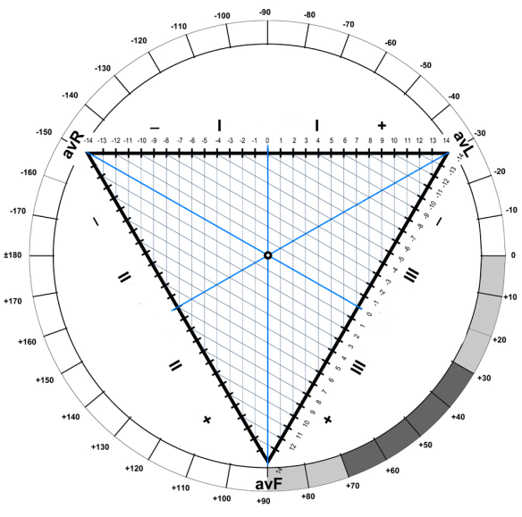

**Conclusion**………………………………………………………………………………………

…………………………………………………………………………………………………

…………………………………………………………………………………………………

…………………………………………………………………………………………………

…………………………………………………………………………………………………

…………………………………………………………………………………………………

…………………………………………………………………………………………………

…………………………………………………………………………………………………

…………………………………………………………………………………………………