**SLIT LAMP – BACKROUND FOR PRACTICE**

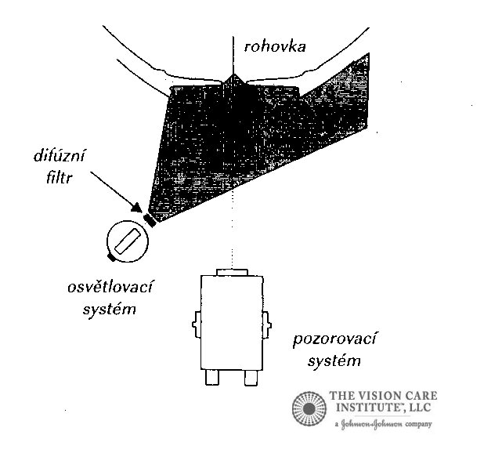**Diffuse light** – We use it to start testing, with small zoom of slit lamp (10 – 16x).

* + **Settings**: We use diffusion filter before light ray, angle of ray with microscope is 10° - 70°, intensity of shine we regulate with rheostat or changing width of slit width
  + **Observe**: We can see clearly every structure of anterior eye segment including tarsus, conjunctiva and puncta lacrimalia.

Notes: …………………………………………………………………………………………………………………………………………………….

………………………………………………………………………………………………………………………………………………………………..

………………………………………………………………………………………………………………………………………………………………..

………………………………………………………………………………………………………………………………………………………………...

**Direct light -** is characteristic by a common focus of light and observe system on one place. We have then more options of settings:

* 1. **Optical cut** – Is characteristic by very thin of light ray with maximum intensity.

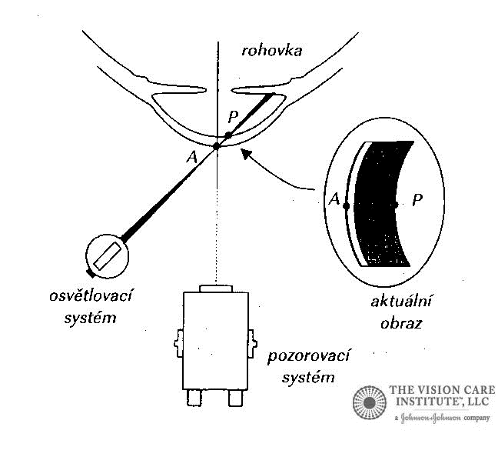

* + **Settings**: Ray thin we set on 0,02 – 0,1 mm, ray forms with the axis of observation 30°- 60°. Intensity is on maximum.
  + **Observe**: Objects in the cornea, changes in the endothelium, stroma end epithelium.

Notes: ………..………………………………………………………………………………………………………………………………………….

………………………………………………………………………………………………………………………………………………………………..

………………………………………………………………………………………………………………………………………………………………..

………………………………………………………………………………………………………………………………………………………………...

* 1. **Parallel cuts** – This method is based on optical cut, the main difference is wider ray. We use it most often.

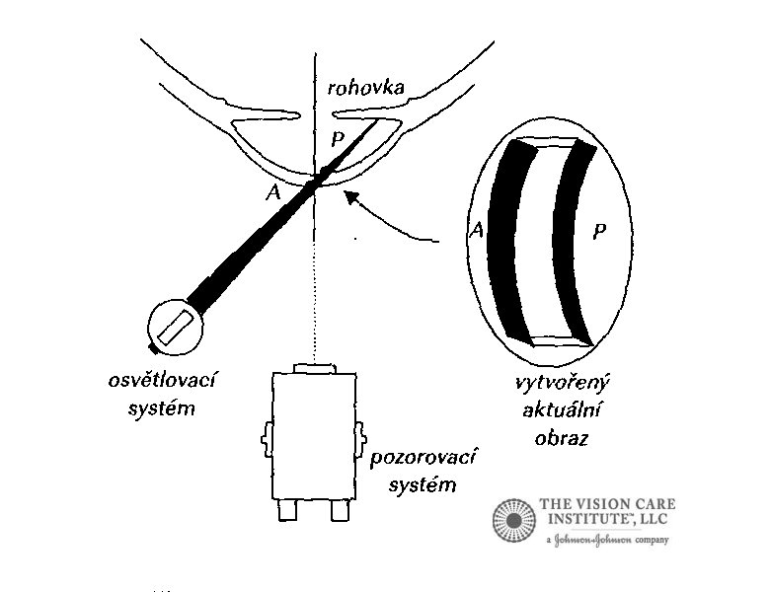

* + **Settings**: thin of cut is similar with approximate thin of cornea (0,1 – 0,7mm), zoom we change according to the size of the observed object
  + **Observe**:the corneal endothelium, erosion of the epithelium, vascularisation

Notes: …………………………………………………………………………………………………………………………………………………….

………………………………………………………………………………………………………………………………………………………………..

………………………………………………………………………………………………………………………………………………………………..

………………………………………………………………………………………………………………………………………………………………...

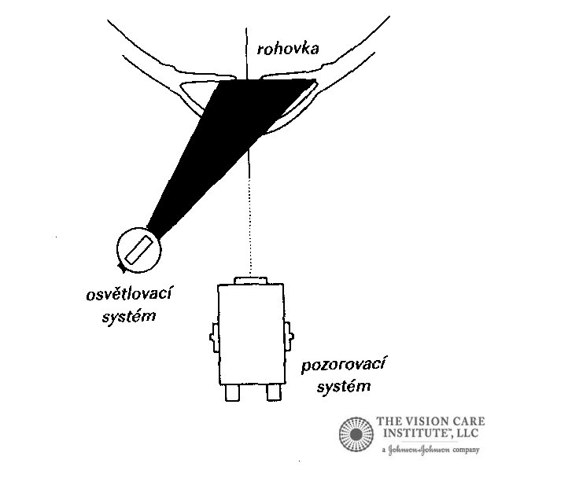

* 1. **Wide ray** – ray is more wide then by parallel cuts
  + **Settings**: based on settings parallel cuts, wide of ray is bigger than thin of cornea 1 – 5mm. Light intensity is reduced.
  + **Observe**:conjunctiva anomalies, pterygium, iris, space of anterior chamber.

Notes: ….……………………………………………………..………………………………………………………………………………………….

………………………………………………………………………………………………………………………………………………………………..

………………………………………………………………………………………………………………………………………………………………..

………………………………………………………………………………………………………………………………………………………………...

* 1. **Cone ray** – we use it for observe space of anterior chamber.

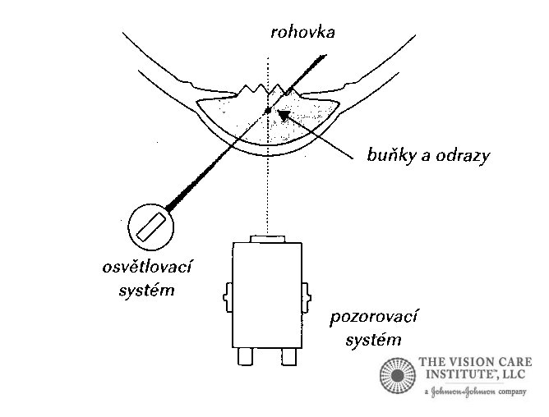

* **Settings**: ray width is same as for optical cut, high is reduced to 1 – 2mm, intensity in on maximum
* **Observe:** space of anterior chamber

Notes: …………………………………………………………………………………………………………………………………………………….

………………………………………………………………………………………………………………………………………………………………..

………………………………………………………………………………………………………………………………………………………………..

………………………………………………………………………………………………………………………………………………………………...

* 1. 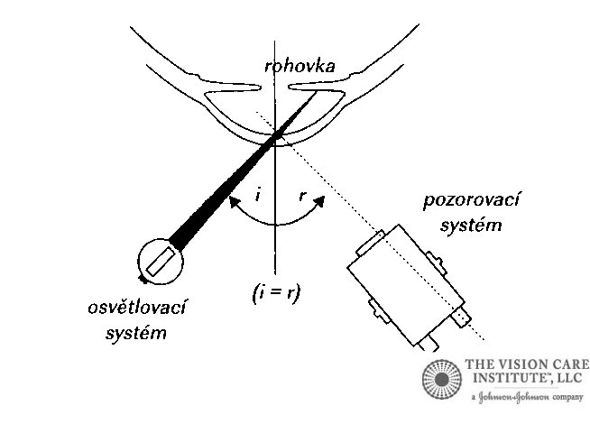**Mirror reflex –** special way to use parallel cuts
  + **Settings**: we set parallel cuts and minimum zoom, than we run with observe and lighting system to the same angle from the middle, the mirror reflex is when we see in one ocular maximum zoom and in the second brilliant reflex.
  + **Observe**: quality of tear film, endothelium.

Notes: …………………………………………………………………………………………………………………………………………………….

………………………………………………………………………………………………………………………………………………………………..

………………………………………………………………………………………………………………………………………………………………..

………………………………………………………………………………………………………………………………………………………………...

* 1. **Oblique illumination –** we use it for display poorly observable objects.
  + **Settings**: Based on parallel cuts, but lighting system is on angle 90°. Than we can see fine unevenness in the structure
  + **Observe**: unevenness in the conjunctive and iris structure, cysts on the conjunctiva, pterygium.

Notes: …………………………………………………………………………………………………………………………………………………….

………………………………………………………………………………………………………………………………………………………………..

* 1. **Oscillation illumination –** based on moving with lighting system, but because of this instability is not so much use.
* **Observe:** details of the defects.

Notes: …………………………………………………………………………………………………………………………………………………….

………………………………………………………………………………………………………………………………………………………………..

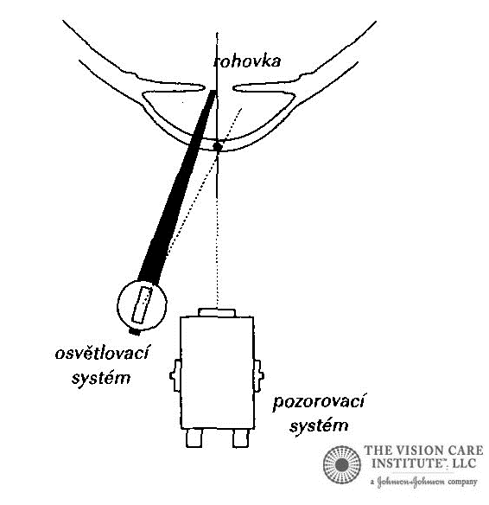**Indirect lighting –** the lighting and observe system is focused on different places, then we can see scattered lighting.

* + - 1. **Lighting surrounding area** – we observe character of cornea by the corneal illness like the pterygium.
  + **Settings**: based on parallel cuts, then we turn the prism of the slit lamp and the lighting system we focused on the observe object.
  + **Observe**: Surroundings of the corneal illness.

Notes: …..……………………………………………………………………………………………………………………………………………….

………………………………………………………………………………………………………………………………………………………………..

………………………………………………………………………………………………………………………………………………………………..

………………………………………………………………………………………………………………………………………………………………...

* + - 1. **Scleral scatter –** based on light propagation through the cornea. Then we can see the illness which penalizing the whole cornea.

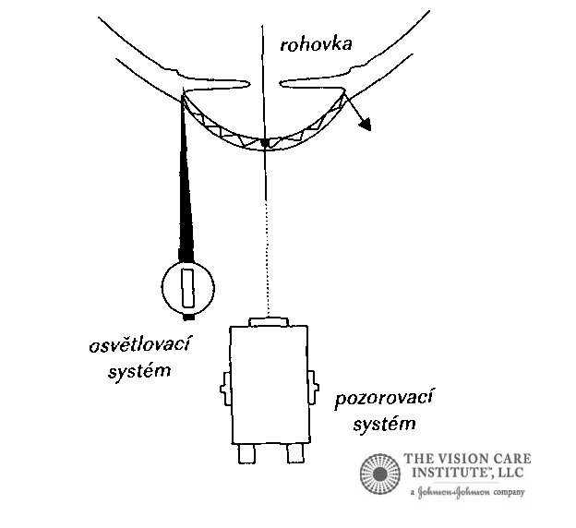

* + - * **Settings**: Based on parallel cuts with bright angle (45° – 60°), we turn the prism on temporal part of limbus, and then we have shining on the opposite site of lighting.
      * **Observe**:edema, scar, central opacities.

Notes:……………………………………………………………………………….…………………………………………………………………….

………………………………………………………………………………………………………………………………………………………………..

………………………………………………………………………………………………………………………………………………………………..

………………………………………………………………………………………………………………………………………………………………...

* + - 1. 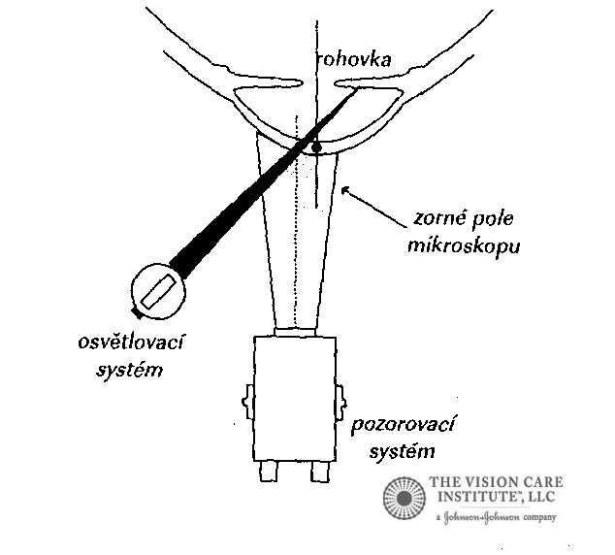**Reverse exposure –** uses lighting of observe objects in the light reflected from another structure.

We divided on:

* + - **Direct –** viewed against the background illumination
    - **Indirect –** viewed against a dark background

Notes: …………………………………………………………………………………………………………………………………………………….

………………………………………………………………………………………………………………………………………………………………..

………………………………………………………………………………………………………………………………………………………………..

………………………………………………………………………………………………………………………………………………………………...