# P12 Clinical microbiology III – examination in urogenital infections

**To study:** special bacteriology from your own protocols

## Urinary tract infections

## Task 1: Sampling and transport of urine

According to the teacher’s explanation, tick which sentences concerning urine sampling and transportation are true/false.

|  |
| --- |
| Urine examination is recommended in non-complicated and necessary in complicated cystitis. ❒ true ❒ false |
| Microbiologists recommend the use of catheterized urine as a routine way of sampling the urine for bacteriology. ❒ true ❒ false |
| It is not important whether foreskin (prepuce – in men) or labia minora (in women) are in the way of urine stream during sampling the urine for bacteriology. ❒ true ❒ false |
| External orifice of urethra should be carefully washed and eventually also disinfected before sampling the urine for bacteriology. ❒ true ❒ false |
| The vessel into which the patient urinates should be sterile. ❒ true ❒ false |
| The test tube used for urine transportation to the laboratory should have a yellow cap. ❒ true ❒ false |
| If urine is not “routinely taken”, the order form should contain information whether it has been catheterized, punctured, or whether it is a specimen taken from a permanent catheter. ❒ true ❒ false |
| Urine from a permanent catheter is equally important for bacteriological diagnostics as the catheterized urine (just for examination). ❒ true ❒ false |
| Urine specimen should be delivered to the laboratory within 2 hours after sampling; if this is impossible, it should be kept in a refrigerator. ❒ true ❒ false |
| Urine sample is better than urethral swab in gonorrhoea diagnostics. ❒ true ❒ false |

## Task 2: Inoculation of sample of urine

Observe your teacher demonstrating for you inoculation of sample of urine (or video with the same topic, if available). Fill in empty places in the following text:

Urine sample is inoculated using calibrated loop, made of ______________________. The term “calibrated” means that it is set to specific volume, usually _______. The specimen of urine is inoculated to two media: __________________________ and ______________________________. Instead of the second medium we could also use ________________________________ or _____________________________. After inoculation, the specimen is incubated overnight in a thermostat at _____°C.

## Task 3: Evaluation of semiquantitative cultivation of urine

After inoculation and incubation (see Task 2), the agar plates with result of urine specimen cultivation are evaluated. The number of colonies is counted (of estimated approximately) and recounted to number of bacteria in a millilitre of the original specimen of urine.

|  |  |  |  |
| --- | --- | --- | --- |
| Number of colonies on agar | Number of bacteria in one microlitre of the original urine (µl) | Number of bacteria in one millilitre of the original urine (ml) | Interpretation |
| <10 |  |  |  |
| 10–100 |  |  |  |
| >100 |  |  |  |

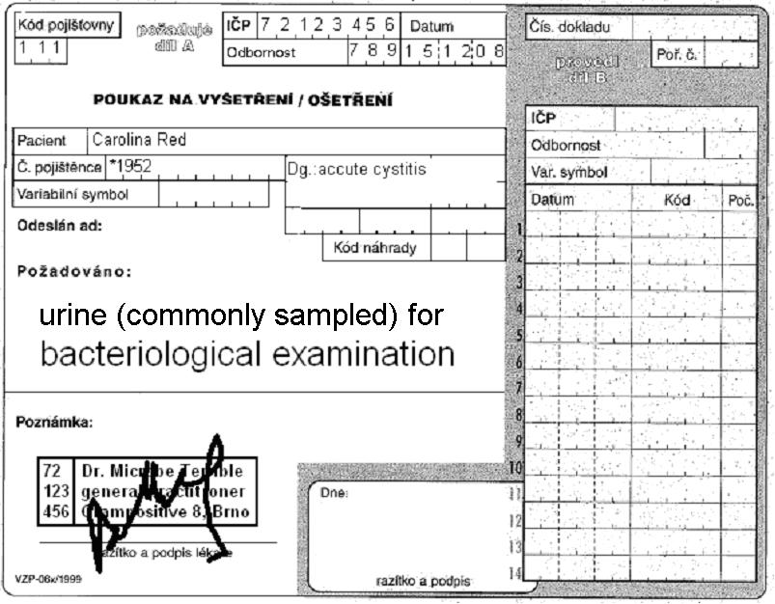

Form for results of Enterotest 16:

|  |  |  |  |  |  |  |  |  |  |  |  |  |  |  |  |  |
| --- | --- | --- | --- | --- | --- | --- | --- | --- | --- | --- | --- | --- | --- | --- | --- | --- |
| ONPG | 1H | 1G | 1F | 1E | 1D | 1C | 1B | 1A | 2H | 2G | 2F | 2E | 2D | 2C | 2B | 2A |
| + | black | blue | red | blue | red | green | black | blue | blue | yellow | yellow | yellow | yellow | yellow | yellow | yellow |
| – | colourless | green | yellow | green | yellow | yellow | colourless | yellow | yellow | green | green | green | green | green | green | green |
| ? |  |  |  |  |  |  |  |  |  |  |  |  |  |  |  |  |
| 1 | 2 | 4 | 1 | 2 | 4 | 1 | 2 | 4 | 1 | 2 | 4 | 1 | 2 | 4 | 1 | 2 |
|  | | |  | | |  | | |  | | |  | | |  | |
| Code: | | | | | | Identification | | | | | | Probability % | | | T index | |

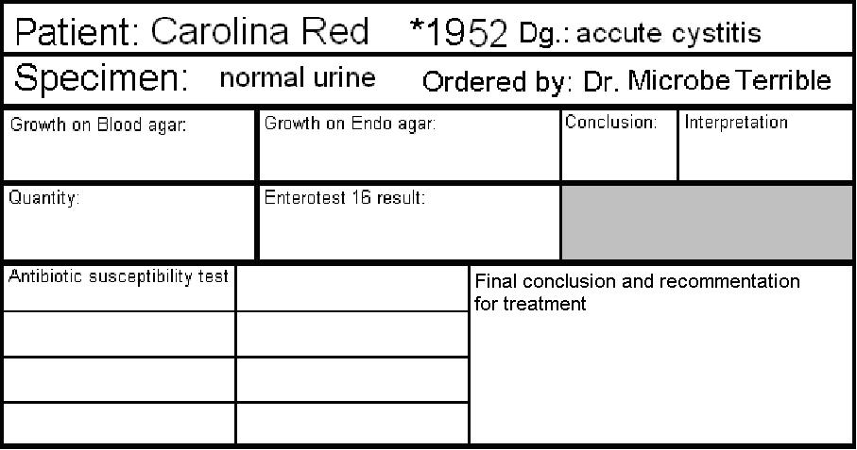

Chromotest URI medium

Antibiotic susceptibility test

|  |  |  |  |  |  |
| --- | --- | --- | --- | --- | --- |
| Ampicillin  AMP | R < 14  S ≥ 14 |  | Tetracycline*  TE | R < 12  S ≥ 15 |  |
| Cephazolin  KZ | R < 14  S ≥ 18 |  | Cefuroxime  CXM | R < 18  S ≥ 18 |  |
| Co-trimoxazole SXT | R < 13  S ≥ 16 |  | Norfloxacin  NOR | R < 19  S ≥ 22 |  |
| Nitrofurantoin  F | R < 11  S ≥ 11 |  |  |  |  |

write S = susceptible, R = resistant, eventually I = intermediary

*result of this test is also valid for doxycycline

Final conclusion and recommendation for treatment: _______________________________________________

## Task 4: Interpretation and treatment of UTI

In following table in each cell (except cells in the first column) **one term is wrong.** Add a dot to all terms you consider wrong. After that, check your choice with your teacher, and **strike through all the really false terms**.

|  |  |  |  |
| --- | --- | --- | --- |
| Clinical situation | Most likely pathogens | Drug of choice for initial therapy | Alternative drugs (allergy etc.) |
| Asymptomatic bacteriuria (ABU)  pregnant women | *Escherichia coli*  *Klebsiella pneumoniae*  *Streptococcus pyogenes*  *Enterococcus* sp. | nitrofurantoin*  ofloxacin | amoxicillin  linezolide |
| Asymptomatic bacteriuria (ABU)  other situations | no therapy  nitrofurantoin | no therapy  cefuroxime |
| Acute non-complicated cystitis (community cystitis, that means „not-nosokomial“ one) | *Clostridium* sp.  *Escherichia coli*  *Staphylococcus saprophyticus*  *Klebsiella pneumoniae* | ciprofloxacin  nitrofurantoin | co-trimoxazole  (co-)amoxicillin  vankomycin  cefuroxime |
| Accute pyelonephritis | *Escherichia coli*  *Bacteroides fragilis*  *Klebsiella pneumoniae*  *Proteus* sp. | (co-)amoxicilin  cefuroxime  nitrofurantoin | co-trimoxazole  norfloxacin  imipenem |

*except first trimester and the second haft of the third trimester

## Infections of genital system

## Task 5: Sampling methods in STIs and other infections of reproductive organs

Find suitable swabs or other sampling methods for following clinical situations (suspicions for individual diseases). For some of them more than one sampling method is suitable. Use numbers 1 to 6 and mark your choice to individual situations. Correct yourself with help of your teacher.

Bacterial vaginosis

Aerobic vaginitis

Vaginal mycosis

Gonorrhoea

Syphilis

Mycoplasma infection

Chlamydia infection

Papillomavirus infection

Numbers: 1 – Amies swab 2 – C. A. T. swab 3 – plain (dry) swab 4 – a smear on a slide 5 – clotted blood for indirect examination 6 – ulcus durum scraping for dark-field microscopy and PCR

## Task 6: Evaluation of vaginal smears

In diagnostics of vaginal infections, one very important method is microscopy. Cultivation results may be positive even when the amount of bacteria (e. g. *Gardnerella* sp.) is not significant. Therefore, microscopy is better, because we can see the ratio between various *morphotypes* of bacteria, and also other structures (epithelial cells including those with adhered bacteria – so called “clue cells”; white blood cells; yeast cells etc.). Sometimes, two smears are sent to the laboratory: one is stained by Giemsa staining (almost because of Trichomonas vaginalis diagnostics, as *T. vaginalis* cannot be Gram stained very well) and the other by Gram (especially for bacteriology).

____________________________________

________________________________­­­­____

Nugent score for BV:

Observe a result of a vaginal smear and draw your result in the laboratory report. Try to count the **Nugent score of bacterial vaginosis** with help of following guide:

**A. Morphotypes**

* **Morphotype *Lactobacillus*** = **robust** and long G+ rods
* **Morphotype *Gardnerella/Bacteroides*** = **subtle** Gram-negative or Gram-variable **straight** rods
* **Morphotype *Mobiluncus***= **subtle** Gram-negative **curved** rods.

Other objects (cocci, human origin cells, yeast cells) are **not counted**

**Note:** the term *morphotype* means “bacteria that look in the microscope the same as”, so not all bacteria of *Gardnerella/Bacteroides* morphotype are really either *Gardnerella* or *Bacteroides*.)

**B. The counting system (+ to ++++) – simplified**

|  |  |
| --- | --- |
| Bacteria are **extremely frequent**, they may be seen in the first moment of looking to the field | ++++ |
| Bacteria are **very frequent**, each field contains lots of them | +++ |
| Bacteria are **present in each field**, but they are not frequent | ++ |
| Bacteria are not very frequent, there are **fields with no bacteria at all** | + |
| Bacteria are **completely absent** | – |

Note: Similar system can be also used for other microscopies, e. g. sputum evaluation

**C. The proper Nugent scoring system (simplified):**

|  |  |  |  |
| --- | --- | --- | --- |
| Points added | *Lactobacillus* morphotype presence | *Gardnerella/Bacteroides* morphotype presence | *Mobilluncus* morphotype presence |
| 0 | ++++ | – | – |
| 1 | +++ | + | + or ++ |
| 2 | ++ | ++ | +++ or ++++ |
| 3 | + | +++ |  |
| 4 | – | ++++ |  |

So each smear may get 0 to 4 points for *Lactobacillus* morphotype (the more bacteria of this morphotype, the **less** points), 0 to 4 points for *Gardnerella/Bacteroides* morphotype presence morphotype (the more bacteria of this morphotype, the **more** points) 0 to 2 points for *Mobilluncus* morphotype presence morphotype (the more bacteria of this morphotype, the **more** points)

The criterion for bacterial vaginosis according to Nugent's criteria is a total score of 7 or more is labeled as Bacterial Vaginosis a score of 4 to 6 is called intermediate, and a score of 0 to 3 is considered normal.

*Reliability of diagnosing bacterial vaginosis is improved by a standardized method of gram stain interpretation. R P Nugent, M A Krohn, and S L Hillier, J Clin Microbiol. 1991 February; 29(2): 297–301.*

## Task 7: Evaluation of vaginal swabs

Vaginal swabs are usually cultured on following media:

* **blood agar** (for common bacterial pathogens)
* **Endo agar** (or McConkey agar)
* **Agar with 10 % NaCl** (for staphylococci)
* **Special blood agar variant for *Gardnerella vaginalis*** (GVA agar)
* **WCHA agar** (anaerobic culture) – only sometimes

As a normal flora, we can observe lactobacilli: very tiny colonies with viridation. There exist many species of lactobacilli, with different relations with oxygen, although they use to be microaerofilic. In practice, it is possible to see three variants of the growth of these microbes:

* sometimes they are able to grow even on blood agar in the **normal atmosphere**
* sometimes they do not grow in aerobic conditions, but they grow on *Gardnerella* agar in an incubator with **elevated CO2 concentration**
* sometimes they only grow on WCHA **in anaerobic conditions.**

So, be prepared to all possibilities and do not be surprised.

Besides lactobacilli, some other findings can be still considered “normal”, namely

* small amounts of coagulase-negative staphylococci
* small amounts of *Enterobacteriaceae*
* small amounts of anaerobic bacteria (if they are not very frequent and they smell is not that of big intensity, they are mostly considered “normal finding”)

On the other hand, sometimes lactobacilli are absent, especially in swabs taken from women after climacterium, or as a result of previous antibiotic treatment.

Write your findings and try to make a conclusion.

|  |  |  |  |
| --- | --- | --- | --- |
| Medium | Normal finding | Possible pathogens | My finding |
| Blood agar | Lactobacilli, small amounts of coagulase negative staphylococci, very small amounts of *Enterobacteriaceae* | *Staphylococcus aureus*, *Enterobacteriaceae, Streptococcus agalactiae* and many others |  |
| Endo agar | No growth, or just very small amounts of *Enterobacteriaceae* | Mostly *Enterobacteriaceae* |  |
| NaCl agar | No growth, or a staphylococcus later proven to be coagulase-negative species | Mostly *Staphylococcus aureus* |  |
| GVA agar | Like on blood agar (maybe different morphology of colonies) | *Gardnerella* seen as very small colonies with partial haemolysis* |  |
| WCHA agar | Like on blood agar, + even small amounts of anaerobic bacteria | Anaerobic bacteria in huge amounts presenting unpleasant scent |  |
| More tests  (only if performed): | | | |

*Compare with a positive control, if available

**Final conclusion:**

**In my “red box team” of letter ____*, we have found**

* Normal flora only
* Normal flora with a patogen, namely ______________________________________

*A, B, C, D, E, F, G or H