# P13 Clinical microbiology IV – examination of wound and bloodstream infections

**To study**: Your own protocols (especially Special bacteriology)

## Wound infections

## Task 1: Specimens in wound infections

Try to fill in the following table:

|  |  |  |  |  |
| --- | --- | --- | --- | --- |
| Type of wound | Superficial wound | Deep wound with amount of pus sufficient for being sent as a liquid | Deep wound with not sufficient amount of pus | Wound with pus, possibly containing anaerobic bacteria |
| Sampling method |  |  |  |  |
| When a specimen from a wound is send to the laboratory, it is very important to fill in the request form, especially to write 1) _____________________________ and 2) _____________________________________ | | | | |

## Task 2: Indirect imprint method for superficial wound examination

## a) Indirect imprint method – performing

Perform the indirect imprint method in pairs. Place a sterile filtration paper on your mate‘s forearm (instead of a superficial wound). Let it 10 seconds here, then using tweezers, transport it carefully to a Petri dish with nutrient agar. After that, remove it and throw it away.

*In practice, the filtration paper is not discarded, but sent together with the agar plate to the laboratory. In the laboratory the filtration paper is placed to two or three more media: agar with 10 % NaCl, chromogenic URI medium etc. After that, all media are cultivated overnight.*

## b) Indirect imprint method – reading of results

Try to read the preliminary result of imprint method on URIchrom chromogenic medium using recounting scheme on your table and with the help of the key of colours of individual bacteria on the chromogenic medium. Attention! You have real results from real patients. Your result is not supposed to be the same as the result of your neighbour with another agar plate. Even the number of strains may be different. More precise determination and antibiotic susceptibility test would not be performed in this task.

**The cultivation result of my imprint contained:**

|  |  |
| --- | --- |
| Likely group or genus of bacterium | Quantity (approx. number of colonies per 25 cm2) |
| 1. |  |
| (2.) |  |
| (3.) |  |

**Clue for preliminary diagnostics: Staphylococci** – white on URI, growing also on NACL, white colonies on blood agar; **Haemolytic streptococci** – haemolytic colonies on blood agar, not growing on NACL, on URI not growing or *(S. agalactiae)* pale turquoise blue. **Enterococci** have greyish colonies on blood agar and small, but rich turquoise colonies on URI. **Enterobacteriaceae and G- non-fermenters** – growing on Endo agar. ***Escherichia*** is pink on URI, ***Klebsiella*** is blue on URI, ***Proteus*** is yellow on URI, ***Pseudomonas*** is white or slightly green (because of its own pigmentation) on URI. *All this is only preliminary, the algorithms from previous practicals are valid!*

## Task 3: Deeper wound swab result

In the case of a wound swab, there is no “common flora”. That is the main difference between wound swab and e. g. swabs from respiratory ways: it is not necessary to search for a pathogen among the normal flora.

On the other hand, we mostly use more culture media to detect all possible pathogens, even if they would be in a mix of them. Besides blood agar and Endo (or McConkey) agar we usually use also blood agar with 10 % NaCl and blood agar with amikacin in order to search for streptococci and enterococci (but none of these media is used in our task). In other situations there is one pathogen only, and even in small amounts, so we have to multiply it in a liquid medium (broth). Also this medium is not present in our task.

Fill in the form again.

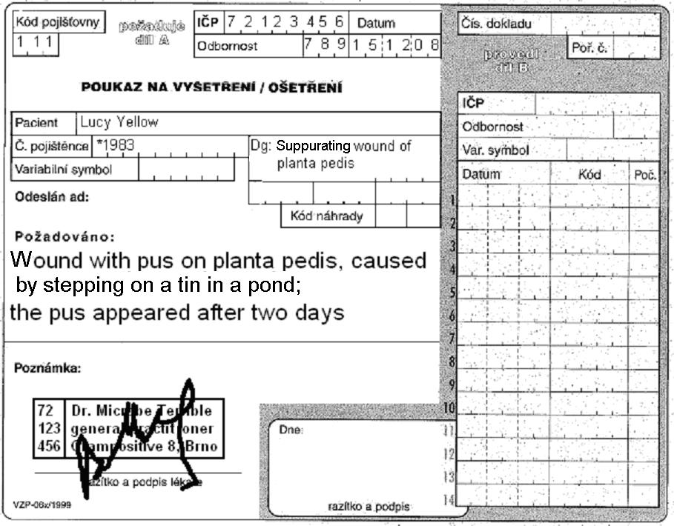

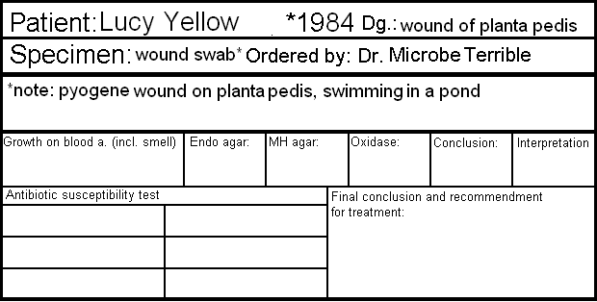

Antibiotic susceptibility test

|  |  |  |  |  |  |
| --- | --- | --- | --- | --- | --- |
| Piperacillin+tazobactam (TZP) | S ≥ 18  R < 18 |  | Ciprofloxacin  (CIP) | S ≥ 25  R < 22 |  |
| Gentamicin  (CN) | S ≥ 15  R < 15 |  | Ceftazidime  (CAZ) | S ≥ 16  R < 16 |  |
| Ofloxacin  (OFL) | S ≥ 16  R < 13 |  | Colistin  (CT) | S ≥ 11  R < 11 |  |

write S = susceptible, R = resistant, eventually I = intermediary

*result of this test is also valid for doxycycline

Final conclusion and recommendation for treatment: _______________________________________________

## Bloodstream infections

## Task 4: Blood cultures – processing

Describe the use of three types of blood culture vessels.

|  |  |
| --- | --- |
|  |  |
|  |  |
|  |  |

Fill in which data should not be missing on the order form in the case of blood culture (only “material type/examination type” field)

|  |
| --- |
|  |

Explain:

|  |
| --- |
| Why is absolute sterility in blood culture samples more necessary than in any other blood specimens (e. g. those sent for biochemical examination)? |
| How many blood cultures should be taken and why? |

Fill in the missing fields in the description of blood culture processing and examination according to the video clip and the teacher’s explanation.

A blood culture vessel arrives in the laboratory. Here it is put into a ___________________________________. The positive result is demonstrated by _____________________ and ______________________________. When the cultivation is positive, a smear is prepared and the content of the vessel is ____________________ onto the blood and Endo agar. Also, a preliminary _____________________________ test is performed directly from the specimen; as the inoculum is not standardized here, its results are only _________________________.

## Task 5: Blood cultures – microscopy of a positive specimen

The cultivator for blood cultures revealed a positive result. For preliminary treatment, a Gram stained smear is performed from the contain of the vessel. Observe the result and write it. **Attention!** The slides have origin in real blood cultures of different patients. Therefore your result may be simply different from that of your neighbour with a different slide.

Blood culture contained gram-positive – gram-negative* cocci – bacilli* arranged in _________________**

*\* delete as appropriate **only for cocci (pairs, chains, clusters…) or G+ bacilli in palisades*

## Task 6: Blood cultures – cultivation result

Observe cultivation result of a positive blood cultures inoculated on solid media. Suggest more methods for detailed diagnostics of bacteria. Try to assess preliminary antibiotic susceptibility. Also here you are not supposed to have the same results as your neighbour.

|  |  |  |  |
| --- | --- | --- | --- |
| Name of medium |  |  |  |
| Growth Y/N, appearance of colonies |  |  |  |

More tests of more detailed determination: _______________________________________________________

__________________________________________________________________________________________

Preliminary name of the microbe: ______________________________________________________________

**Preliminary antibiotic susceptibility testing**

Name of the set of antibiotics:

|  |  |  |  |  |  |  |  |
| --- | --- | --- | --- | --- | --- | --- | --- |
| Antibiotic | Susceptibility Interpretation | Measured size | Result (encircle) | Antibiotic | Susceptibility Interpretation | Measured size | Result (encircle) |
| 1. | R <  S ≥ |  | S–I–R | 4. | R <  S ≥ |  | S–I–R |
| 2. | R <  S ≥ |  | S–I–R | 5. | R <  S ≥ |  | S–I–R |
| 3. | R <  S ≥ |  | S–I–R | 6. | R <  S ≥ |  | S–I–R |

## Task 7: Blood cultures – interpretation

Find suitable interpretation for results of two different patients.

|  |  |
| --- | --- |
| John White, *1942, elevated temperature and inflammatory markers, three blood culture specimens sent to the laboratory | Joe Black, *1945, elevated temperature and inflammatory markers, three blood culture specimens sent to the laboratory |
| I Central venous catheter. Time to detection 10 hours, finding: *Staphylococcus hominis*, susceptible to oxacilin, tetracycline, vankomycin, resistant to erythromycin, klindamycin, co-trimoxazole. | I Central venous catheter. Time to detection 8 hours, finding: *Staphylococcus epidermidis*, susceptible to oxacilin, resistant to tetracycline, vankomycin, erythromycin, klindamycin, co-trimoxazole. |
| II Peripheral catheter. Time to detection 13 hours, finding: *Staphylococcus hominis*, susceptible to oxacilin, tetracycline, vankomycin, resistant to erythromycin, clindamycin, co-trimoxazole. | II Peripheral catheter. Time to detection 26 hours, finding: *Staphylococcus hominis*, susceptible to oxacilin, tetracycline, vankomycin, erythromycin, clindamycin, co-trimoxazole, no resistance observed |
| III Venepunction. Time to detection 13.5 hours, finding: *Staphylococcus hominis*, susceptible to oxacilin, tetracycline, vankomycin, resistant to erythromycin, clindamycin, co-trimoxazole. | III Venepunction. Time to detection 38 hours, finding: *Staphylococcus epidermidis*, susceptible to oxacilin, co-trimoxazole, vankomycin, resistant to tetracycline, erythromycin, clindamycin. |
| Likely interpretation: | Likely interpretation: |