# BorreliaTopic PZ09: Diagnostics of spirochetal infections

**To study:** *Borrelia, Leptospira, Treponema* (from textbooks, www etc.).

**From spring term:** Microscopy, PCR, methods of antibody and antigen detection.

## Lyme borreliosis

Common table for Task 1, 2 and 3. Abs. = absorbance value

|  |  |  |  |  |  |  |  |  |  |
| --- | --- | --- | --- | --- | --- | --- | --- | --- | --- |
| Patient  Letter | Short clinical  description  (1–3 words characterizing the situation | ELISA (Task 1) | | | | Blot (Task 2) | | PCR  (T3)  (+/–) | Conclusion:  final interpretation, recommendation for future therapy |
| IgM | | IgG | | IgM  (+/–) | IgG  (+/–) |
| Abs. | (+/–) | Abs. | (+/–) |
| J |  |  |  |  |  |  |  |  |  |
| K |  |  |  |  |  |  |  |  |  |
| L |  |  |  |  |  |  |  |  |  |
| M |  |  |  |  |  |  |  |  |  |
| N |  |  |  |  |  |  |  |  |  |

## Task 1: Detection of antibodies to *Borrelia garinii* using ELISA

Read the results of patients with suspect Lyme borreliosis. Both IgG and IgM antibodies are assessed. In A1 field (corresponding to A1 well in the microtitration plate) you can see CAL level (CAL for “calibrator” – borderline level; all absorbance levels above CAL are positive, all absorbance levels beneath CAL are negative). There are controls in B1 and C1. Patients J to N are in fields with coloured squares.

Write the CAL level in the table below, check, whether negative control is really negative and positive control really positive. Then read and interpret ELISA results for patients J to N (write them in the main table above).

|  |  |  |  |  |  |
| --- | --- | --- | --- | --- | --- |
| CAL level  (well A1): |  | K+ absorbance level (well B1): |  | ❒ K+ is OK  ❒ K+ is not OK | 🡨  tick what is correct |
| **IgM** | | K– absorbance level (well C1): |  | ❒ K– is OK  ❒ K– is not OK |
|  | | | | | |
| CAL level  (well A1): |  | K+ absorbance level (well B1): |  | ❒ K+ is OK  ❒ K+ is not OK | 🡨  tick what is correct |
| **IgG** | | K– absorbance level (well C1): |  | ❒ K– is OK  ❒ K– is not OK |

## Task 2: Detection of antibodies to *Borrelia garinii* using immunoblotting

In patients diagnosed in the task 1, the detection of antibodies in serum or CSF samples was performed by immunoblotting. Read the results according to the instructions. Use the presented pattern for evaluation of the reaction. The diagnostic scheme is always the same – ELISA is used for screening, whereas immunoblotting is performed as a confirmation of ELISA results. Read the immunoblot results of patients J to N and write the results in the main table.

## Task 3: Diagnostics of Lyme borreliosis using polymerase chain reaction (PCR)

According to the presented photos of a PCR product on the agarose gel, draw and record which of the tested samples are positive. Note, that with regard to the anamnesis, PCR reaction was performed only in two out of our five patients. After that, perform the final interpretation of all three tasks and write down a conclusion.

## Syphilis

## Task 4: Direct detection of syphilis

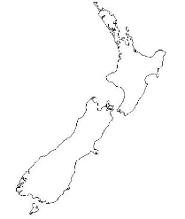Direct detection of syphilis is only possible if suitable samples are sent to the laboratory. In some stages of the disease, however, sampling for this purpose is not possible.

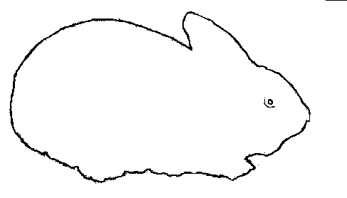**a) Rabbit infectivity testing – RIT**

Write down the name of the rabbit stock used for the test.

(It is derived from these islands: 🡪🡪🡪🡪🡪🡪🡪🡪🡪)

Exsudate from a suspect ulcer is usually evaluated with dark field microscopy and inoculated into rabbit testes. The animal starts to suffer from orchitis. Rabbit stock name:

## b) Darkfield microscopy

Look at the microphotography of treponemas taken from a dark field microscope, draw the principle of dark field microscopy, and also record your observation.

## c) Direct immunofluorescence

Look at the microphotography of treponemas taken from a fluorescent microscope and record your observation.

|  |  |  |
| --- | --- | --- |
| 4b) principle | 4b) result | 4c) |

The causative agent of syphilis, *Treponema pallidum*, is **not** a culturable microogranism. The diagnostics depends on the stage of disease.

## Indirect diagnostics of syphilis

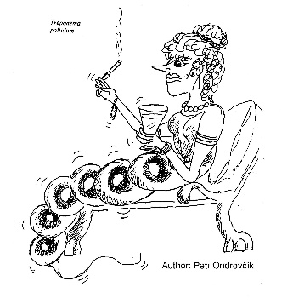Joint table for Task 5 and 6.

|  |  |  |  |  |  |  |  |  |  |  |  |
| --- | --- | --- | --- | --- | --- | --- | --- | --- | --- | --- | --- |
| Patient  Letter | Short  clinical  characterisation | **Task 5**  **Screening** | | **Task 6**  **Confirmation** | | | | | | | Conclusion:  final interpretation, recommended therapy |
| RRR | MHA-TP | FTA-ABS | ELISA | | | | Blot | |
| IgM | | IgG | | IgM (+/–) | IgG (+/–) |
| Absor- bance | (+/–) | Absor- bance | (+/–) |
| A |  |  |  |  |  |  |  |  |  |  |  |
| B |  |  |  |  |  |  |  |  |  |  |  |
| C |  |  |  |  |  |  |  |  |  |  |  |
| D |  |  |  |  |  |  |  |  |  |  |  |
| E |  |  |  |  |  |  |  |  |  |  |  |

## Task 5: Screening of syphilis – RRR and MHA-TP

Pregnant women and blood donors undergo screening performed using rapid reagin reaction (RRR) and *Treponema pallidum* microhaemagglutination (MHA-TP). Read the results of the screening in the presented group of persons and assess which of them need further tests for confirmation. Record your results directly into the table.

Positive result: RRR – flocculation in the well; MHA-TP – agglutinate formation (see Practical J08).

## Task 6: Confirmation of syphilis – FTA-ABS, ELISA and immunoblotting

Evaluate the results of FTA-ABS, ELISA and immunoblotting in patients with suspect syphilis (see the previous task). In the ELISA reaction, count the cut-off and compare K–, K+ and patient values with it.

A1 field (A1 well) represents the blank.

|  |  |  |  |  |  |
| --- | --- | --- | --- | --- | --- |
| Cut off level (C1 + D1) / 2 |  | K– absorbance level (B1 value): |  | ❒ K– is OK  ❒ K– is not OK | 🡨  tick what is correct |
| **IgM** | | K+ absorbance level (E1 value): |  | ❒ K+ is OK  ❒ K+ is not OK |
| Cut off level (C1 + D1) / 2 |  | K– absorbance level (B1 value): |  | ❒ K– is OK  ❒ K– is not OK | 🡨  tick what is correct |
| **IgG** | | K+ absorbance level (E1 value): |  | ❒ K+ is OK  ❒ K+ is not OK |

## Leptospirosis

## Task 7: Direct detection of *Leptospira* sp.

According to the presented picture, describe and draw the morphology of leptospiras cultivated in the liquid Korthoff's medium for 2 weeks. Urine of a patient with suspect leptospirosis was used for the test.

