# P11 Clinical microbiology II – examination in respiratory and GI infections

**To study**: Infections of various organs and organ systems (from textbooks, www etc.)

**From the spring term**: Microscopy, culture, biochemical identification

## Examination in respiratory tract infections

## Task 1: Search for respiratory pathogens in clinical microbiology

With the help of your teacher and the slideshow, describe the following picture. Use the knowledge from this picture in the Task 2 and Task 3.

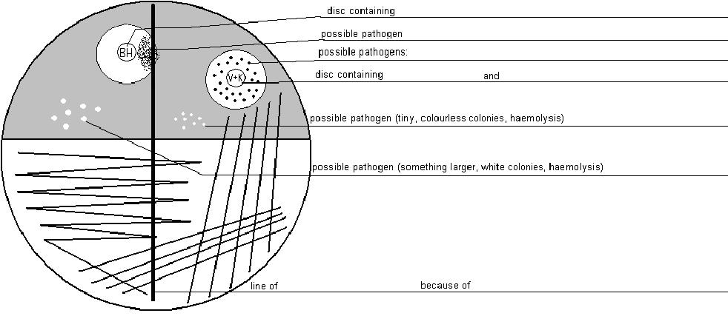

Common pharyngeal flora consists mostly of

a) _____________ appearance: ________________________

b) _____________ appearance: ________________________

## Task 2: Examination in acute bronchopneumonia

For this casuistic, documented by the order form, try to examine the corresponding specimen (sputum), to find a possible pathogen, make a conclusion and interpret the result. Step by step, fill in the individual fields in “the screen of laboratory information system”.

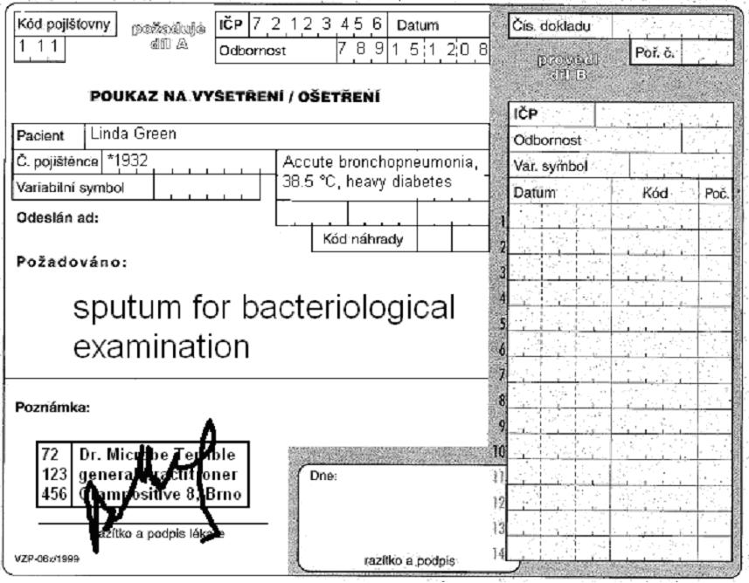

## výsledky sputum EN

Antibiotic susceptibility test (bacterium C)

|  |  |  |  |  |  |
| --- | --- | --- | --- | --- | --- |
| Cefoxitin (FOX)* | R < 22  S ≥ 22 |  | Co-trimoxazole (SXT) | R < 14  S ≥ 17 |  |
| Erythromycin (E) | R < 18  S ≥ 21 |  | Tetracyclin** (TE) | R < 19  S ≥ 22 |  |
| Clindamycin (DA) | R < 19  S ≥ 22 |  | Chloramfenicole (C) | R < 18  S ≥ 18 |  |

write S = susceptible, R = resistant, eventually I = intermediary

*interpreted as oxacillin and other beta-lactams

**result of this test is also valid for doxycycline

Final conclusion and recommendation for treatment: _______________________________________________

## a) Microscopy of sputum

Look at the smear prepared from your specimen. Try to find the individual objects (bacteria, host cells). Fill in the field “Microscopy result”:

+++ = more than 10 objects in the observation area

++ = less than 10 objects in the observation area

+ = only rare objects (one or less per an observation area)

0 = none

## b) Description of bacteria

On the blood agar, describe the size, colour and haemolytic properties of the grown bacteria. Do not describe other characteristics. Take into account that there was no growth visible on Endo agar. Bacteria A and B should be bacteria considered to be parts of normal flora. Bacterium C will be a pathogenic bacterium that will be tested in detail in parts c) and d)

## c) Further tests

Fill in the results of the catalase test, hyaluronidase test and of the growth on blood agar with 10 % NaCl for Bacterium C.

## d) Antibiotic susceptibility

Fill in the antibiotic susceptibility test for Bacterium C. Always write down the name of the antibiotics and “S” or “R” (susceptible or resistant). Reference zones are written in your table.

## e) Final conclusion

Try to formulate several words for the general practitioner. Especially try to find out (with the help of your teacher) which antibiotics would be the best choice.

## Task 3: Examination in acute tonsillitis

Similarly as in the previous case, there is an order form. Try to examine the corresponding specimen (throat swab) to find a possible pathogen, make a conclusion and interpret the results. Gradually, fill in the individual fields in “the screen of laboratory information system”. The way of doing it is the same as in the previous task.

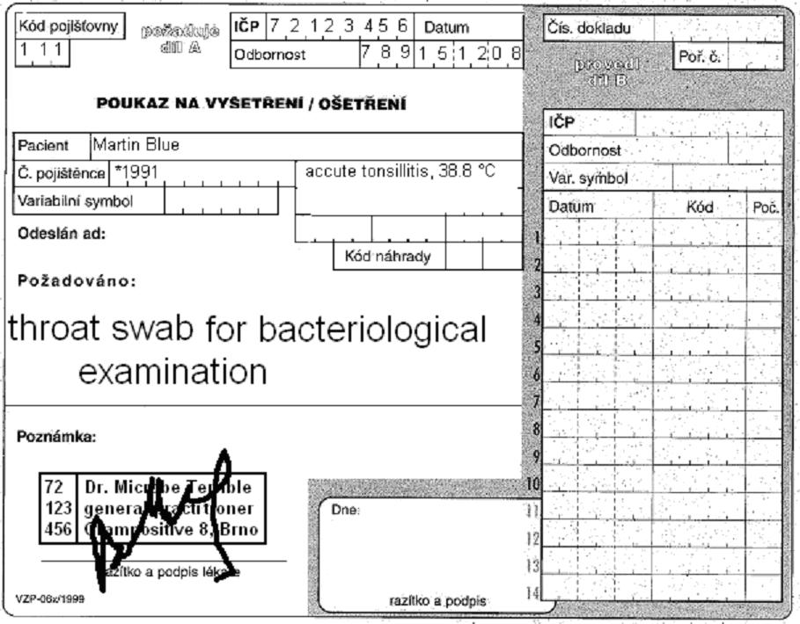

## výsledky krk EN

Antibiotic susceptibility tests (bacterium C)

|  |  |  |  |  |  |
| --- | --- | --- | --- | --- | --- |
| Penicillin  (P) | R < 18  S ≥ 18 |  | Chloramphenicole (C) | R < 19  S ≥ 19 |  |
| Erythromycin  (E) | R < 18  S ≥ 21 |  | Tetracyclin*  (TE) | R < 20  S ≥ 23 |  |
| Clindamycin (DA) | R < 17  S ≥ 27 |  | Vancomycin (VA) | R < 13  S ≥ 13 |  |

write S = susceptible, R = resistant, eventually I = intermediary

*interpreted as oxacillin and other beta-lactams

**result of this test is also valid for doxycycline

Final conclusion and recommendation for treatment: _______________________________________________

## Task 4: Suitable specimens for various respiratory infections

Using slideshow, find suitable way of examination for various clinical situations

|  |  |  |  |
| --- | --- | --- | --- |
| Suspicion for | Type of specimen | Suspicion for | Type of specimen |
| rhinitis |  | bronchitis |  |
| sinusitis |  | acute pneumonia (expectoration of pus) |  |
| pharyngitis |  | subacute pneumonia (dry cough) |  |
| influenza |  | lung aspergillosis |  |

## Examination in gastrointestinal system

## Task 5: Examination in acute diarrhoea

In this case, stool has been sent to the laboratory. We have to know, that stool normally contains strictly anaerobic flora, but this cannot be found during normal examination, as normal examination is only aerobic. Even enterococci are only found in blood agar is used, and this is not part of routine examination of stool. On the other hand, members of *Enterobacteriaceae* family are often found in stool – both parts of normal flora (with some strains with elevated virulence, for example EPEC for *E. coli*) and obligatory pathogens (*Salmonella*). – The stool specimens are observed after 24 hours (direct result of Endo agar and XLD agar) and 48 hours (direct result of *Campylobacter* examination on CCDA agar and *Yersinia* examination on CIN agar, and subcultures from selenite broth on Endo agar and MAL agar). The 24 h examination was already performed in your case. Fill in results of 48 h examination and try to make a final conclusion.

**Attention:** On media like XLD, MAL, CIN or CCDA you identify the finding as “suspicious” only if it resembles the positive control (see the side table). Any other findings (something is growing, but “not like the control”) are considered negative!

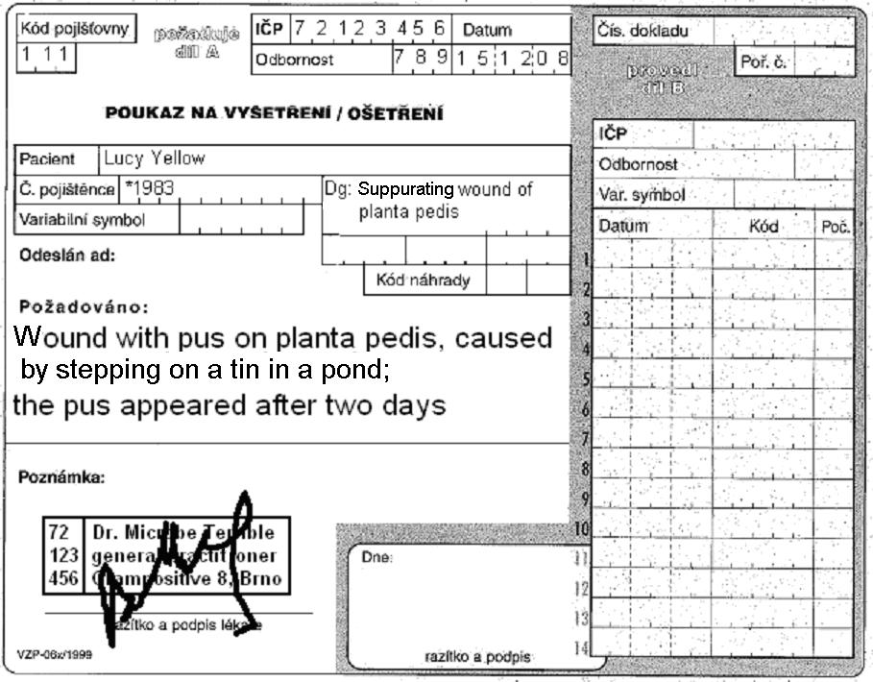

Acute diarrhoea

Cecilia Brown

Stool for bacteriological examination

|  |  |  |  |  |  |  |
| --- | --- | --- | --- | --- | --- | --- |
| Patient Cecilia Brown, *1984 Dg.: Accute diarrhoea | | | | | | |
| Endo agar  (24 h) | XLD agar  (24 h) | | Endo agar  (subcultivation) | MAL agar  (subcultivation) | CIN agar  (48 h) | CCDA agar  (48 h) |
| *E. coli* | negative | |  |  | Final conclusion and interpretation | |
| More tests | | | | |
| HAJNA medium | |  | | |
| Serotypisation | | Dental students do not perform this part | | |

## Task 6: Stool samples for different types of pathogens and toxins

For some purposes, it is possible to send rectal swabs, while for others, it is necessary to send a piece of stool, sometimes even refrigerated.

Watch the next table. For dental students it is already filled in.

|  |  |  |  |
| --- | --- | --- | --- |
| Stool sent for | Type of specimen | Stool sent for | Type of specimen |
| bacteriology | Anal/rectal swab (Amies) | virology – virus isolation | Nut-sized piece of stool (cooling necessary!) |
| mycology | Anal/rectal swab (Amies or FungiQuick) | parasitology | Nut-sized piece of stool (cooling not necessary) |
| virology – antigen detection | Nut-sized piece of stool (cooling not necessary) | detection of the *Clostridium difficile* toxin | Nut-sized piece of stool (cooling not necessary) |