Calculate the buoyancy, gravitational and net forces acting on an object suspended in water. The object has a mass of 2 kg and a volume of 0.5 dm3.

20,5,15 N

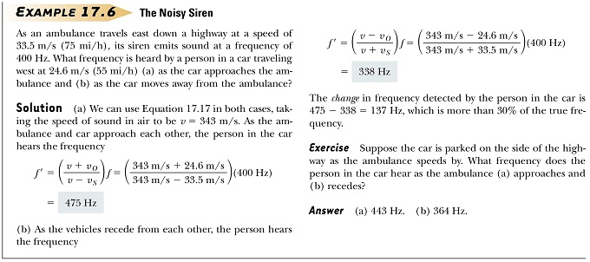

v=343 m/s, v0=24,6 m/s, vs=33,5 m/s. f=400 Hz.

A closed-end air tube resonates to a tuning fork of 480 Hz at lengths of 53.0 and 88.5 cm. What is the speed of sound in air.

430ms-1