# P10 Clinical microbiology I – general

**To study:** Sampling, specimen transport (from textbooks, www etc.)

**From spring term:** Microscopy

## Task 1: Indications for microbiological examination

For following casuistries, fill in the table.

❶ Fill in always the case description (left column).

❷ Try to find out your solution. Try to structure your answer as follows:

Microbiological examination: yes/no

* **yes** → select a specimen
* **no →** select other steps, e. g. direct treatment – what antibiotics etc.)

❸ After the three minute limit, write down a correction according to the teacher’s explanation.

|  |  |  |  |
| --- | --- | --- | --- |
|  | Description of a case | Your solution ( 3 minutes) | Correction according to the teacher’s explanation |
| **a** |  |  |  |
| **b** |  |  |  |
| **c** |  |  |  |
| **d** |  |  |  |

## Task 2: Swabs and vessels

Observe the swabs in your table and fill in their “identity cards”.

|  |  |  |  |
| --- | --- | --- | --- |
| **Name: Plain swab** | | | |
| Suchý tampon čb | Stick material | plastic, wood, aluminium | |
| Swab material | synthetic cotton | |
| Practical use: | | | |
| **Name: Swab with Amies transport medium** | | | |
| Amies a Stuart čb | Stick material | | plastic or aluminium |
| Swab material | | synthetic cotton |
| Medium | | Amies (Stuart, Cary Blair) |
| *Note: The medium may contain charcoal (then it is black); without charcoal, it would be colourless.* | | | |
| Practical use:  Variant with aluminium stick is used for | | | |

|  |  |  |  |  |
| --- | --- | --- | --- | --- |
| **Name: Fungi-Quick swab** | | | | |
| P1010011čb | Stick material | | | plastic |
| Transport medium colour | | colourless | |
| Cap colour | |  | |
| Practical use: | | | | |
| **Name: C. A. T. swab** | | | | |
| P1010011čb | Stick material | | | plastic |
| Transport medium colour | | colourless | |
| Cap colour | |  | |
| Practical use: | | | | |
| **Name: Common test tube for microbiology** | | | | |
| Zkumavka sérová čb otočená bez popisu | Sterile? (yes or no) |  | | |
| Description | made of polystyrene, 16 × 100 mm, 10 ml | | |
| Practical use: | | | | |
| **Name: Sputum test tube** | | | | |
| Sputovka čb otočená bez popisu | Sterile? (yes or no) |  | | |
| Description | made of polystyrene or polypropylene,  26 × 92 mm, 30 ml | | |
| Practical use: | | | | |
| **Name: Stool container** | | | | |
| Na střevní parazity čb otočený bez popisu | Sterile? (yes or no) |  | | |
| Description | made of polypropylene,  26 × 82 mm, 30 ml | | |
| Practical use: | | | | |
| **Do toho se vychčije čbName: Sampling vessel for urine** | | | | |
| Do toho se vychčije čb | Sterile? (yes or no) |  | | |
| Description | made of polypropylene,  45 × 70 mm, 120 ml | | |
| Practical use: | | | | |

## Task 3: Other sampling methods than swabs and vessels

Fill in the following table:

|  |  |
| --- | --- |
| Sampling method | Typical example(s) of use |
| smear on a slide |  |
| imprint with an agar |  |
| moulage method (indirect imprint) |  |
| uricult |  |

## Task 4: The order form

## a) Filling in the order form

Fill in the following order form with a patient name and data and the requested examination related to the disease, according to a card that has been given to you by the teacher.

**Examples of a description to be written on the request form (in „Požadováno“ field):**

* Throat swab for bacteriology examination
* Blood for antibodies againts EB virus and cytomegatovirus
* Stool for parazites (after stay in Congo and Gabon)

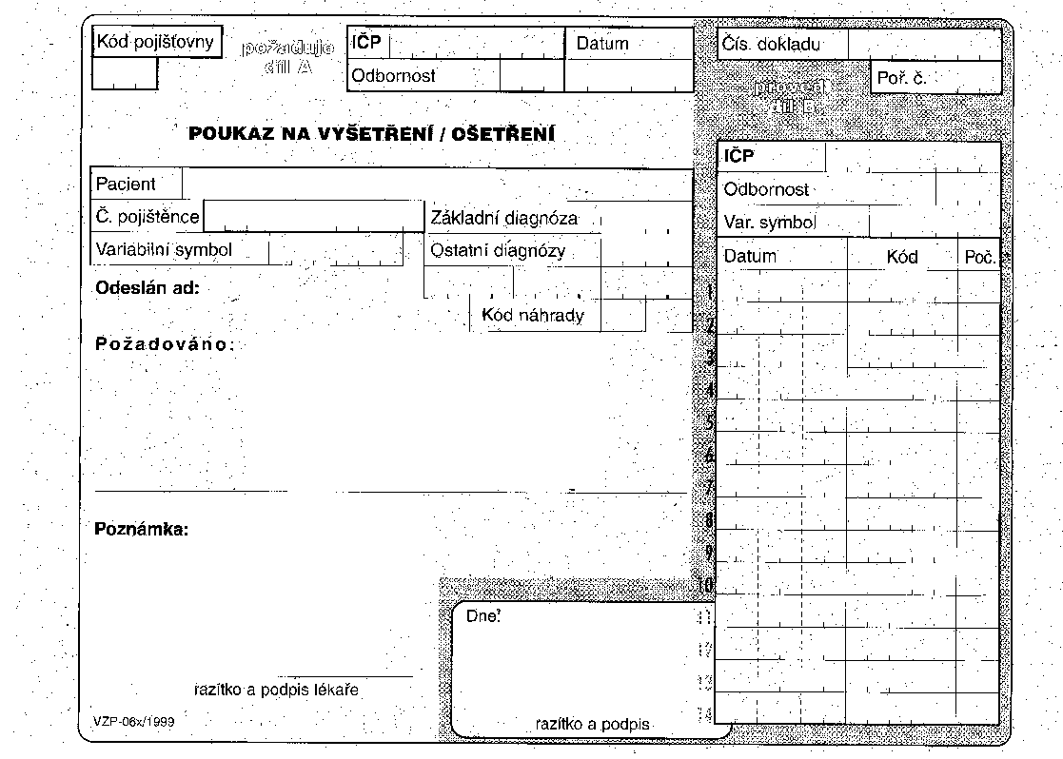

## b) Order form common mistakes

To each of the following order forms write down what is wrong. There are some mistakes at filling in the order form, but you should also identify improperly requested examinations.

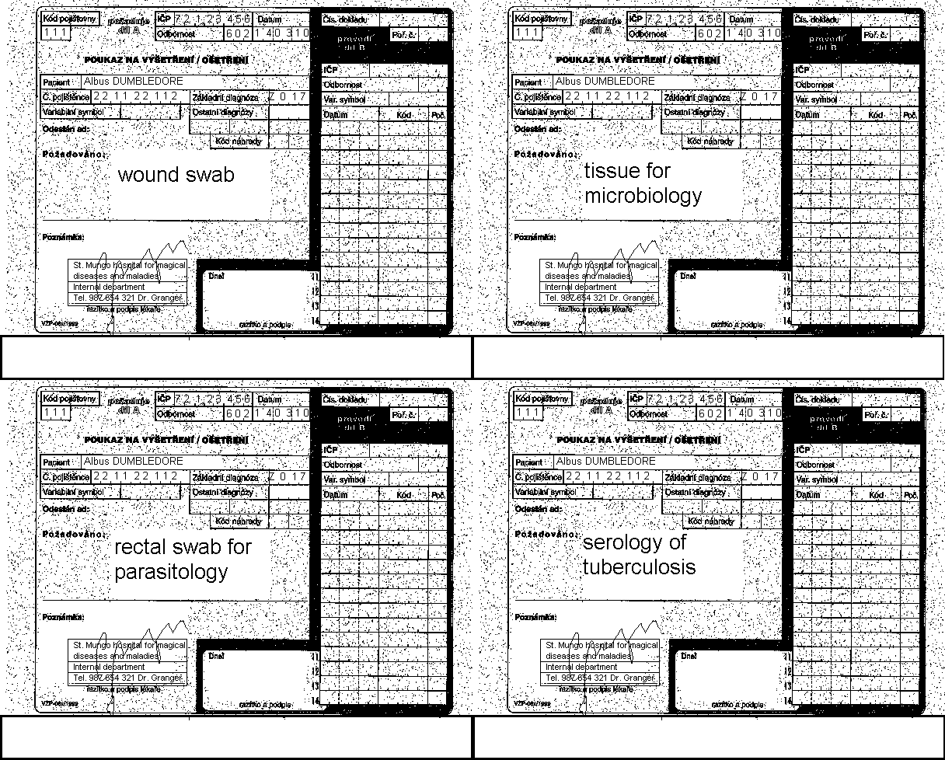

Tissue for syphilis cultivation

## Task 5: Interpretation

## a) Direct diagnostic interpretation

Using the table in the slideshow, write the likely interpretation for thirteen various findings written on cards available on your table. Use terms “pathogen”, “common flora”, “accidental finding”, “colonization” and “contamination”

|  |  |
| --- | --- |
| Finding | Interpretation |
|  |  |
|  |  |
|  |  |
|  |  |
|  |  |
|  |  |
|  |  |
|  |  |
|  |  |
|  |  |
|  |  |
|  |  |
|  |  |

## b) Indirect diagnostic interpretation

Interpret several clinical situations with data given on the card. Do not forget to make your interpretation on the base of both clinical findings and laboratory results (clinical findings)

|  |  |  |
| --- | --- | --- |
| Rewrite from the card (simplify the sentences) | | Conclusion |
| Clinical situation | Serology examination results |
|  |  |  |
|  |  |  |
|  |  |  |
|  |  |  |
|  |  |  |

Notes (correction of your conclusion done by the teacher)