# P09+10 Clinical microbiology I – general. Diagnostics of spirochetes.

**To study:** Sampling, specimen transport (from textbooks, www etc.). Spirochetes.

**From spring term:** Microscopy

## Task 1: Indications for microbiological examination

For following casuistries, fill in the table.

❶ Fill in always the case description (left column).

❷ Try to find out your solution. Try to structure your answer as follows:

Microbiological examination: yes/no

* **yes** → select a specimen
* **no →** select other steps, e. g. direct treatment – what antibiotics etc.)

❸ After the three minute limit, write down a correction according to the teacher’s explanation.

|  |  |  |  |
| --- | --- | --- | --- |
|  | Description of a case | Your solution ( 3 minutes) | Correction according to the teacher’s explanation |
| **a** |  |  |  |
| **b** |  |  |  |
| **c** |  |  |  |
| **d** |  |  |  |

## Task 2: Swabs and vessels

Observe the swabs in your table and fill in their “identity cards”.

|  |  |  |  |
| --- | --- | --- | --- |
| **Name: Plain swab** | | | |
| Suchý tampon čb | Stick material | plastic, wood, aluminium | |
| Swab material | synthetic cotton | |
| Practical use: | | | |
| **Name: Swab with Amies transport medium** | | | |
| Amies a Stuart čb | Stick material | | plastic or aluminium |
| Swab material | | synthetic cotton |
| Medium | | Amies (Stuart, Cary Blair) |
| *Note: The medium may contain charcoal (then it is black); without charcoal, it would be colourless.* | | | |
| Practical use:  Variant with aluminium stick is used for | | | |

|  |  |  |  |  |
| --- | --- | --- | --- | --- |
| **Name: Fungi-Quick swab** | | | | |
| P1010011čb | Stick material | | | plastic |
| Transport medium colour | | colourless | |
| Cap colour | |  | |
| Practical use: | | | | |
| **Name: C. A. T. swab** | | | | |
| P1010011čb | Stick material | | | plastic |
| Transport medium colour | | colourless | |
| Cap colour | |  | |
| Practical use: | | | | |
| **Name: Common test tube for microbiology** | | | | |
| Zkumavka sérová čb otočená bez popisu | Sterile? (yes or no) |  | | |
| Description | made of polystyrene, 16 × 100 mm, 10 ml | | |
| Practical use: | | | | |
| **Name: Sputum test tube** | | | | |
| Sputovka čb otočená bez popisu | Sterile? (yes or no) |  | | |
| Description | made of polystyrene or polypropylene,  26 × 92 mm, 30 ml | | |
| Practical use: | | | | |
| **Name: Stool container** | | | | |
| Na střevní parazity čb otočený bez popisu | Sterile? (yes or no) |  | | |
| Description | made of polypropylene,  26 × 82 mm, 30 ml | | |
| Practical use: | | | | |
| **Do toho se vychčije čbName: Sampling vessel for urine** | | | | |
| Do toho se vychčije čb | Sterile? (yes or no) |  | | |
| Description | made of polypropylene,  45 × 70 mm, 120 ml | | |
| Practical use: | | | | |

## Task 3: Other sampling methods than swabs and vessels

Fill in the following table:

|  |  |
| --- | --- |
| Sampling method | Typical example(s) of use |
| smear on a slide |  |
| imprint with an agar |  |
| moulage method (indirect imprint) |  |
| uricult |  |

## Task 4: The order form

## a) Filling in the order form

Fill in the following order form with a patient name and data and the requested examination related to the disease, according to a card that has been given to you by the teacher.

**Examples of a description to be written on the request form (in „Požadováno“ field):**

* Throat swab for bacteriology examination
* Blood for antibodies againts EB virus and cytomegatovirus
* Stool for parazites (after stay in Congo and Gabon)

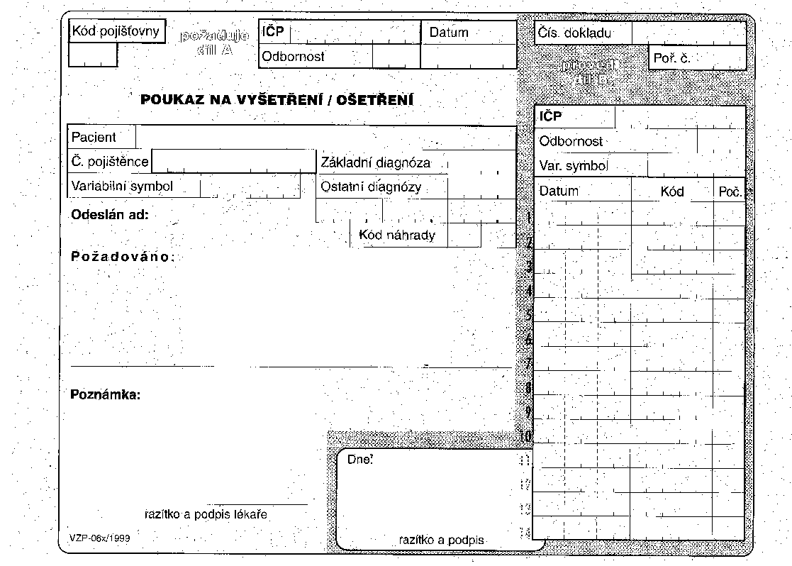

## b) Order form common mistakes

To each of the following order forms write down what is wrong. There are some mistakes at filling in the order form, but you should also identify improperly requested examinations.

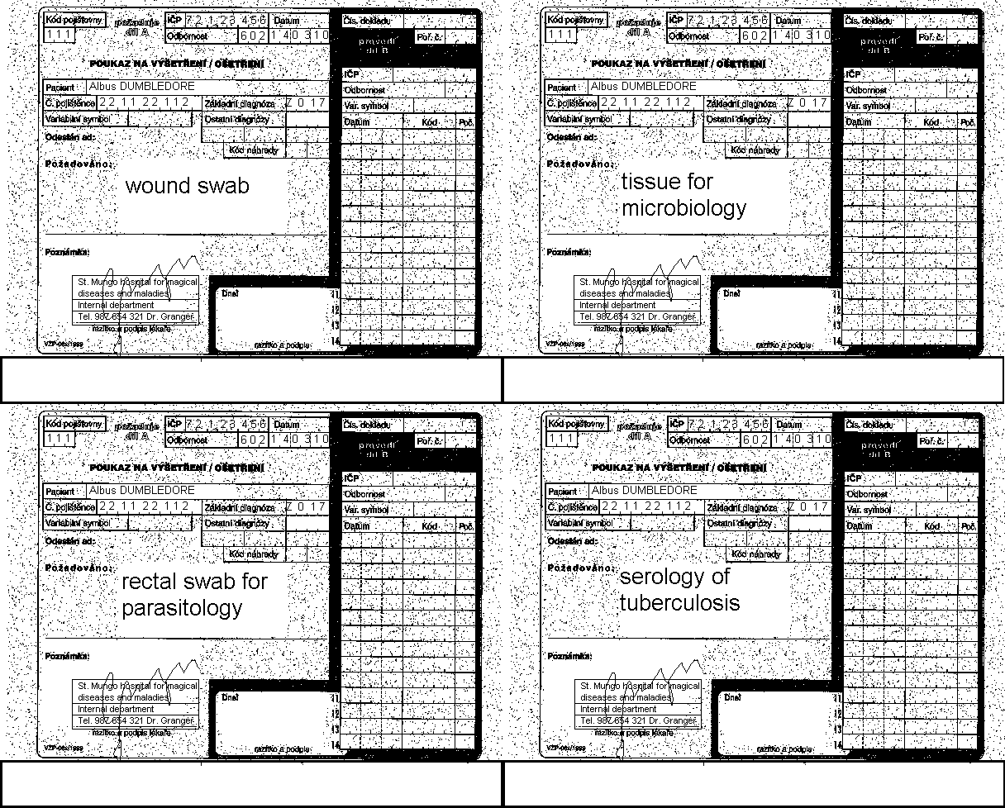

Tissue for syphilis cultivation

## Task 5: Interpretation

## a) Direct diagnostic interpretation

Using the table in the slideshow, write the likely interpretation for thirteen various findings written on cards available on your table. Use terms “pathogen”, “common flora”, “accidental finding”, “colonization” and “contamination”

|  |  |
| --- | --- |
| Finding | Interpretation |
|  |  |
|  |  |
|  |  |
|  |  |
|  |  |
|  |  |
|  |  |
|  |  |
|  |  |
|  |  |
|  |  |
|  |  |
|  |  |

## b) Indirect diagnostic interpretation

Interpret several clinical situations with data given on the card. Do not forget to make your interpretation on the base of both clinical findings and laboratory results (clinical findings)

|  |  |  |
| --- | --- | --- |
| Rewrite from the card (simplify the sentences) | | Conclusion |
| Clinical situation | Serology examination results |
|  |  |  |
|  |  |  |
|  |  |  |
|  |  |  |
|  |  |  |

Notes (correction of your conclusion done by the teacher)

## c) Interpretation of Lyme borreliosis results

With help of you teacher, evaluate the results of ELISA and immunoblot to five patients. Normally, blotting is only performed in a special reason, but this time, all specimens had to be tested also by the immunoblot. On the other hand, PCR was performed just for two of them – those with suspicion for neuroborreliosis.

|  |  |  |  |  |  |  |  |  |
| --- | --- | --- | --- | --- | --- | --- | --- | --- |
| Patient  Letter | Short clinical  description | ELISA (Task 1) | | | Blot (Task 2) | | PCR  (+/–) | Conclusion:  final interpretation, recommendation for future therapy |
| IgM | IgG | | IgM  (+/–) | IgG  (+/–) |
| (+/–) | (+/–) |  |
| J | Erythema migrans |  |  | |  | |  |  |
| K | Fatigue syndrome |  |  | |  | |  |  |
| L | Likely neuroborreliosis |  |  | |  | |  |  |
| M | “Website reader” |  |  | |  | |  |  |
| N | Neuroborreliosis??? |  |  | |  | |  |  |

## d) Interpretation of syphilis

With help of you teacher, evaluate the results of screening and confirmatory reactions for syphilis in five patients.

## Screening of syphilis – RRR and MHA-TP

Pregnant women and blood donors undergo screening performed using rapid reagin reaction (RRR) and *Treponema pallidum* microhaemagglutination (MHA-TP). Read the results of the screening in the presented group of persons and assess which of them need further tests for confirmation. Record your results directly into the table.

Positive result: RRR – flocculation in the well; MHA-TP – agglutinate formation (see Practical J08).

## Confirmation of syphilis – FTA-ABS, ELISA and immunoblotting

Evaluate the results of FTA-ABS, ELISA and immunoblotting in patients with suspect syphilis (see the previous task). In the ELISA reaction, count the cut-off and compare K–, K+ and patient values with it.

A1 field (A1 well) represents the blank.

|  |  |  |  |  |  |  |  |  |  |  |
| --- | --- | --- | --- | --- | --- | --- | --- | --- | --- | --- |
| Patient  Letter | Short  clinical  characterisation | **Screening** | | **Confirmation** | | | | | | Conclusion:  final interpretation, recommended therapy |
| RRR | MHA-TP | FTA-ABS | ELISA | | | Blot | |
| IgM | IgG | | IgM (+/–) | IgG (+/–) |
| (+/–) | (+/–) |  |
| A | Pregnant woman – screening |  |  |  |  |  | |  |  |  |
| B | Lesion (chancre?) two days |  |  |  |  |  | |  |  |  |
| C | Susp. Syphilis latens |  |  |  |  |  | |  |  |  |
| D | Blood donor |  |  |  |  |  | |  |  |  |
| E | A newborn of a mother with syphilis |  |  |  |  |  | |  |  |  |

## Task 6: Direct detection of syphilis

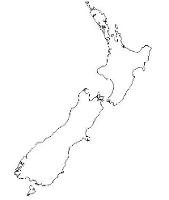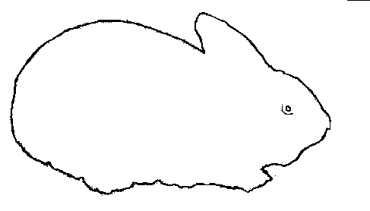Direct detection of syphilis is only possible if suitable samples are sent to the laboratory. In some stages of the disease, however, sampling for this purpose is not possible.

**a) Rabbit infectivity testing – RIT**

Write down the name of the rabbit stock used for the test.

(It is derived from these islands: 🡪🡪🡪🡪🡪🡪🡪🡪🡪)

Exsudate from a suspect ulcer is usually evaluated with dark field microscopy and inoculated into rabbit testes. The animal starts to suffer from orchitis. Rabbit stock name:

## b) Dark field microscopy

Look at the microphotography of treponemas taken from a dark field microscope, draw the principle of dark field microscopy, and also record your observation.

## c) Direct immunofluorescence

Look at the microphotography of treponemas taken from a fluorescent microscope.

|  |  |  |
| --- | --- | --- |
| 6b) principle  Zástin | 6b) result  Zástin do protokolu | 6c)  Přímá imunofluorescence |

The causative agent of syphilis, *Treponema pallidum*, is **not** a culturable microorganism. The diagnostics depends on the stage of disease.

## Leptospirosis

## Task 7: Direct detection of *Leptospira* sp.

According to the presented picture, describe and draw the morphology of leptospiras cultivated in the liquid Korthoff's medium for 2 weeks. Urine of a patient with suspect leptospirosis was used for the test.

