**PART I: EXERCISES**

1. ***Describe the following nouns using one of the given adjectives. Pay attention to their meanings and correct gender forms:***

|  |  |
| --- | --- |
| collum | longus, a, um |
| os | sinister, a, um |
| intestinum | urinarius, a, um |
| ostium | anatomicus, a, um |
| periodus | durus, a, um |
| glandula | thyroideus, a, um |
| costa | congenitus, a, um |
| antebrachium | internus, a, um |
| palatum | crassus, a, um |
| vesica | spurius, a um |
| morbus | sacer, a, um |

1. ***Create meaningful diagnoses of your own choice using the following nouns and adjectives (listed in their basic forms):***

fractura +

ulna, pelvis, calcaneus, coccyx, clavicula, corpus vertebrae, caput femoris

*dexter, tra, trum; transversus, a, um; complicatus, a, um*

_ _ _ _ _ _ _ _ _ _ _ _ _ _ _ _ _ _ _ _ _ _ _ _ _ _ _ _ _ _ _ _ _ _ _ _ _ _ _ _ _ _ _ _ _ _ _ _ _ _ _ _ _ _ _ _ _ _ _ _

_ _ _ _ _ _ _ _ _ _ _ _ _ _ _ _ _ _ _ _ _ _ _ _ _ _ _ _ _ _ _ _ _ _ _ _ _ _ _ _ _ _ _ _ _ _ _ _ _ _ _ _ _ _ _ _

cancer +

ovarium, cervix uteri, lobus pulmonis, intestinum, vesica, colon

*sinister, tra, trum; crassus, a, um; sigmoideum, a, um; felleus, a, um*

_ _ _ _ _ _ _ _ _ _ _ _ _ _ _ _ _ _ _ _ _ _ _ _ _ _ _ _ _ _ _ _ _ _ _ _ _ _ _ _ _ _ _ _ _ _ _ _ _ _ _ _ _ _ _ _ _ _ _ _

_ _ _ _ _ _ _ _ _ _ _ _ _ _ _ _ _ _ _ _ _ _ _ _ _ _ _ _ _ _ _ _ _ _ _ _ _ _ _ _ _ _ _ _ _ _ _ _ _ _ _ _ _ _ _ _

morbus +

bronchi, ventriculus (cerebri), arteriae, medulla

*chronicus, a, um; quartus, a, um; acutus, a, um; oblongatus, a, um*

_ _ _ _ _ _ _ _ _ _ _ _ _ _ _ _ _ _ _ _ _ _ _ _ _ _ _ _ _ _ _ _ _ _ _ _ _ _ _ _ _ _ _ _ _ _ _ _ _ _ _ _ _ _ _ _ _ _ _ _

_ _ _ _ _ _ _ _ _ _ _ _ _ _ _ _ _ _ _ _ _ _ _ _ _ _ _ _ _ _ _ _ _ _ _ _ _ _ _ _ _ _ _ _ _ _ _ _ _ _ _ _ _ _ _ _

anomalia +

bulbus oculi, digitus, mandibula, vesica, coxae

*congenitus, a, um; acquisitus, a, um; urinarius, a, um; secundus, a, um*

_ _ _ _ _ _ _ _ _ _ _ _ _ _ _ _ _ _ _ _ _ _ _ _ _ _ _ _ _ _ _ _ _ _ _ _ _ _ _ _ _ _ _ _ _ _ _ _ _ _ _ _ _ _ _ _ _ _ _ _

_ _ _ _ _ _ _ _ _ _ _ _ _ _ _ _ _ _ _ _ _ _ _ _ _ _ _ _ _ _ _ _ _ _ _ _ _ _ _ _ _ _ _ _ _ _ _ _ _ _ _ _ _ _ _ _

1. ***Translate the names of the structures into Latin:***

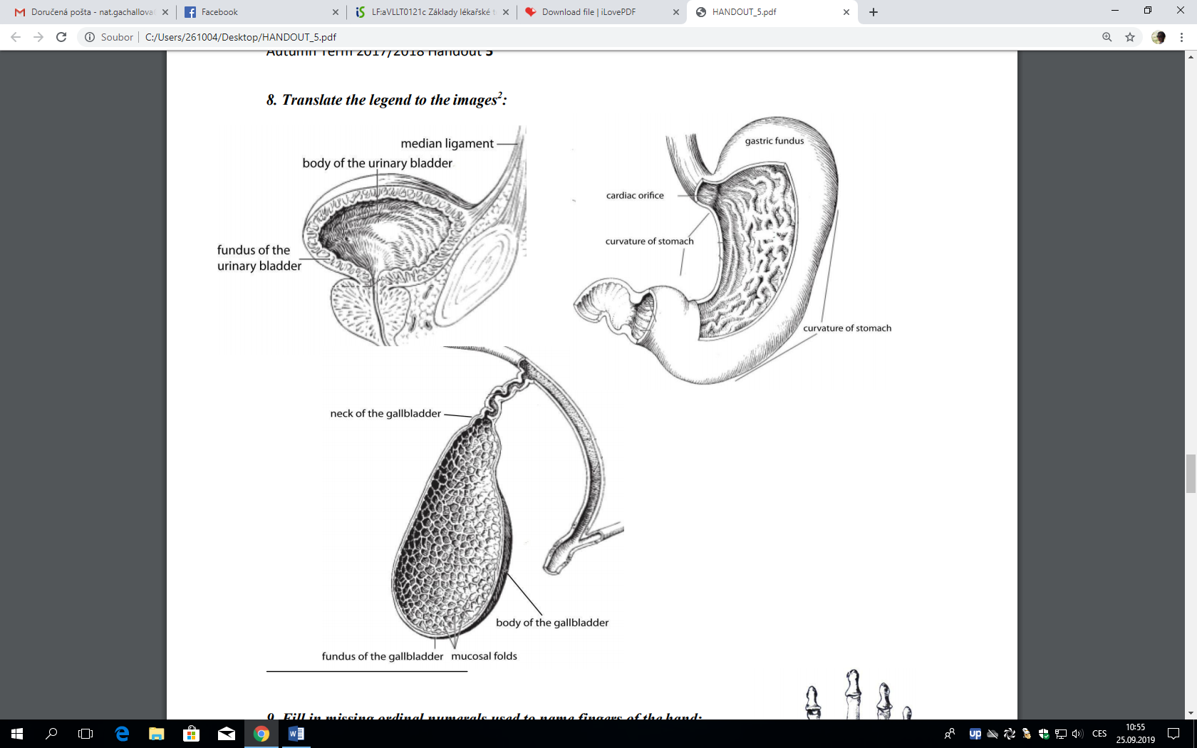

***4.*** ***Put the words into correct order. Do not change their case endings:***

lati ~ ruptura ~ uteri ~ ligamenti

transversae ~ congenita ~ fissurae ~ cerebri ~ anomalia

plicarum ~ recti ~ operatio ~ transversarum

dorsi ~ transversorum ~ musculorum ~ ruptura

felleae ~ defectus ~ acquisitus ~ vesicae

1. ***Form prepositional phrases. The nouns are given in their Nominative forms:***

PER + rectum, arteria, vena PRO + neonatus (pl.), adultus

_ _ _ _ _ _ _ _ _ _ _ _ _ _ _ _ _ _ _ _ _ _ _ _ _ _ _ _ _ _ _ _ _ _ _ _ _ _ _ _ _ _ _ _ _ _ _ _ _ AD + medulla, bulbus oculi, arteria INTER + vertebrae, bulbi, musculi

_ _ _ _ _ _ _ _ _ _ _ _ _ _ _ _ _ _ _ _ _ _ _ _ _ _ _ _ _ _ _ _ _ _ _ _ _ _ _ _ _ _ _ _ _ _ _ _ _

SUB + lingua, ligamentum IN + musculus, cerebrum, aorta, ostium uteri

_ _ _ _ _ _ _ _ _ _ _ _ _ _ _ _ _ _ _ _ _ _ _ _ _ _ _ _ _ _ _ _ _ _ _ _ _ _ _ _ _ _ _ _ _ _ _ _ _¨

1. ***Change the following phrases into plural:***

diameter obliqua _________________________

ruptura musculi transversi _________________________

vitium congenitum _________________________

ramus nervi _________________________

musculus thoracicus _________________________

signum morbi acuti _________________________

nucleus ruber _________________________

1. ***Fill in missing endings to make meaningful phrases. Translate into English:***

ruptura ligament transvers scapul

patiens cum fractur _fibul apert

nervus transvers coll

nodi lymphatic iliac intern

fractura sept nas complicat

musculi obliqu _bulb ocul

status post therapi intestin crass chirurgic

periculum ruptur aort

1. ***Translate the following phrases into Latin. Pay attention to correct case endings and word order:***

|  |
| --- |
| long muscles of the neck |
| radiating ligament of rib |
| wide ligament of the uterus |
| transverse process of the third coccygeal vertebra |
| transverse ligament of the shoulder blade |
| anatomical neck of the humerus |
| accessory organs of the eye |
| coccygeal and thoracic muscles |
| base of the urinary bladder |
| defect of the wandering nerve |
| acquired insufficiency of the aortic valve |
| cause of the fissure of the palate |
| cancer of the large intestine |
| fracture of the surgical neck of the femur |
| congenital anomaly of an internal organ |
| open fracture of the second left true rib |
| a newborn with jaundice |
| an adult (woman) with cancer of the uterine cervix |
| acute disease of the urinary bladder |
| rupture of the ligaments of the ankle bone  patient with muscle atrophy  anomaly in the left lobe of the thyroid gland  bleeding out of the nose  foreign body in the nose |

# PART II: GRAMMAR

**GREEK 2ND DECLENSION**

## Greek 2nd declension includes MALES ending in -OS and NEUTERS ending in -ON. The former are no longer used in anatomical nomenclature (i.e. they appear only in clinical terminology); however, some Greek neuters still appear in anatomy, embryology, and histology: **olecranon**, i, n. (the pointed part of the elbow), **ganglion**, ii, n. (nerve cell cluster), **acromion**, ii, n. (the bony process of the shoulder blade); see also **amnion**, ii, n. (the inner membrane covering embryo); **chorion**, ii, n. (outer fetal membrane), or **embryon**, ii, n. (embryo).

## These words preserve their original Greek ending **–on** in Nom. sg. and, since they are of neuter gender, also in acc. sg.; all the other endings are identical with the Latin paradigm SEPTUM.

## Masculines ending in **-os** in Nom. sg. differ from the NERVUS paradigm only in Nom. Sg. And Acc. Sg. (*-on* instead of *-um*).

## **INFLECTION OF ADJECTIVES ENDING IN *-US (ER), A, UM***

Adjectives ending in -us(er), a, um in Nom. Sg. are inflected as the Latin 1st and 2nd declension nouns, i.e. **male forms** ending in -us(er) according to the **NERVUS** paradigm, **females** ending in -a according to the **VENA** paradigm, and **neuters** ending in -um according to the **SEPTUM** paradigm.

***REMEMBER!***Adjectives have to agree with the nouns they modify in gender, case, and number. This definitely does NOT mean that the adjective and the noun it modifies belong to one and the same declension. In other words, the case endings of the adjective do not have to be identical with those of the respective noun.

*Fractur****a*** *complicat****a***, *therapia fractur****ae*** *complicat****ae*** (*fractura* is female; therefore, the adjective ends in *-a* and follows the *vena* paradigm, i.e. the two words have identical endings since they coincidentally fall into the same group)

BUT!

*Diabet****es*** *mellit****us***, *therapia diabet****ae*** *mellit****i*** (*diabetes* is male; therefore, the adjective ends in *-us* and follows the *nervus* paradigm)

*Periodus longa*, *post period****um*** *long****am*** (*periodus* is female; therefore, the adjective ends in *-a* and follows the *vena* paradigm)

# PART III : VOCABULARY

|  |  |  |  |
| --- | --- | --- | --- |
| *ANATOMICAL NOMENCLATURE* | | *CLINICAL and PHARMACOLOGICAL TERMINOLOGY* | |
| **acromion, ii, n.** | acromion, bony process of shoulder blade | **alienus, a, um** | foreign |
| **angulus, i, m.** | angle, curved part of a bone | **aqua, ae, f.** | water |
|  |  | **atrophia, ae, f.** | atrophy, wasting or a decrease in size of a body part |
| **cavus, a , um** | hollow, concave (with vein) | **destillatus, a, um** | distilled |
| **conoideus, a, um** | cone-shaped | **diureticus, a, um** | stimulating urine production |
| **colon, i, n.** | large intestine, colon | **extractum, i, n.** | extract (from plants) |
| **deltoideus, a, um** | shaped like greek letter δ | **icterus, i, m.** | jaundice |
| **encephalon, i, n.** | brain | **laxativus, a, um** | stimulating bowel movements |
| **ganglion, ii, n.** | gaglion, nerve cell cluster | **locus, i, m.** | place |
| **griseus, a, um** | grey | **medicus, i, m.** | doctor |
| **labium, ii, n.** | lip; skin fold | **methodus, i, f.** | method |
| **lambdoideus, a, um** | shaped like greek letter λ | **novus, a, um** | new |
| **olecranon, i, n.** | curved bony eminence of ulna, the pointed part of elbow | **oleum, i, n.** | oil |
| **pericardium, ii, n.** | sack around the heart | **periculum, i, n.** | danger |
| **ramus, i, m.** | branch | **pillula, ae, f.** | pill |
| **sigmoideus, a, um** | shaped like geek letter ϛ | **remedium, ii, n.** | remedy, medication |
| **substantia, ae, f.** | matter, substance | **sanus, a, um** | healthy |
| **trochlea ae, f.** | pulley-shaped structure | **siccus, a um** | dry |
| **velum, i, n.** | a covering structure resembling veil | **suppositorium, ii, n.** | suppository, medication applied rectally |
|  |  | **tinctura, ae, f.** | tincture, alcoholic solution made of plants |
|  |  | **unguentum, i, n.** | ointment |
|  |  | **venenum, i, n.** | poison |
|  |  | **vitrum, i, n.** | glass, test tube |
|  |  | **vivus a, um** | alive, living |

**COLLOCATIONS**

|  |  |
| --- | --- |
| *vena cava superior* | large vein returning blood to the heart from the head, upper limbs, and the neck |
| *vena cava inferior* | large vein returning blood to the heart from the lower part of the body |
| *vena portae* | portal vein, the vein that conducts blood from the digestive organs, spleen, pancreas, and gallbladder to the liver |
| *substantia alba* | white matter of the nervous system |
| *substantia grisea* | grey matter of the nervous system |
| *icterus neonatorum* | jaundice in newborn infants, also called neonatal jaundice |
| *colon sigmoideum* | the part of the colon describing an S-shaped curve between the pelvic brim and the 3rd sacral segment |
| *sub signo veneni* | phrase used when medication should be marked as poison (lit. “under the sign of poison”) |
| *collum anatomicum* | site of epiphyseal fusion of a long bone, just below the head of bone |
| *collum chirurgicum* | the part of bone which has a landmark near it important in surgeries (artery, vein, or a nerve), also a common site of injuries requiring surgery |