PZ12 Clinical microbiology III – examination in urogenital infections
To study: special bacteriology from your own protocols

Urinary tract infections

Task 1: Sampling and transport of urine
According to the teacher’s explanation, tick which sentences concerning urine sampling and transportation are true/false.
Urine examination is recommended in non-complicated and necessary in complicated cystitis. true false
Microbiologists recommend the use of catheterized urine as a routine way of sampling the urine for bacteriology. true false
It is not important whether foreskin (prepuce – in men) or labia minora (in women) are in the way of urine stream during sampling the urine for bacteriology. true false
External orifice of urethra should be carefully washed and eventually also disinfected before sampling the urine for bacteriology. true false
The vessel into which the patient urinates should be sterile. true false
The test tube used for urine transportation to the laboratory should have a yellow cap. true false
If urine is not “routinely taken”, the order form should contain information whether it has been catheterized, punctured, or whether it is a specimen taken from a permanent catheter. true false
Urine from a permanent catheter is equally important for bacteriological diagnostics as the catheterized urine (just for examination). true false
Urine specimen should be delivered to the laboratory within 2 hours after sampling; if this is impossible, it should be kept in a refrigerator. true false
Urine sample is better than urethral swab in gonorrhoea diagnostics. true false

Task 2: Inoculation of sample of urine
Observe your teacher demonstrating for you inoculation of sample of urine (or video with the same topic, if available). Fill in empty places in the following text:
Urine sample is inoculated using calibrated loop, made of ______________________. The term “calibrated” means that it is set to specific volume, usually _______. The specimen of urine is inoculated to two media: __________________________ and ______________________________. Instead of the second medium we could also use ________________________________ or _____________________________. After inoculation, the specimen is incubated overnight in a thermostat at _____°C.

Task 3: Evaluation of semiquantitative cultivation of urine
After inoculation and incubation (see Task 2), the agar plates with result of urine specimen cultivation are evaluated. The number of colonies is counted (of estimated approximately) and recounted to number of bacteria in a millilitre of the original specimen of urine.
Number of colonies on agar | Number of bacteria in one microlitre of the original urine (µl) | Number of bacteria in one millilitre of the original urine (ml) | Interpretation
<10
10–100
>100
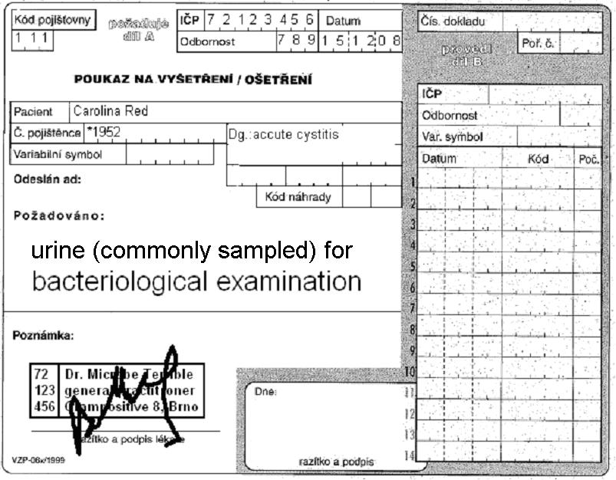
Form for results of Enterotest 16:
ONPG | 1H | 1G | 1F | 1E | 1D | 1C | 1B | 1A | 2H | 2G | 2F | 2E | 2D | 2C | 2B | 2A
+ | black | blue | red | blue | red | green | black | blue | blue | yellow | yellow | yellow | yellow | yellow | yellow | yellow
– | colourless | green | yellow | green | yellow | yellow | colourless | yellow | yellow | green | green | green | green | green | green | green
?
1 | 2 | 4 | 1 | 2 | 4 | 1 | 2 | 4 | 1 | 2 | 4 | 1 | 2 | 4 | 1 | 2
Code: |  |  |  |  |  | Identification |  |  |  |  |  | Probability % |  |  | T index

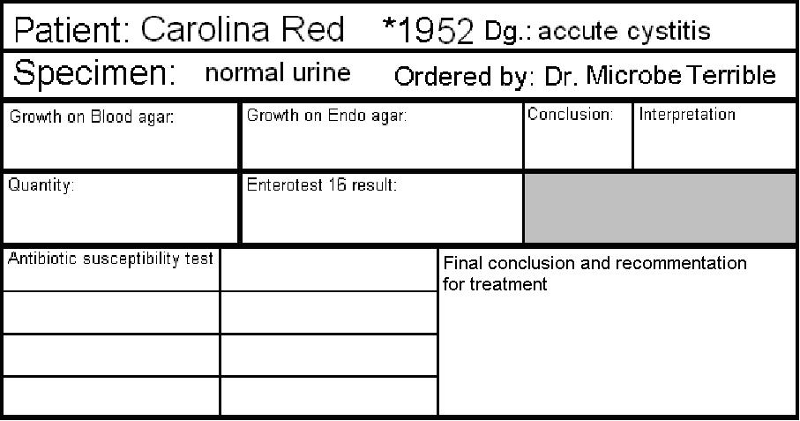

Antibiotic susceptibility test
Ampicillin  AMP | R < 14  S ≥ 14 | Chromotest URI medium | Tetracycline*  TE | R < 12  S ≥ 15
Cephazolin  KZ | R < 14  S ≥ 18 |  | Cefuroxime  CXM | R < 18  S ≥ 18
Co-trimoxazole SXT | R < 13  S ≥ 16 |  | Norfloxacin  NOR | R < 19  S ≥ 22
Nitrofurantoin  F | R < 11  S ≥ 11
write S = susceptible, R = resistant, eventually I = intermediary
*result of this test is also valid for doxycycline
Final conclusion and recommendation for treatment: _______________________________________________

Task 4: Interpretation and treatment of UTI
In following table in each cell (except cells in the first column) one term is wrong. Add a dot to all terms you consider wrong. After that, check your choice with your teacher, and strike through all the really false terms.
Clinical situation | Most likely pathogens | Drug of choice for initial therapy | Alternative drugs (allergy etc.)
Asymptomatic bacteriuria (ABU)  pregnant women | Escherichia coli  Klebsiella pneumoniae  Streptococcus pyogenes  Enterococcus sp. | nitrofurantoin*  ofloxacin | amoxicillin  linezolide
Asymptomatic bacteriuria (ABU)  other situations |  | no therapy  nitrofurantoin | no therapy  cefuroxime
Acute non-complicated cystitis (community cystitis, that means „not-nosokomial“ one) | Clostridium sp.  Escherichia coli  Staphylococcus saprophyticus  Klebsiella pneumoniae | ciprofloxacin  nitrofurantoin | co-trimoxazole  (co-)amoxicillin  vankomycin  cefuroxime
Accute pyelonephritis | Escherichia coli  Bacteroides fragilis  Klebsiella pneumoniae  Proteus sp. | (co-)amoxicilin  cefuroxime  nitrofurantoin | co-trimoxazole  norfloxacin  imipenem
*except first trimester and the second haft of the third trimester

Infections of genital system

Task 5: Sampling methods in STIs and other infections of reproductive organs
Find suitable swabs or other sampling methods for following clinical situations (suspicions for individual diseases). For some of them more than one sampling method is suitable. Use numbers 1 to 6 and mark your choice to individual situations. Correct yourself with help of your teacher.

Bacterial vaginosis

Aerobic vaginitis

Vaginal mycosis

Gonorrhoea
Syphilis

Mycoplasma infection

Chlamydia infection

Papillomavirus infection

Numbers: 1 – Amies swab 2 – C. A. T. swab 3 – plain (dry) swab 4 – a smear on a slide 5 – clotted blood for indirect examination 6 – ulcus durum scraping for dark-field microscopy and PCR

Task 6: Evaluation of vaginal smears
In diagnostics of vaginal infections, one very important method is microscopy. Cultivation results may be positive even when the amount of bacteria (e. g. Gardnerella sp.) is not significant. Therefore, microscopy is better, because we can see the ratio between various morphotypes of bacteria, and also other structures (epithelial cells including those with adhered bacteria – so called “clue cells”; white blood cells; yeast cells etc.). Sometimes, two smears are sent to the laboratory: one is stained by Giemsa staining (almost because of Trichomonas vaginalis diagnostics, as T. vaginalis cannot be Gram stained very well) and the other by Gram (especially for bacteriology).
____________________________________
____________________________________
Nugent score for BV:
Observe a result of a vaginal smear and draw your result in the laboratory report. Try to count the Nugent score of bacterial vaginosis with help of following guide:

A. Morphotypes
- Morphotype Lactobacillus = robust and long G+ rods
- Morphotype Gardnerella/Bacteroides = subtle Gram-negative or Gram-variable straight rods
- Morphotype Mobiluncus = subtle Gram-negative curved rods.
Other objects (cocci, human origin cells, yeast cells) are not counted
Note: the term morphotype means “bacteria that look in the microscope the same as”, so not all bacteria of Gardnerella/Bacteroides morphotype are really either Gardnerella or Bacteroides.)

B. The counting system (+ to ++++) – simplified
Bacteria are extremely frequent, they may be seen in the first moment of looking to the field | ++++
Bacteria are very frequent, each field contains lots of them | +++
Bacteria are present in each field, but they are not frequent | ++
Bacteria are not very frequent, there are fields with no bacteria at all | +
Bacteria are completely absent | –
Note: Similar system can be also used for other microscopies, e. g. sputum evaluation

C. The proper Nugent scoring system (simplified):
Points added | Lactobacillus morphotype presence | Gardnerella/Bacteroides morphotype presence | Mobilluncus morphotype presence
0 | ++++ | – | –
1 | +++ | + | + or ++
2 | ++ | ++ | +++ or ++++
3 | + | +++
4 | – | ++++
So each smear may get 0 to 4 points for Lactobacillus morphotype (the more bacteria of this morphotype, the less points), 0 to 4 points for Gardnerella/Bacteroides morphotype presence morphotype (the more bacteria of this morphotype, the more points) 0 to 2 points for Mobilluncus morphotype presence morphotype (the more bacteria of this morphotype, the more points)
The criterion for bacterial vaginosis according to Nugent's criteria is a total score of 7 or more is labeled as Bacterial Vaginosis a score of 4 to 6 is called intermediate, and a score of 0 to 3 is considered normal.
Reliability of diagnosing bacterial vaginosis is improved by a standardized method of gram stain interpretation. R P Nugent, M A Krohn, and S L Hillier, J Clin Microbiol. 1991 February; 29(2): 297–301.

Task 7: Evaluation of vaginal swabs
Vaginal swabs are usually cultured on blood agar, Endo agar, agar with 10 % NaCl, special blood agar for Gardnerella vaginalis, eventually also VL agar (anaerobic culture). As a normal flora, we can observe lactobacilli: very tiny colonies with viridation. There exist many species of lactobacilli, with different relations with oxygen, although they use to be microaerofilic. Nevertheless, sometimes they are able to grow on blood agar in normal atmosphere, sometimes in Gardnerella agar in an incubator with elevated CO₂ concentration, and sometimes under anaerobic conditions only. Besides lactobacilli, normal finding may contain small amounts of staphylococci, Enterobacteriaceae and some other bacteria. Sometimes lactobacili are absent, especially in swabs taken from women after climacterium.
Dental students do not perform this task practically.

