**Fenotyp haptoglobinu – typ 1-1,2-1 a 2-2**

**A**

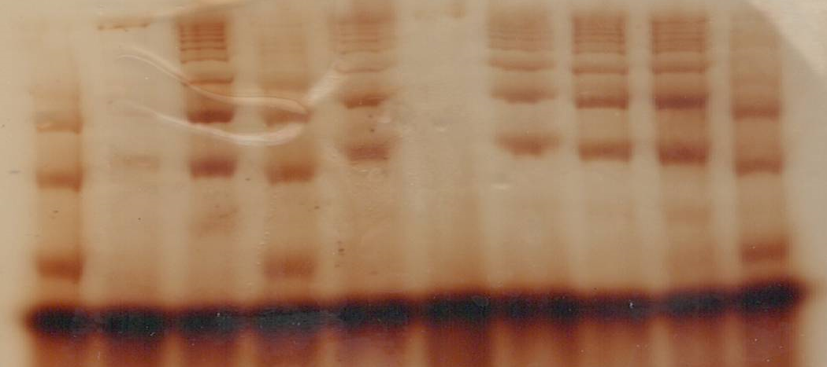

**1 2 3 4 5 6 7 8 9 10**

**A**

|  |  |
| --- | --- |
| **1** | 2-1 |
| **2** | 1-1 |
| **3** | 2-2 |
| **4** |  |
| **5** |  |
| **6** |  |
| **7** |  |
| **8** |  |
| **9** |  |
| **10** |  |

**HPT**

**B**

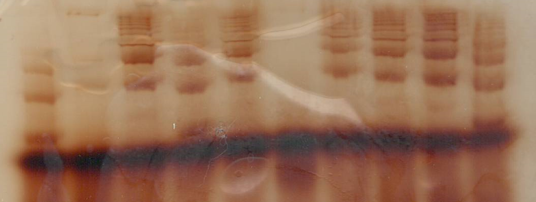

**1 2 3 4 5 6 7 8 9 10**

**B**

|  |  |
| --- | --- |
| **1** | 2-1 |
| **2** | 1-1 |
| **3** | 2-2 |
| **4** |  |
| **5** |  |
| **6** |  |
| **7** |  |
| **8** |  |
| **9** |  |
| **10** |  |