1. **Grammatical gender**: watch the tutorial, study also from: Textbook, p. 18
   * Textbook, p. 17/ex. 5: Listen and fill in the gaps (link for audio: [here](https://www.czechstepbystep.cz/coLm4dEPxQE9/uploads/2018/06/CD1_track_15.mp3))
     + make sure you understand the dialogues, use the dictionnary

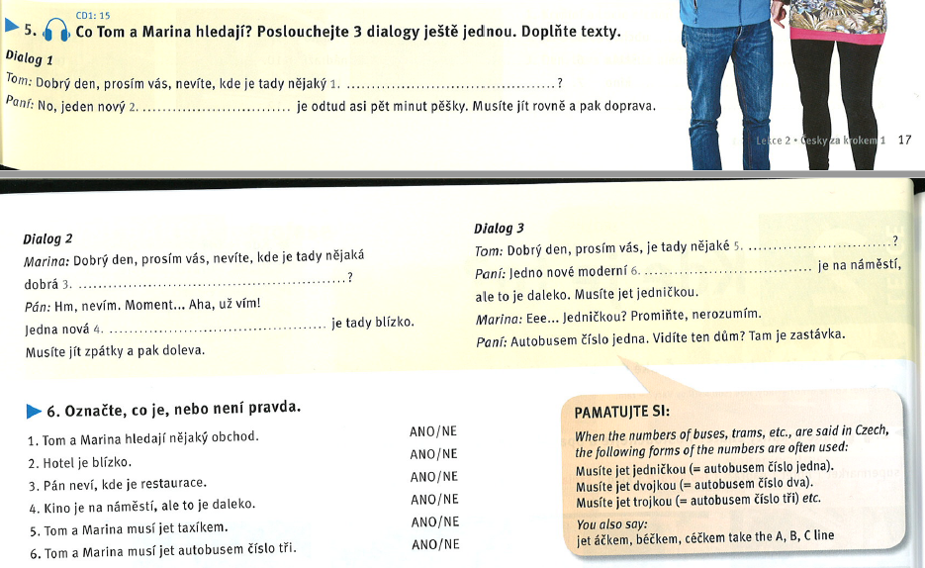



Ex. 5

1. hotel
2. hotel
3. restaurace
4. restaurace
5. kino nebo divadlo
6. kino

## Important phrases & info

* 1 = jedna = *one (numeral)*; jednička = *number one* = tramvaj *číslo jedna*
  + *trolejbus číslo 25*
* nevíte, kde je = *do you know, where*…? (*polite: asking in negative way*)
  + nestudujete medicínu?
* kde je tady nějaký/á/é [place]? *Is there any [place] around?* (lit. Where is any [place] here?)
* *Musíte jít / jet* = you have to go
* [place] je na náměstí = there is a [place] on the square (lit. [place] is on the square) = no *there is* in czech language
* už = already
  + Textbook, p. 18/ex. 6: read the dialogues again and decide whether the statements are true (ANO) or false (NE)
  + sort the words out according to their gender, observe the pronunciation: [link](https://learningapps.org/watch?v=pja5qon8n20)

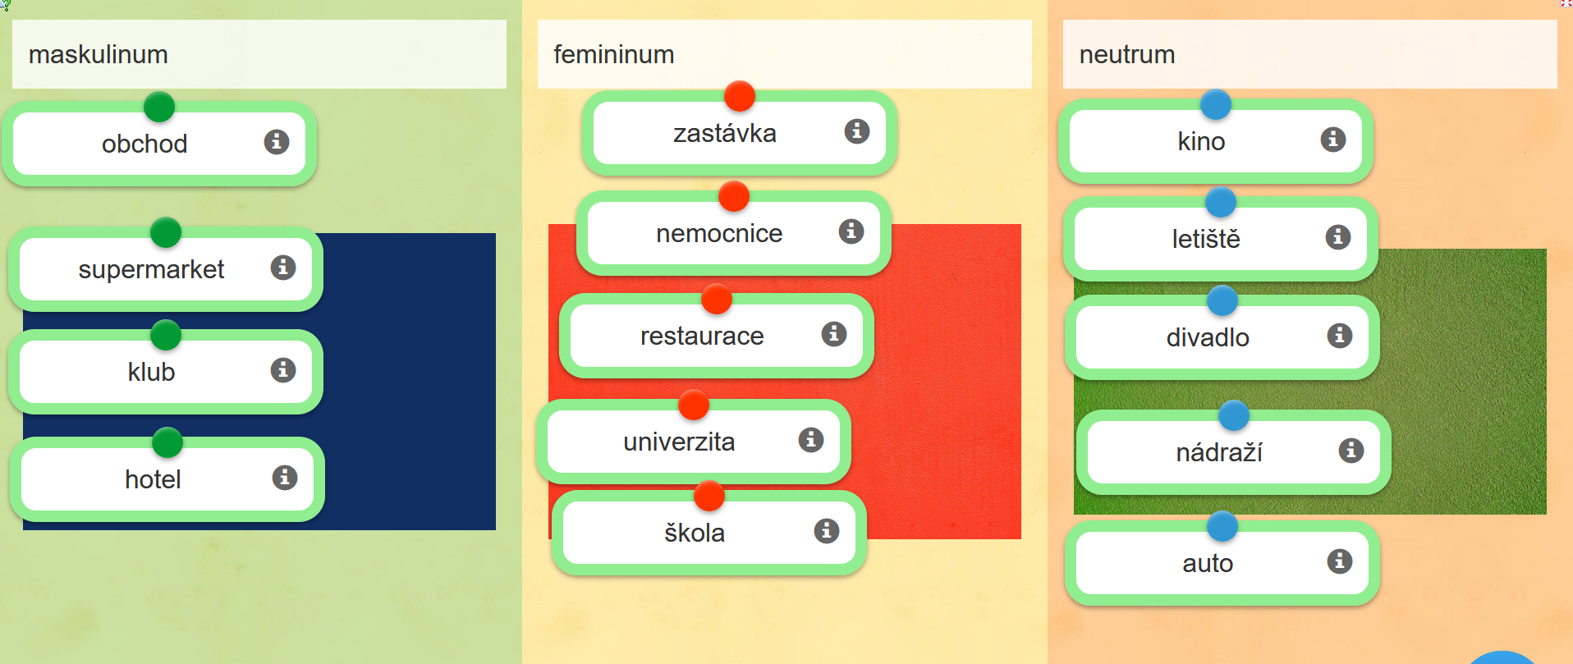

nové velké nádraží

hlavní nádraží,

* + Textbook, p. 18/ex. 7: fill in *nový* and *moderní* in correct forms (according to the gender of given nouns)

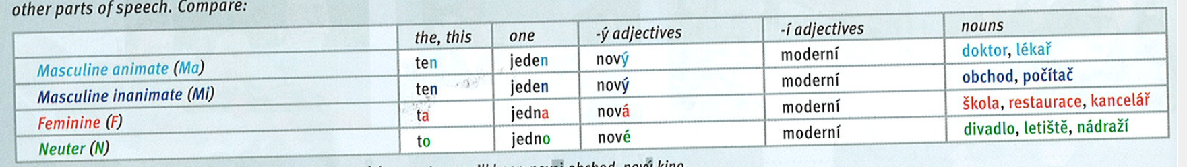

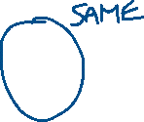

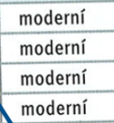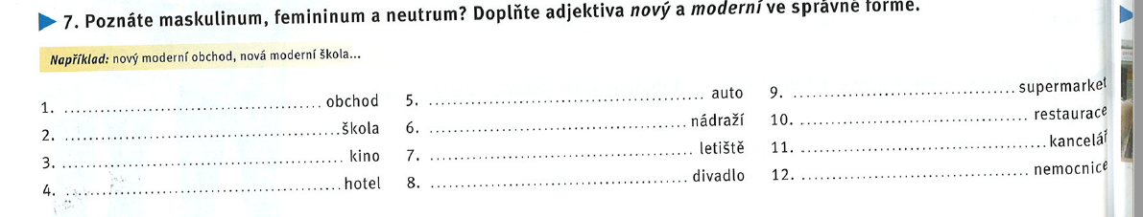

* + choose the correct forms of adjectives: [link](https://learningapps.org/watch?v=pn3mhob6a20)

# BREAK UNTIL 8:53

1. **Likes and dislikes**: observe the grey box in Texbook, p. 22

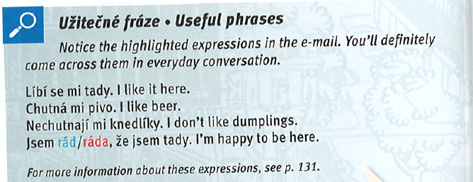

***Líbí*** se mi **tady** = lit. Here *seems* nice to me…

~~Líbím se ti = you like me~~

~~Líbíš se mi = I like you~~

**Chutná** mi pivo = lit. Beer seems tasty to me…

Questions:

Líbí se vám Brno? – Ano, líbí se mi Brno. × Ne, nelíbí se mi Brno.

* + Textbook, **p. 22/ex. 5**: decide what is positive and what is negative statement

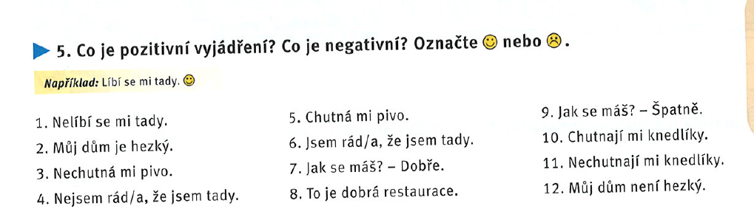



1. **Writing an email**
   * read the email (Textbook, p. 21/ex. 2)

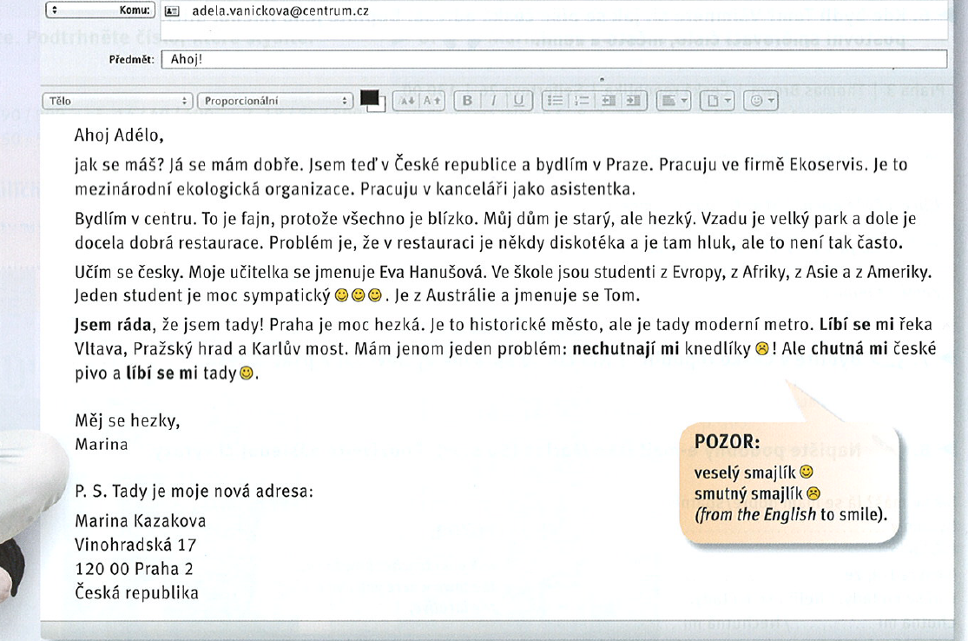

* „international vocabulary“:
  + diskotéka, asistentka, firma, ekologická organizace,
  + fajn = fine; džus = juice
  + „false friends“: sympatický (nice, likeable)
* hluk: noise
* pracuju jako… = I work as…
* **dům** = house → doma = home
* často = often
  + learn the vocabulary from this email, use the dictionnary
  + Textbook, p. 22/ex. 3: read the email again and decide whether the statements are true (ANO) or false (NE)

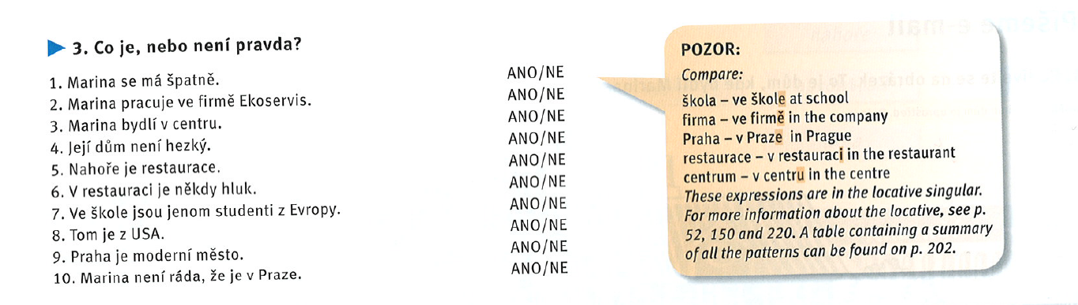



* + Textbook, p. 22/ex. 4: match the left and right parts

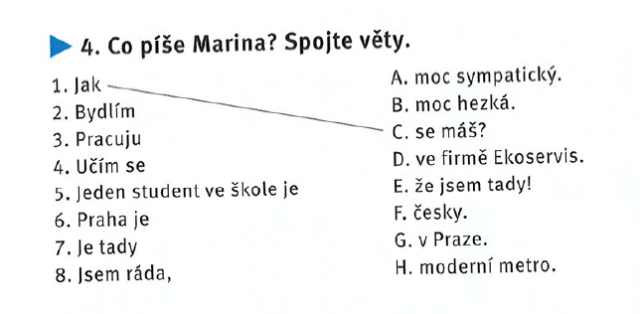



1. **Revision**
   * lesson 2 test: [link](https://learningapps.org/watch?v=p7w3kzgi220)
2. **Project**
   * write an email to your friend (50 words)
   * follow the structure from: Textbook, p. 22/ex. 8
   * tell him/her where you are, what you do, where you live, what you like
   * upload it on IS (onto your homework vaults)

**Homework**

* revise for the test

**Tutorial**